1. Authenticate, Authorize
2. Secure REST services.
3. 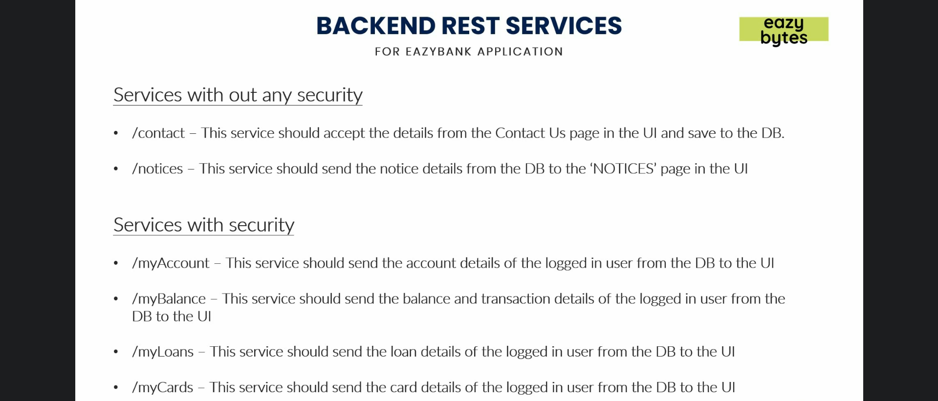
4. 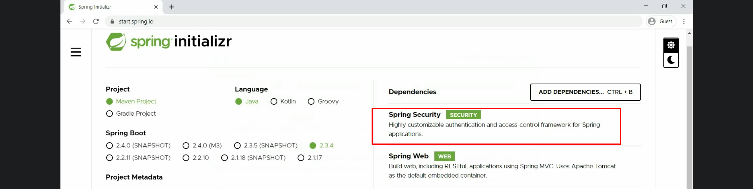
5. 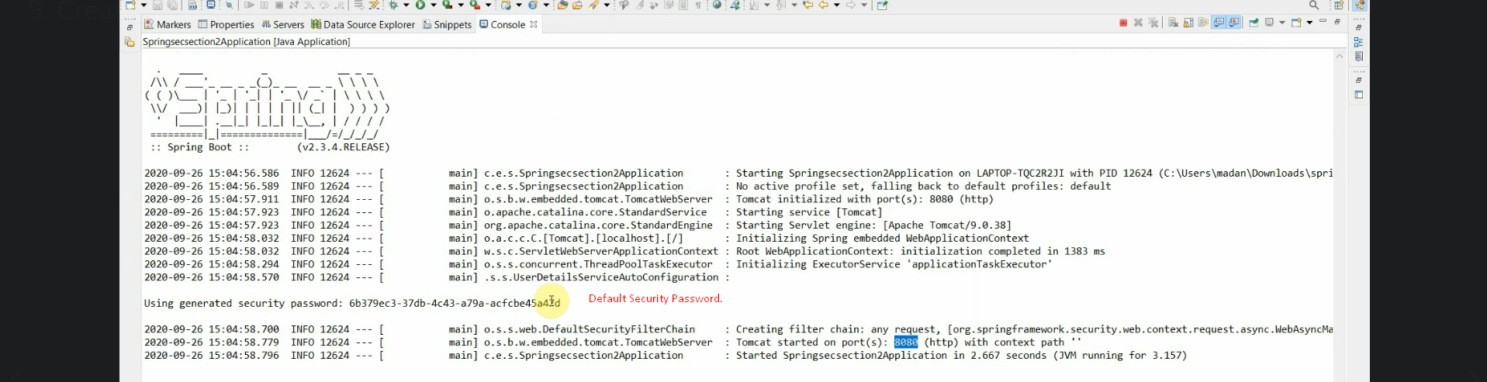
6. 
7. 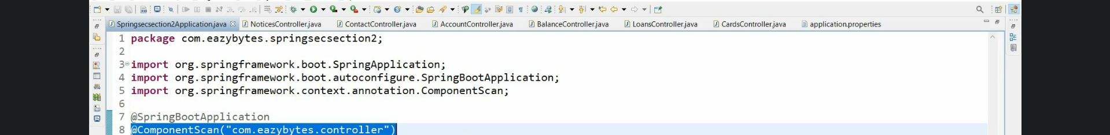
8. 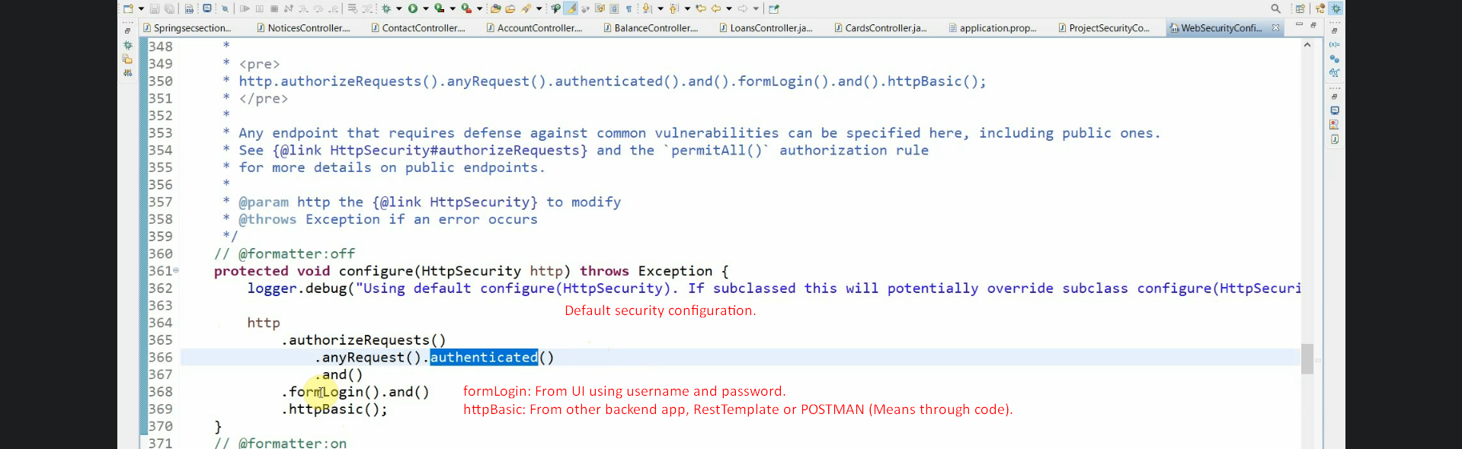
9. 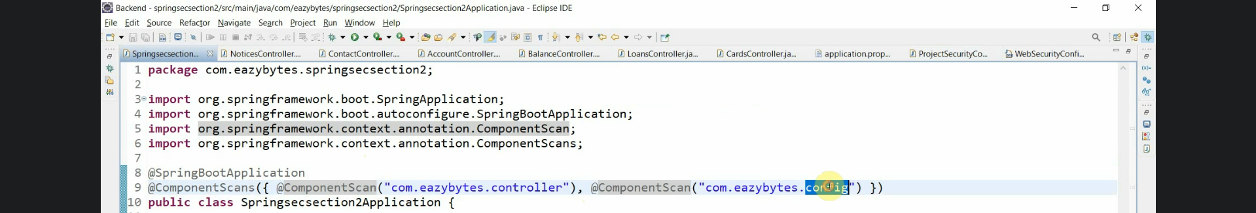
10. 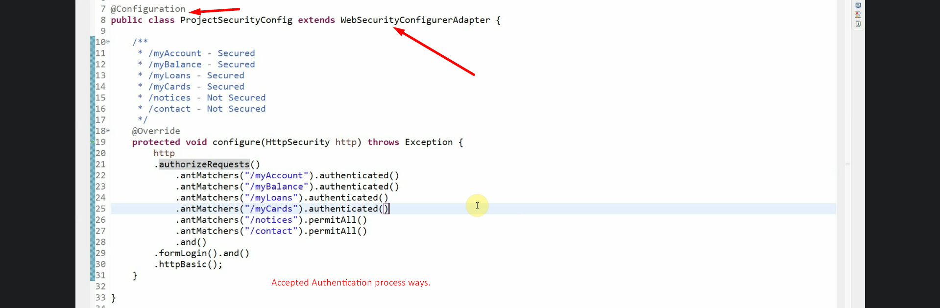
11. 
12. 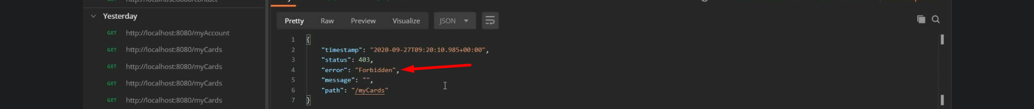
13. 
14. 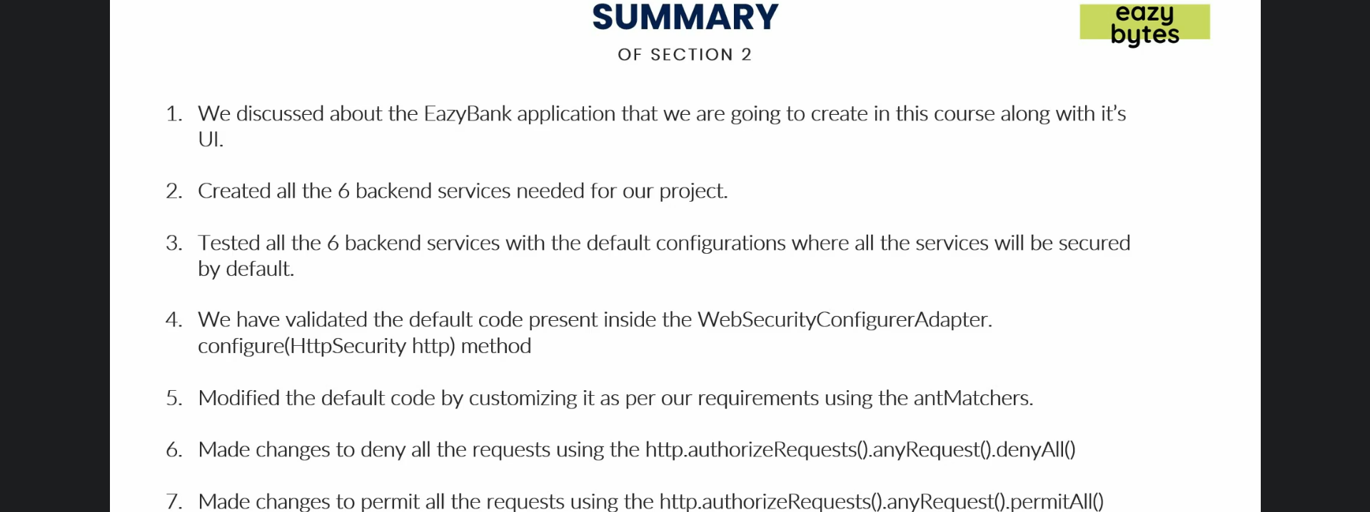
15. 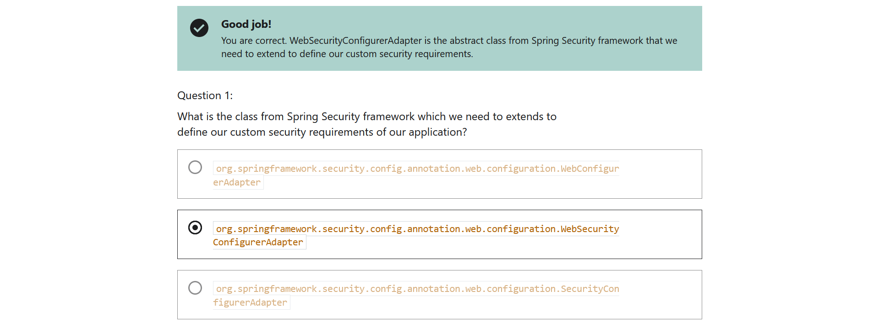
16. 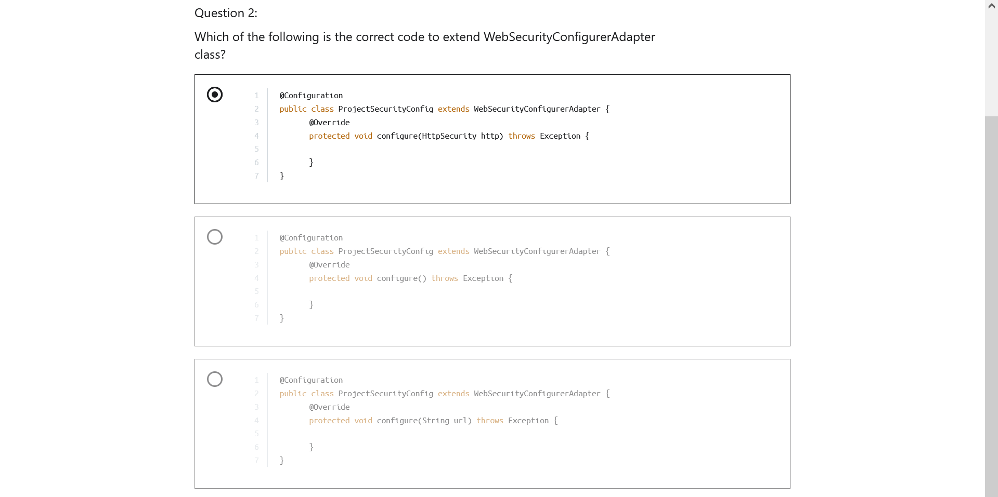
17. 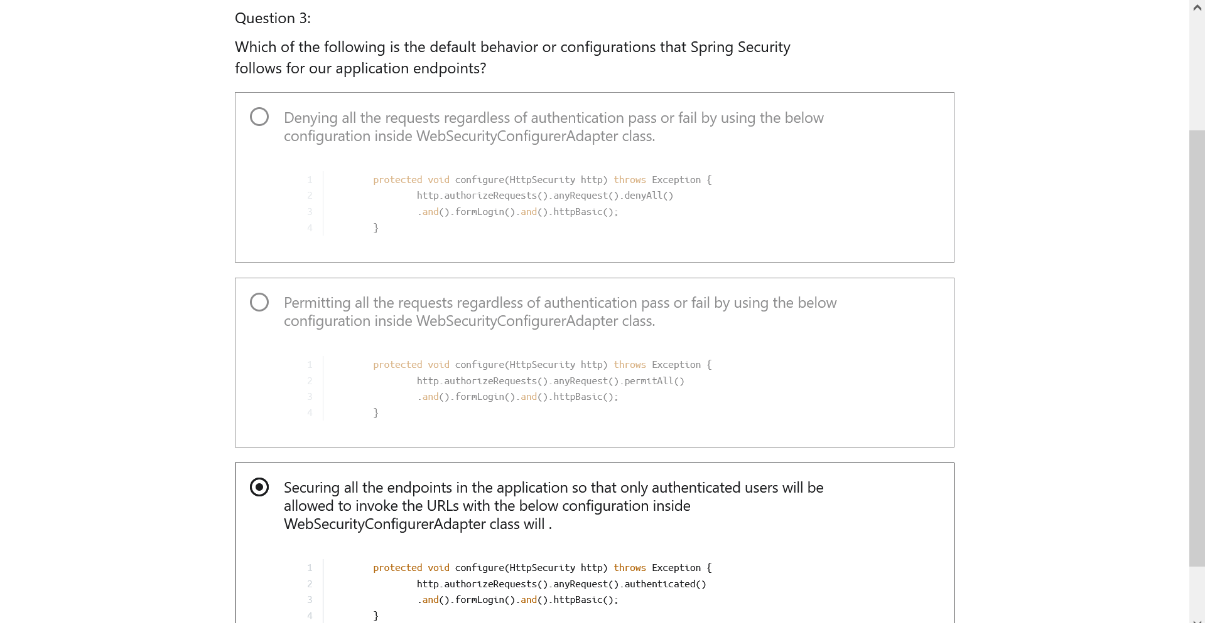
18. 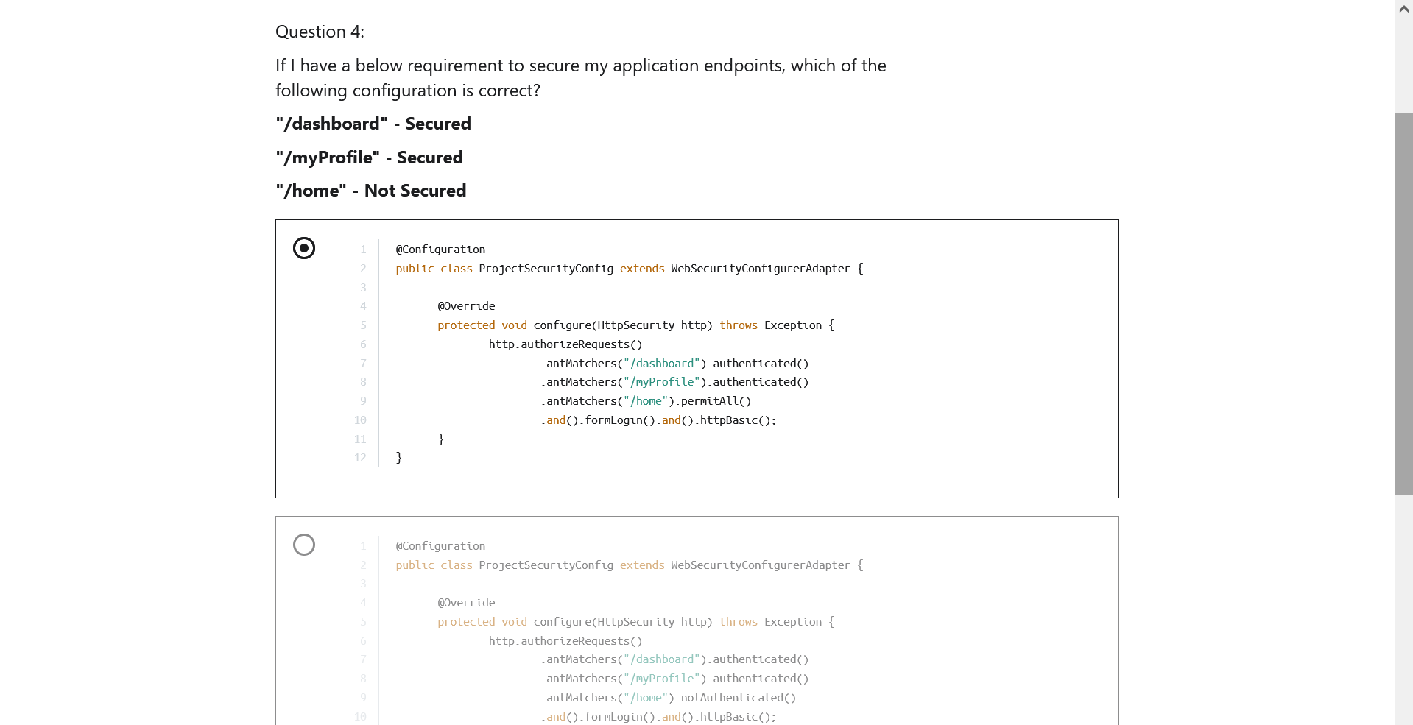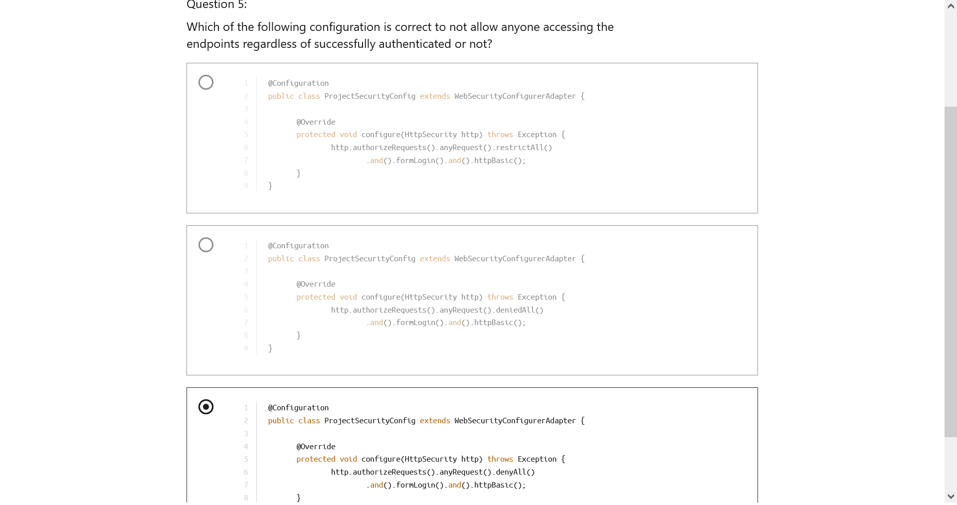’ 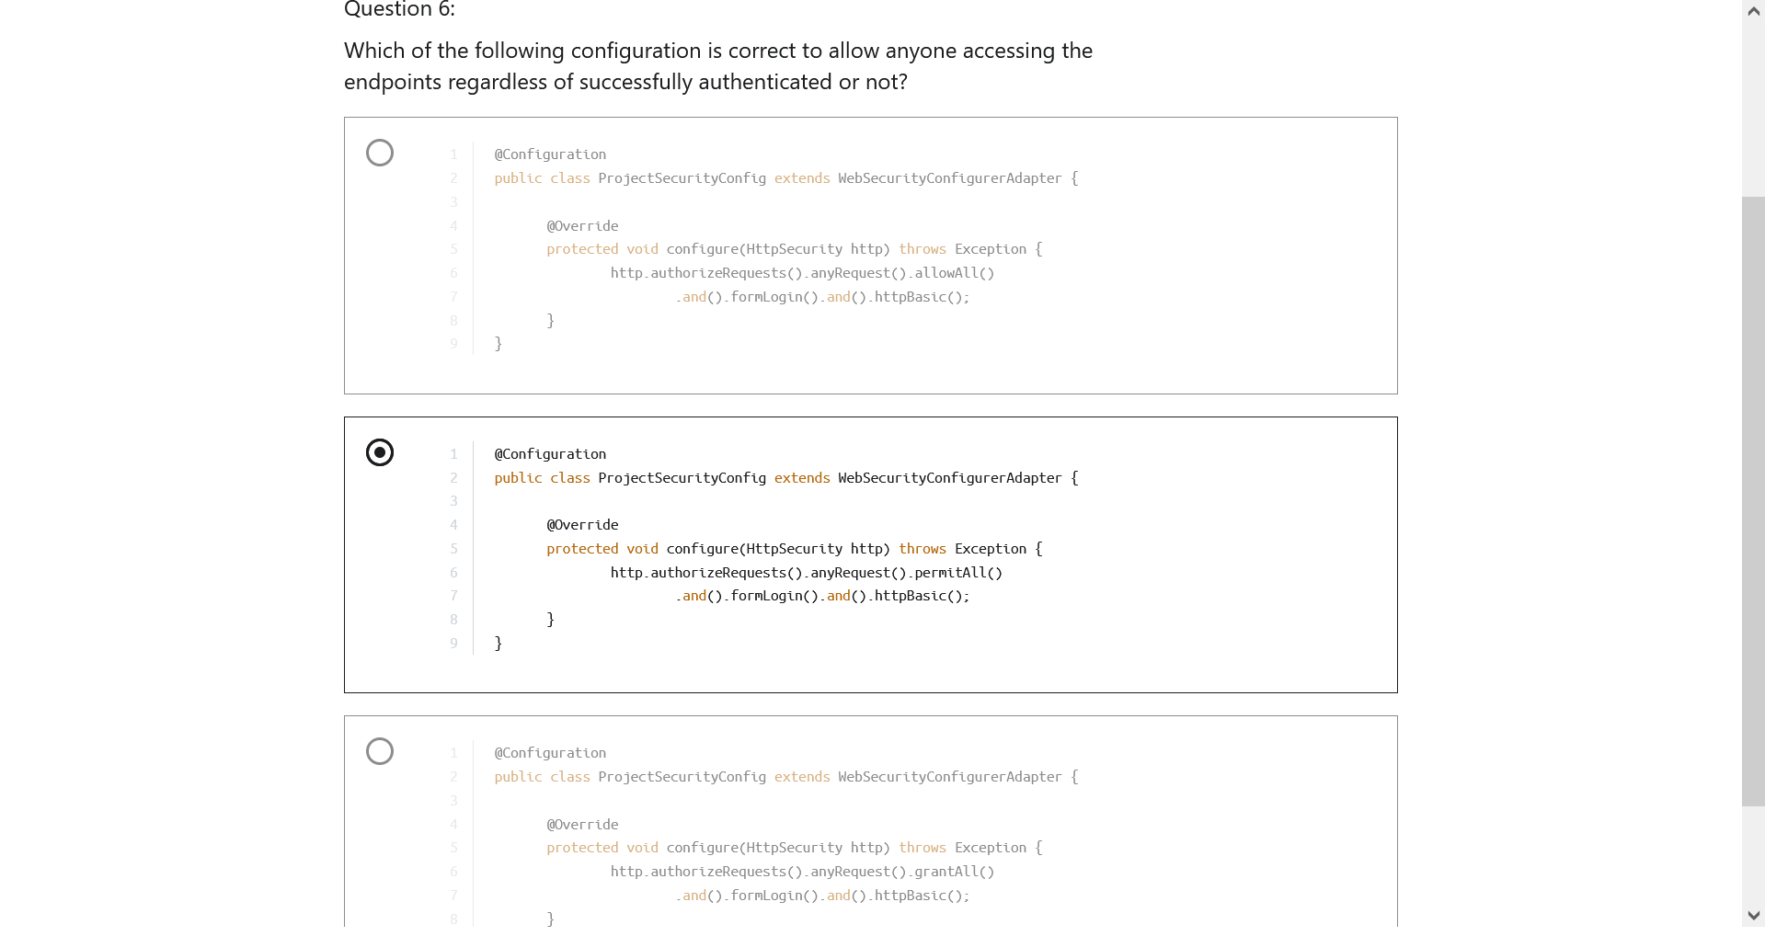
19. 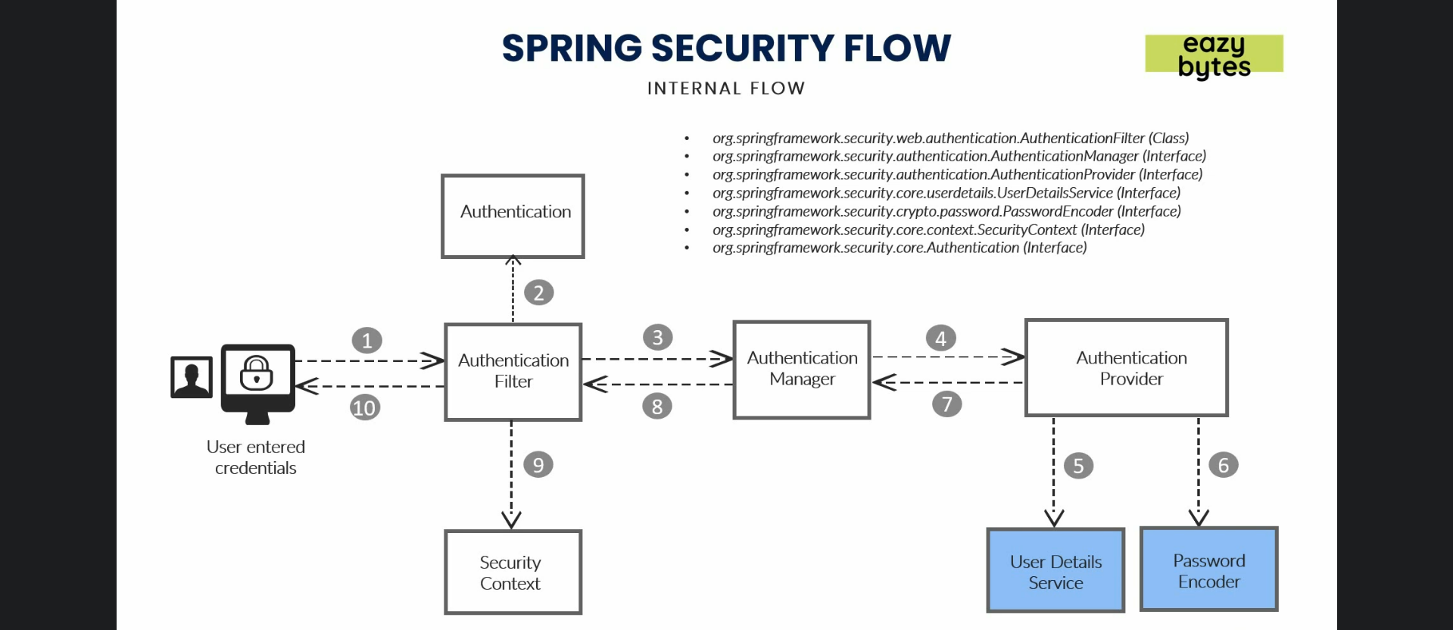
20. Path level security using antmatchers.
21. 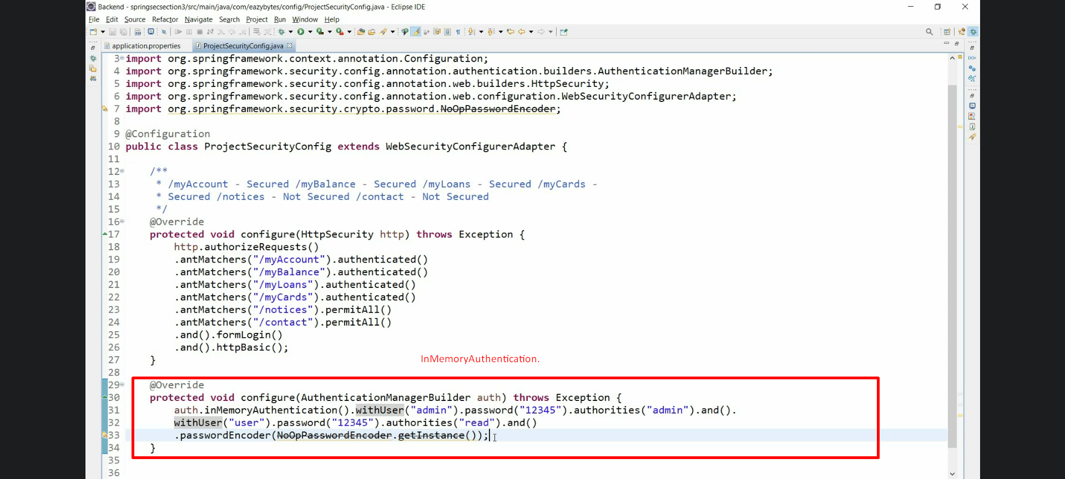
22. 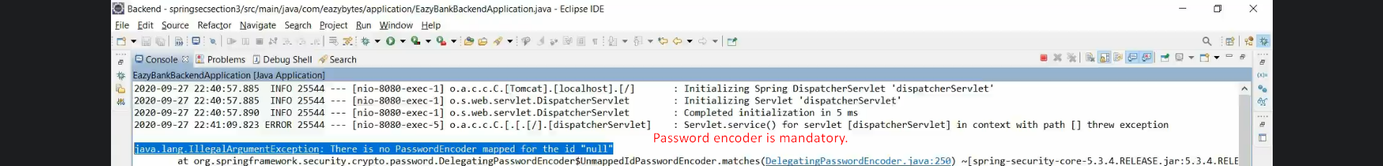
23. 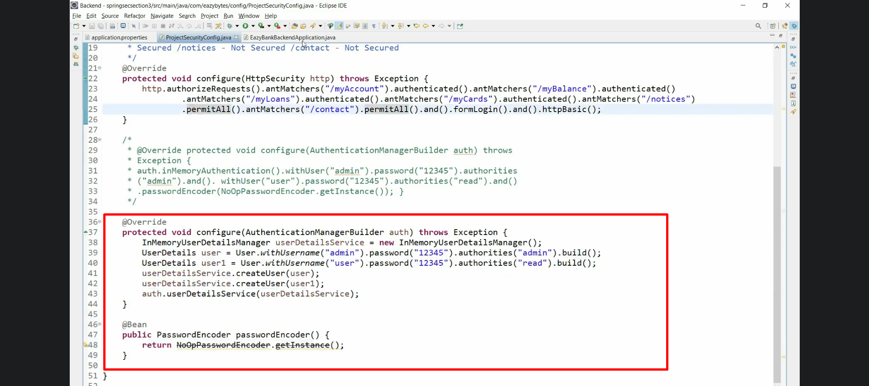
24. 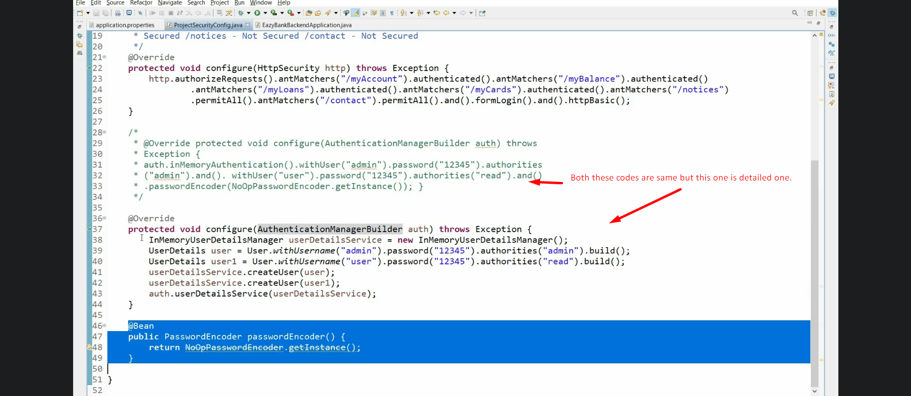
25. 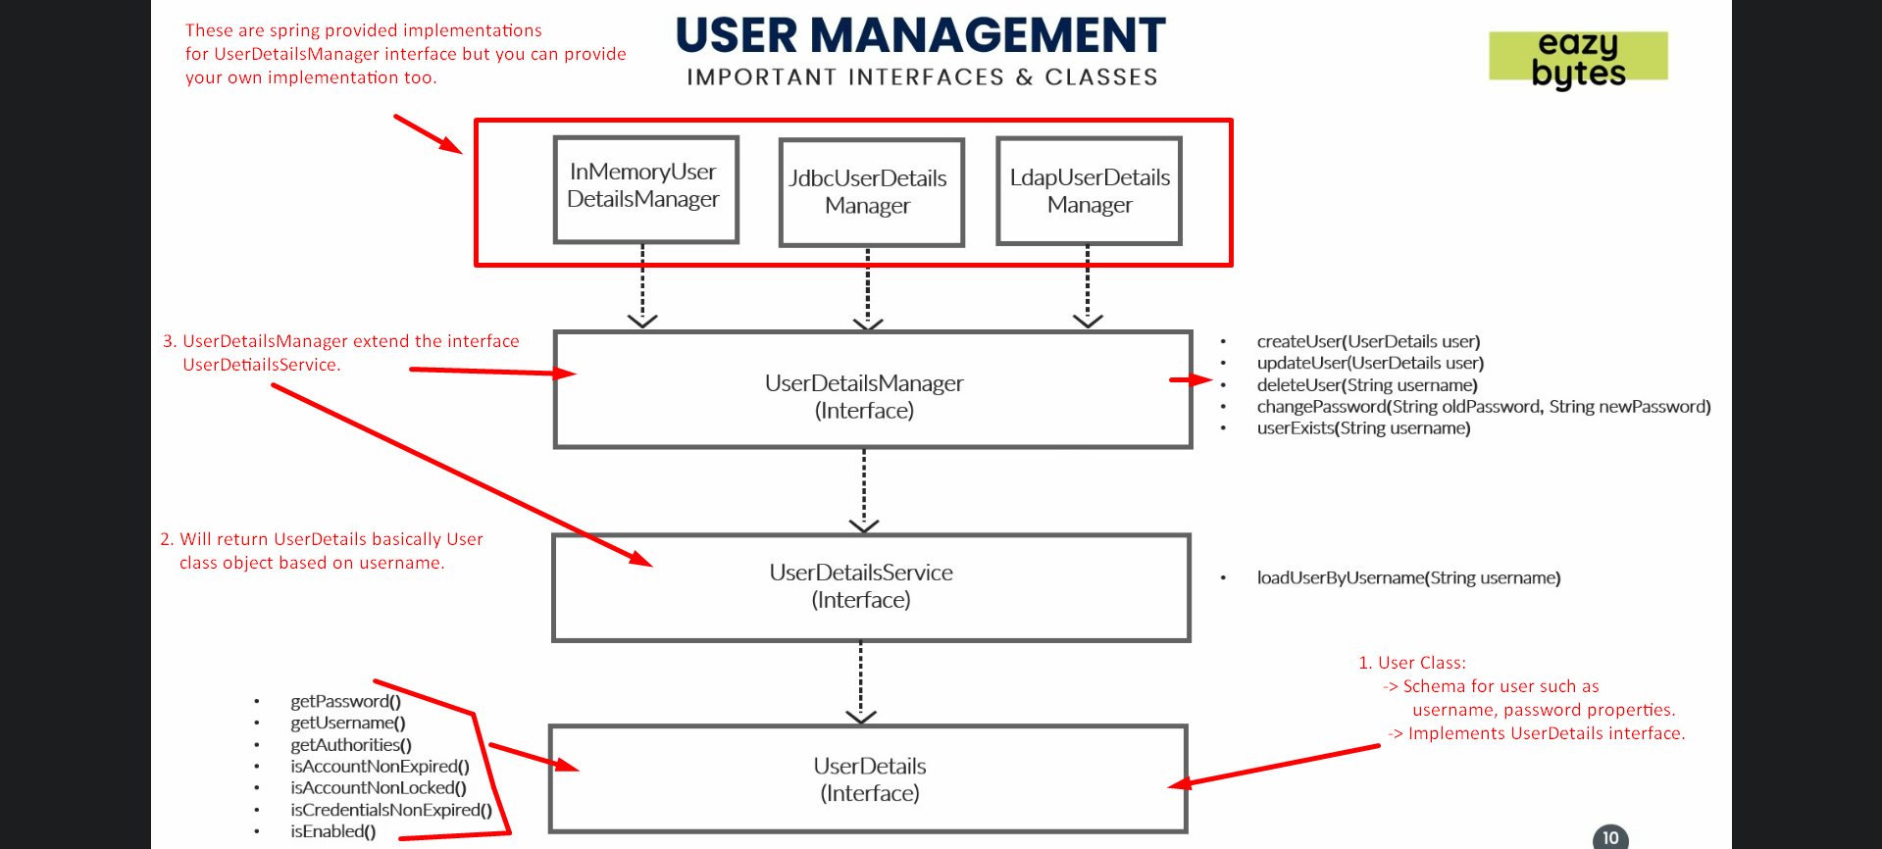

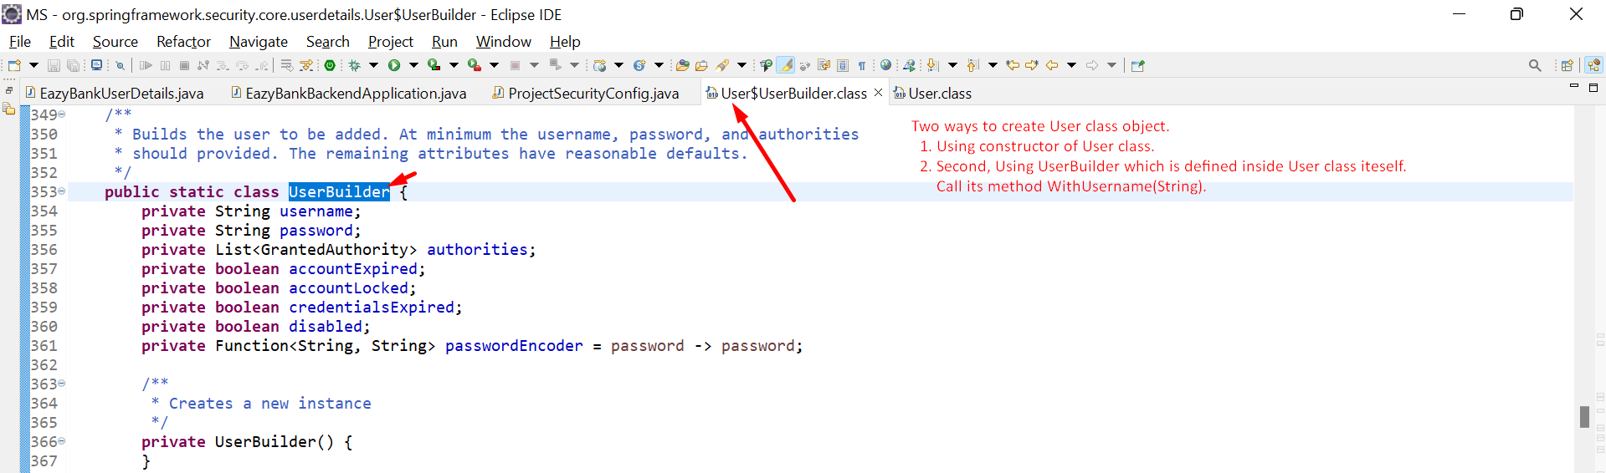

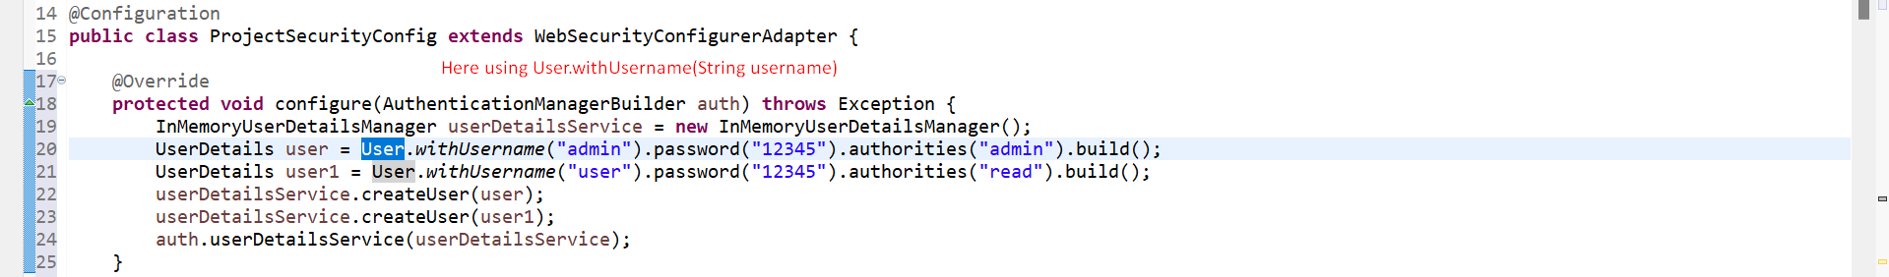

1. 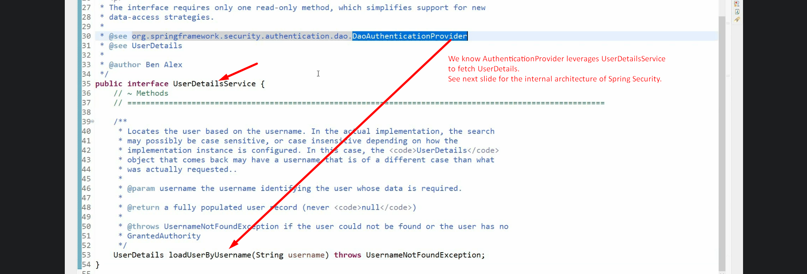  
   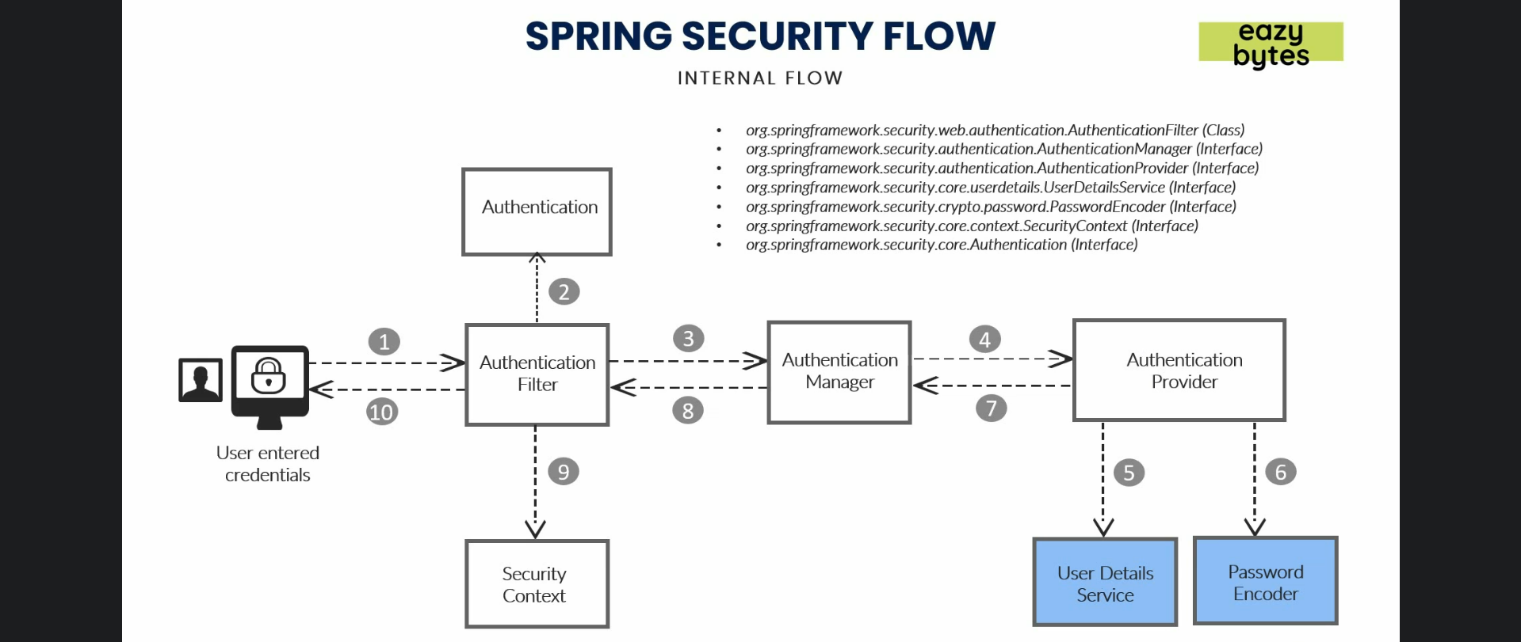
2. Basically, UserDetailsService.loadUserByUsername(String username):UserDetails has the business logic to user details based on username.
3. 
4. 
5. 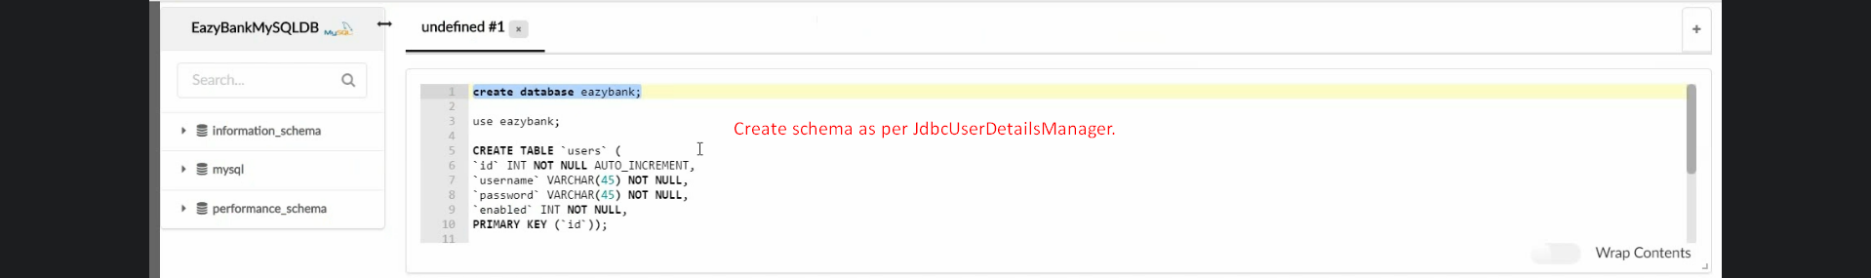
6. 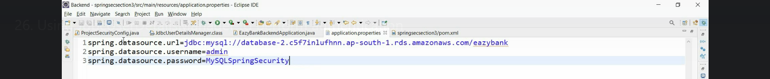
7. 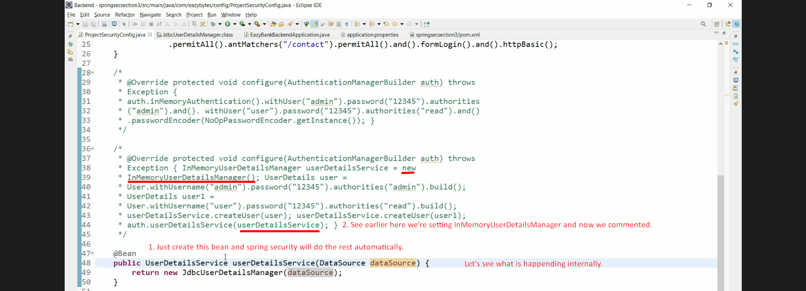  
   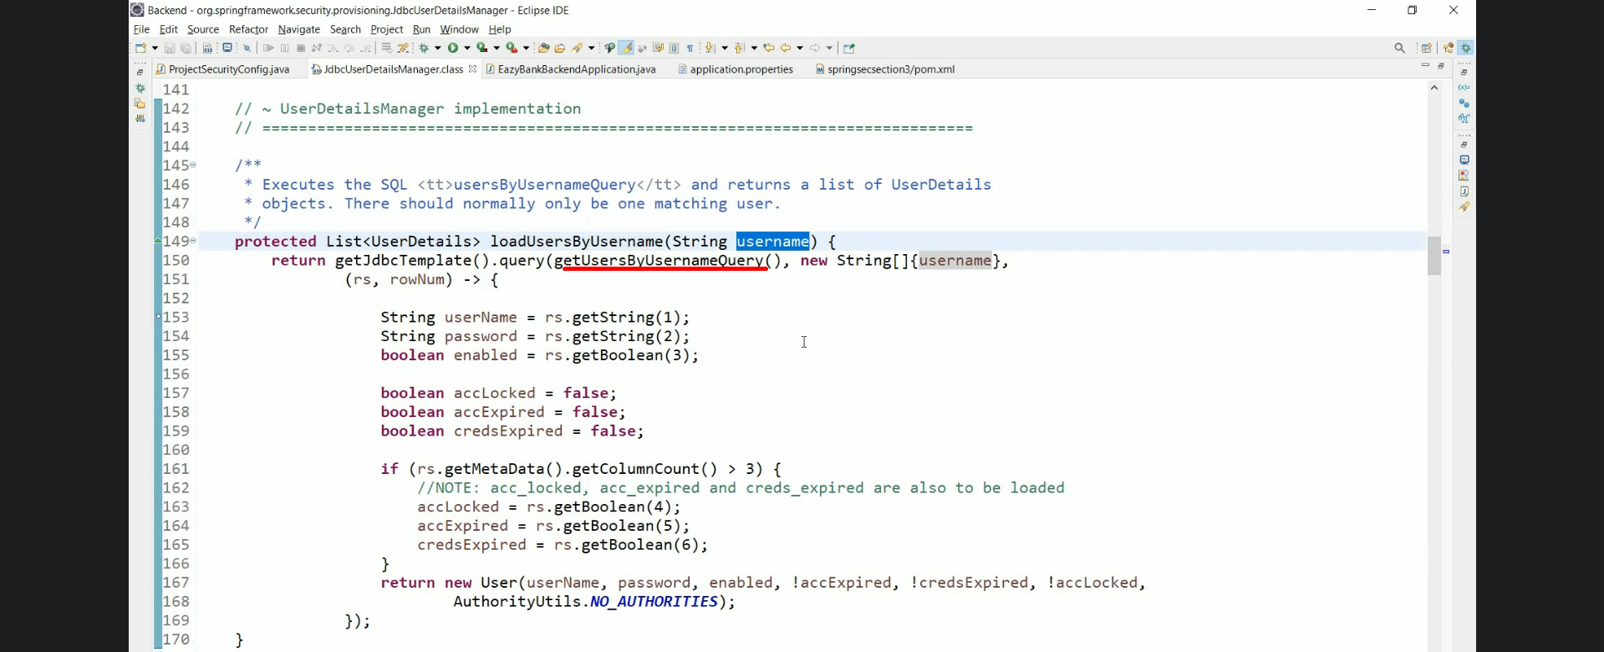
8.   
     
   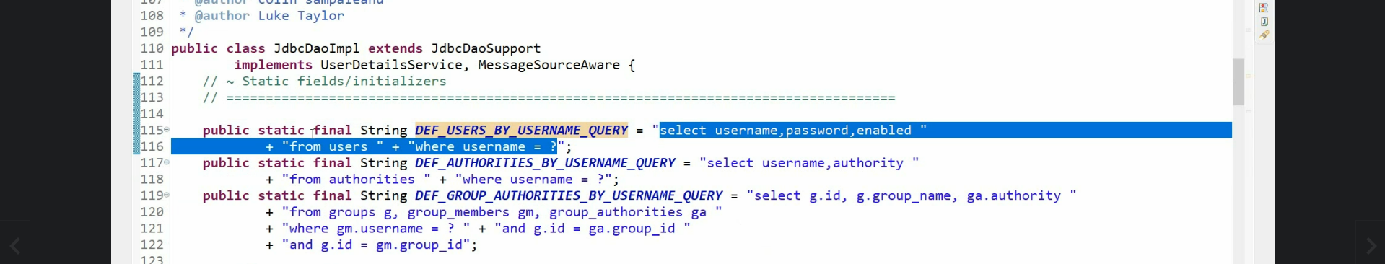
9. Custom implementation of UserDetailsService  
   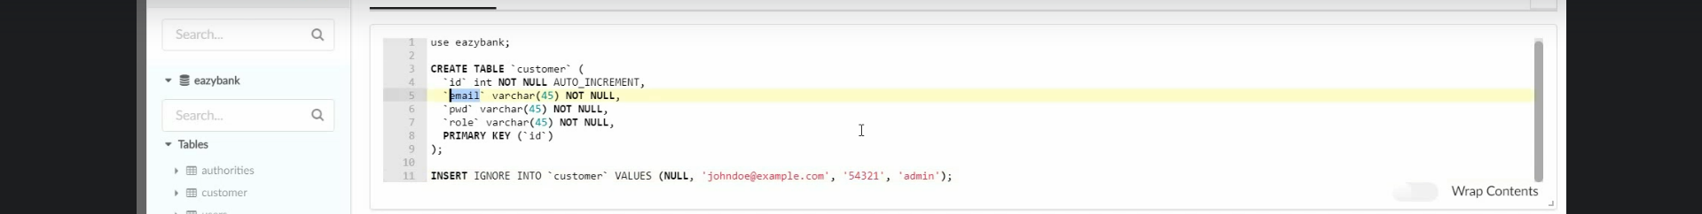

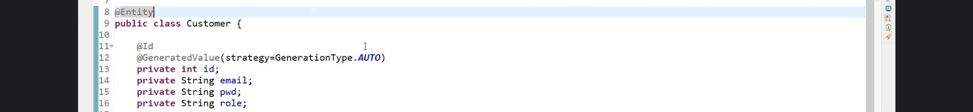

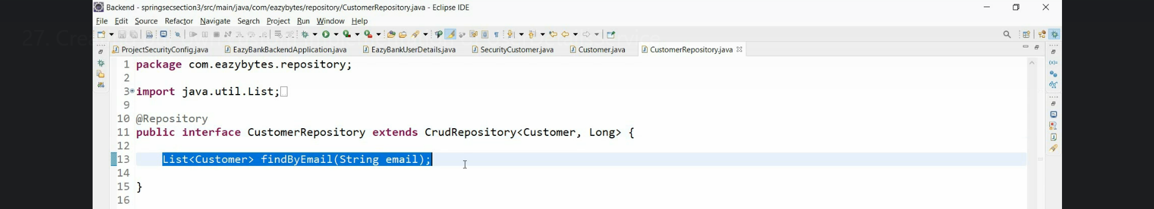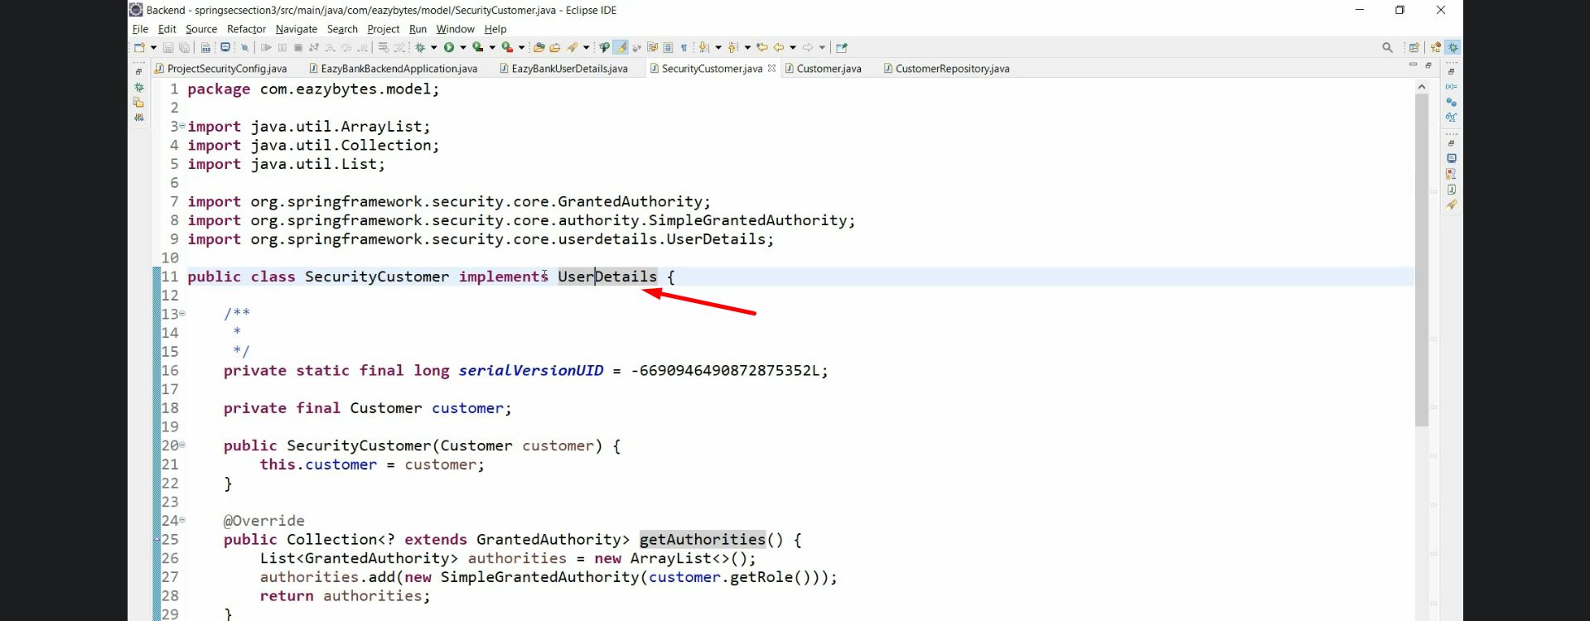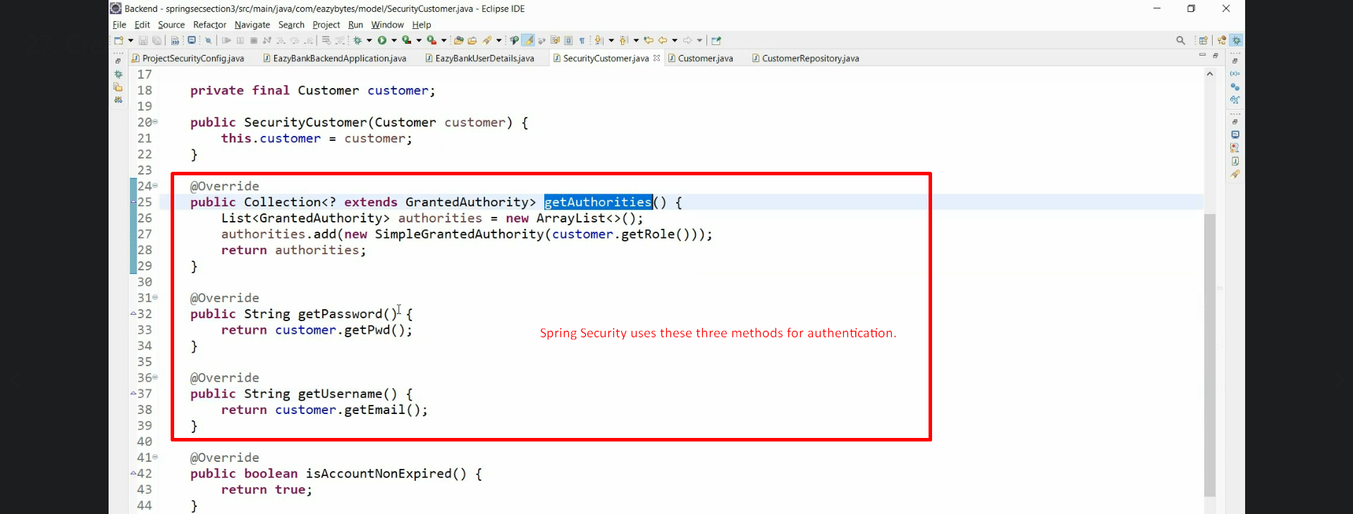

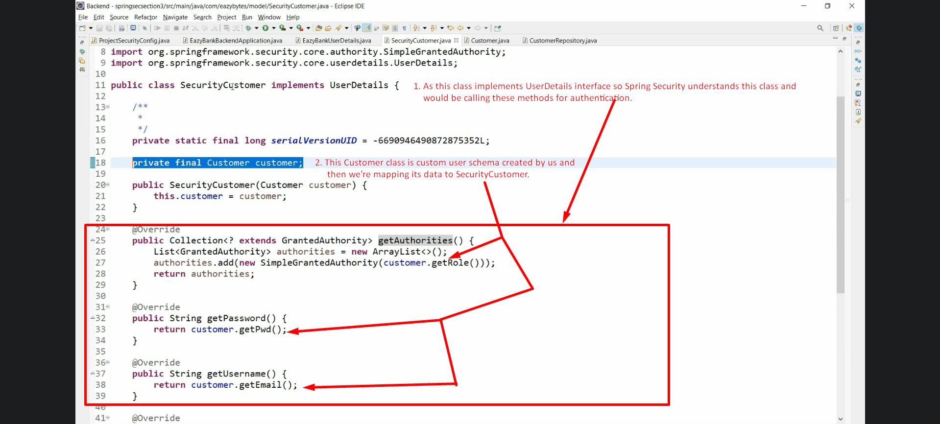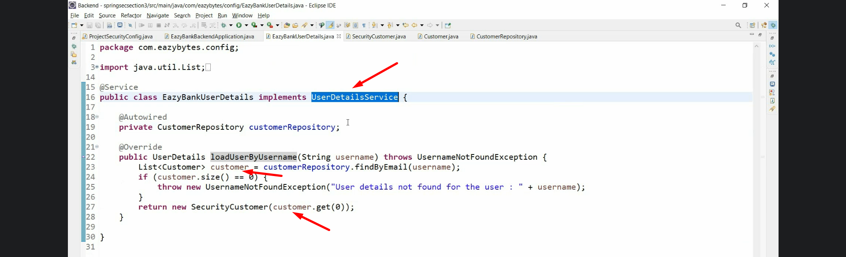

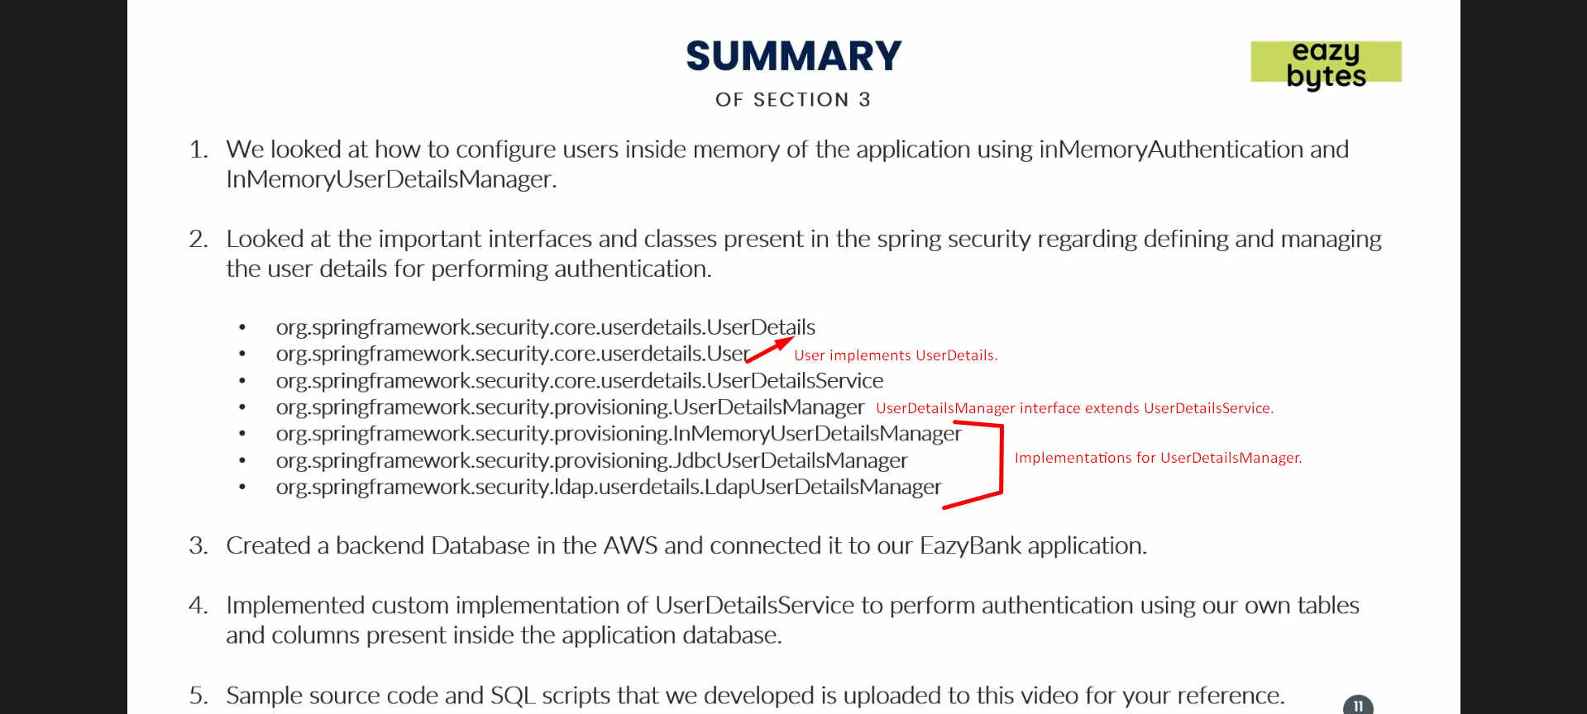

1. 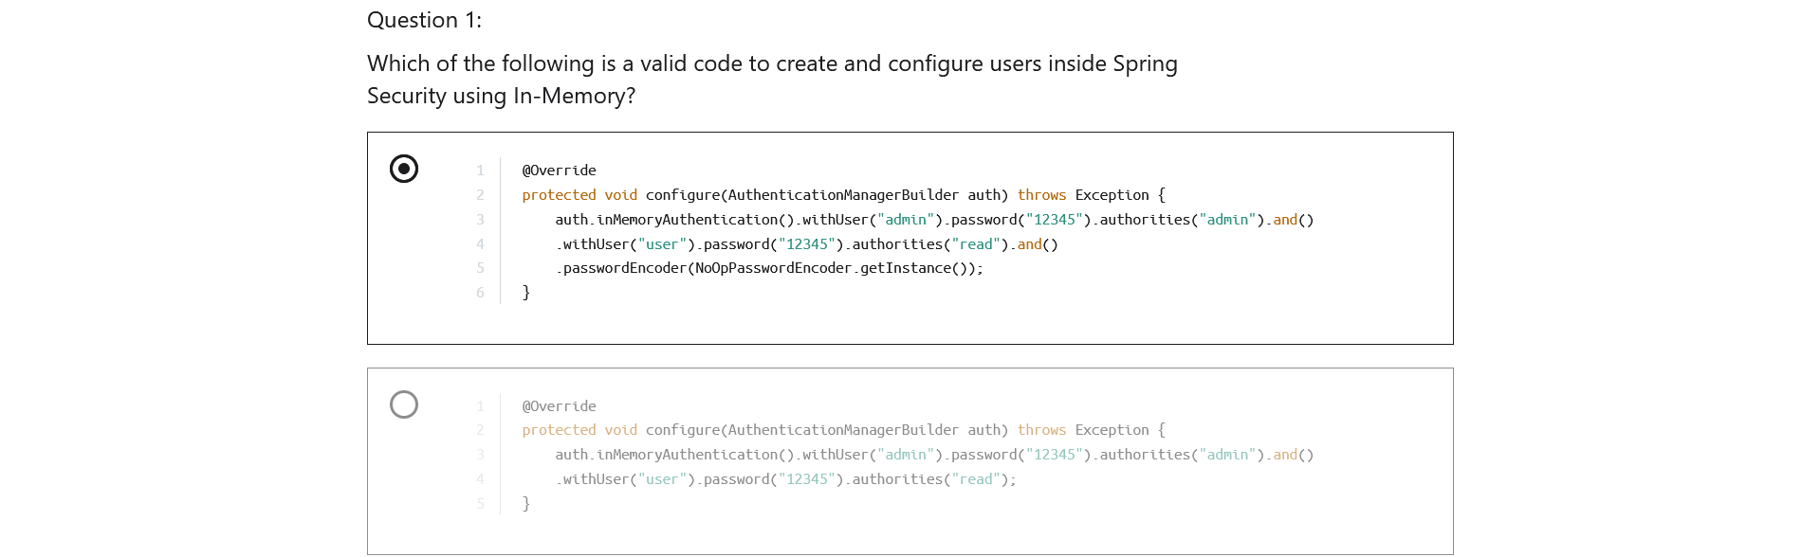
2. 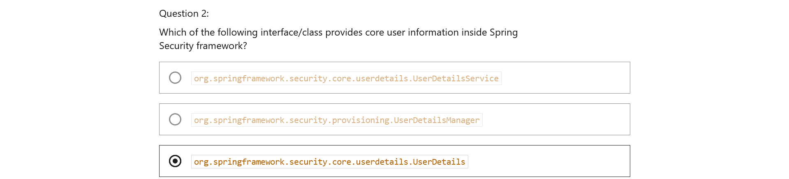
3. 
4. 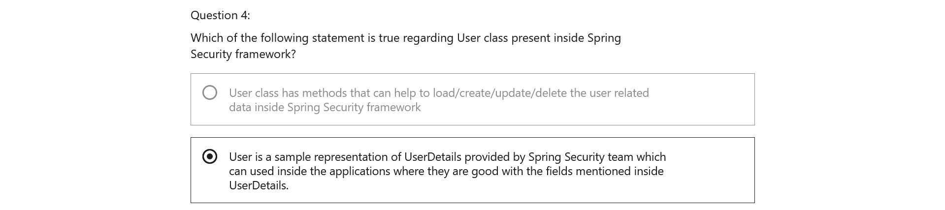
5. 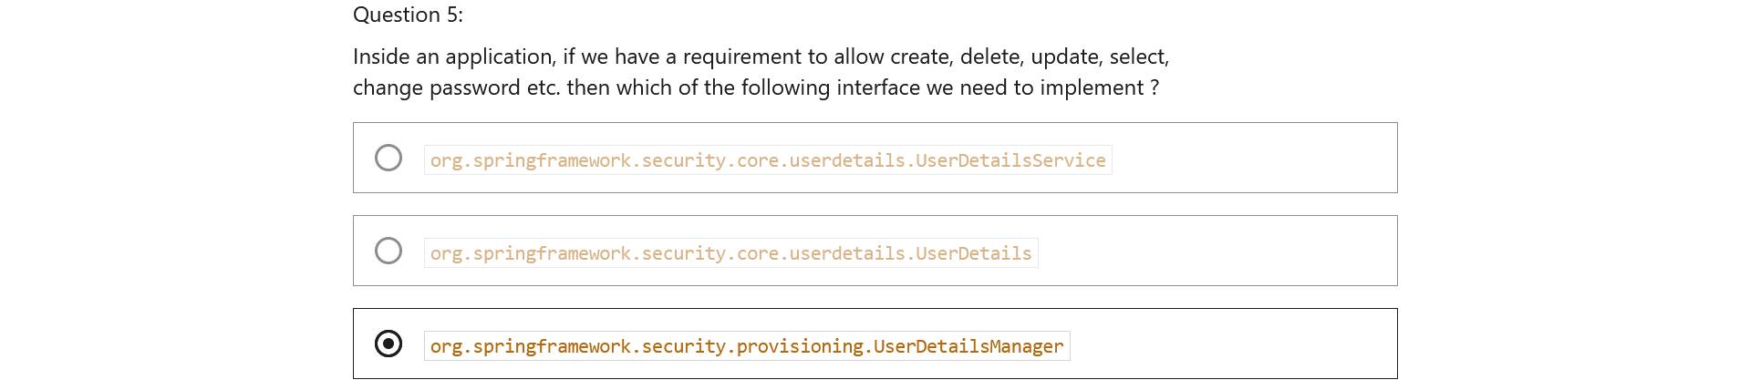
6. 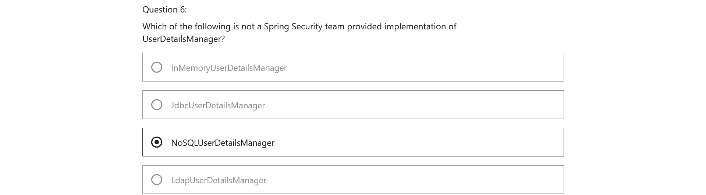

Section 5: Understanding Authentication Provider and Implementing it

1. 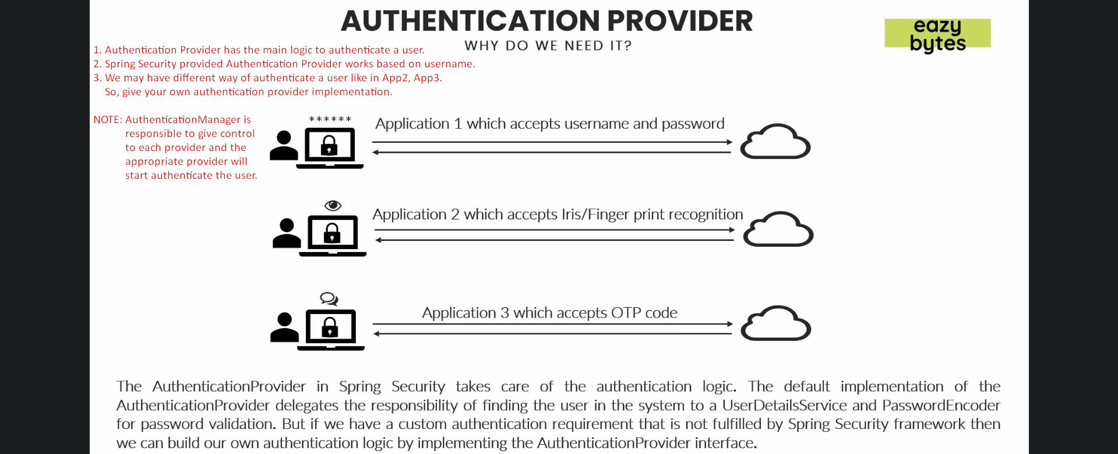
2. 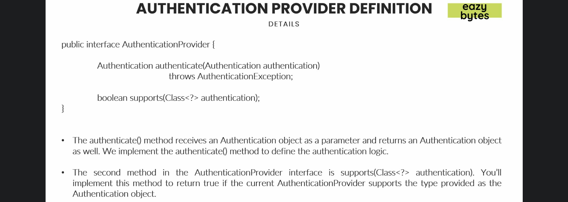
3. 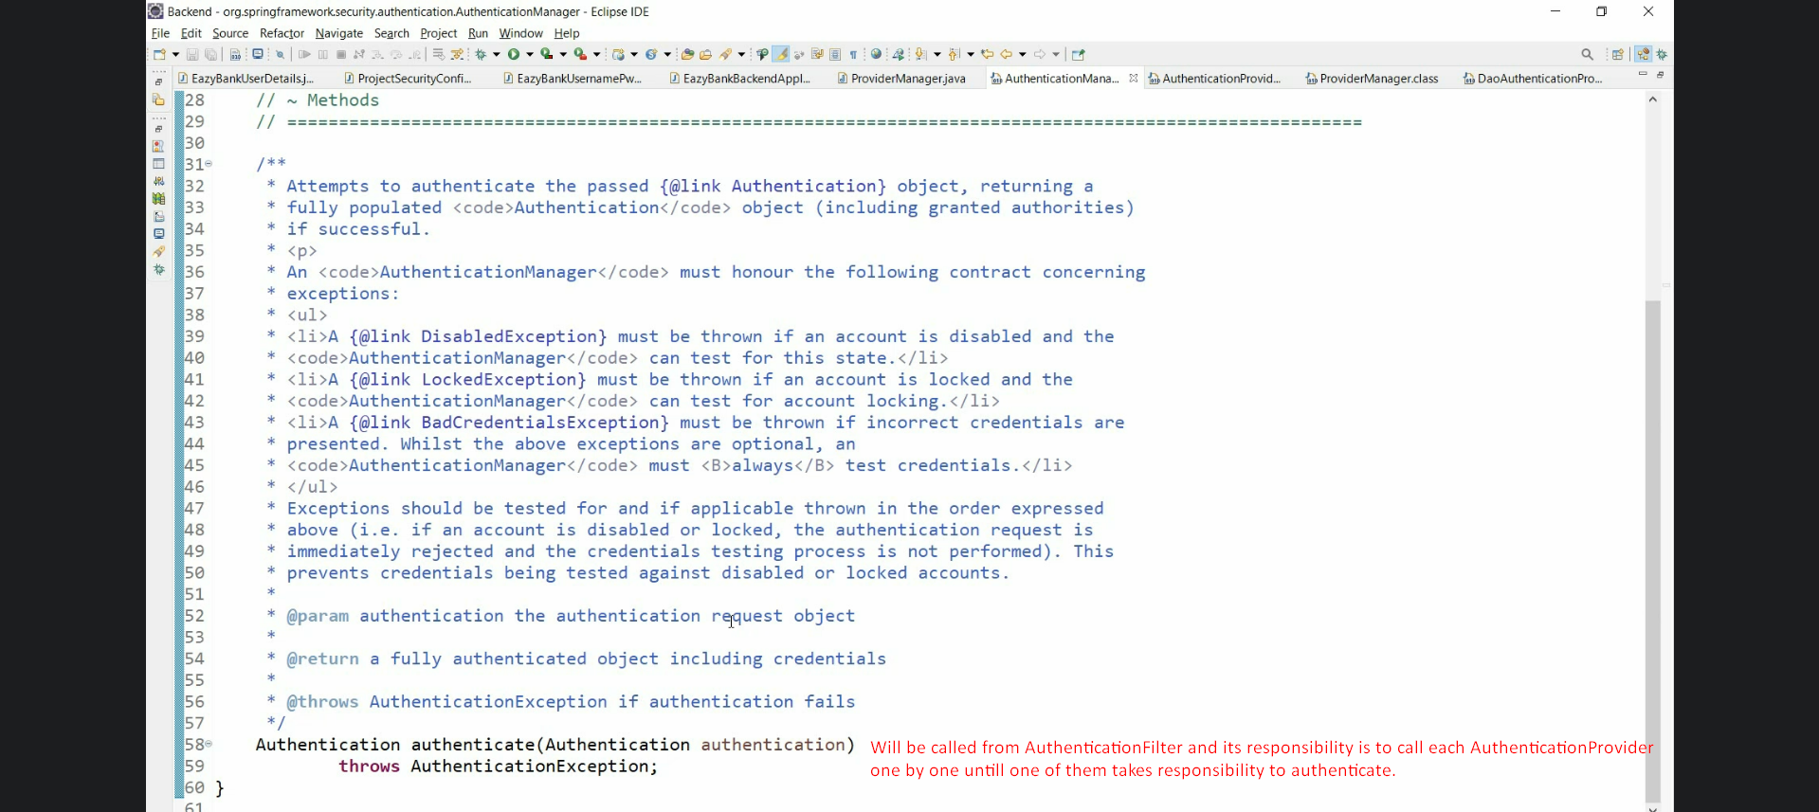
4. 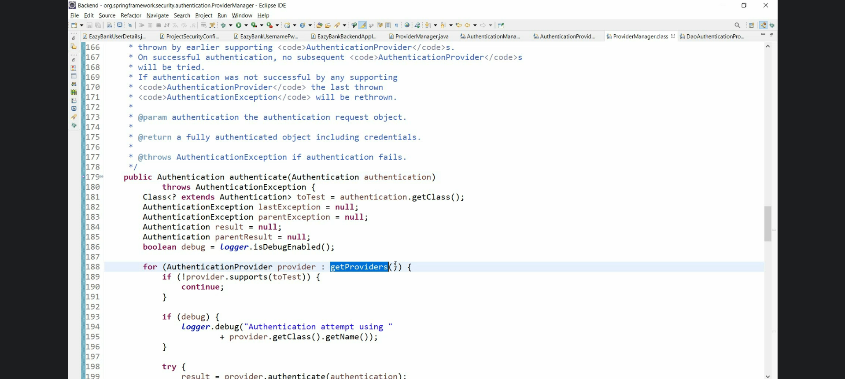
5. 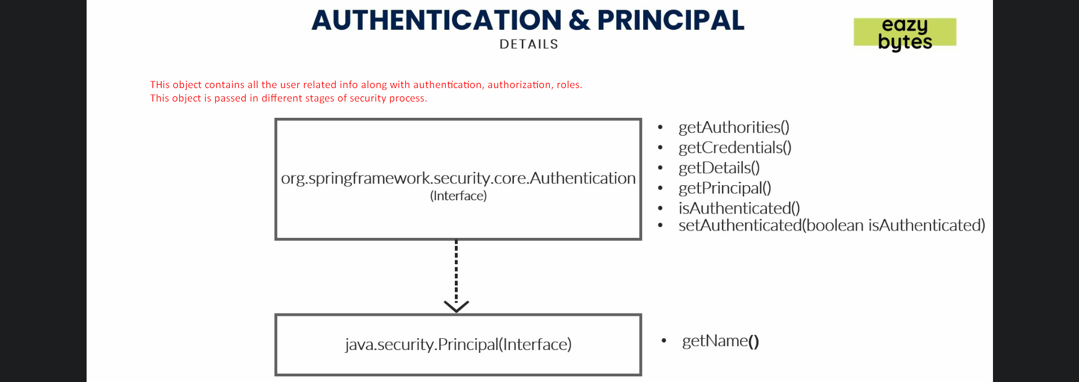
6. d
   1. Hey: Spring Security configures the following by default
      1. DaoAuthenticationProvider.java which supports UsernamePasswordAuthenticationToken based authentication.
      2. InMemoryUserDetailsManager.java: Stores users in memory and DaoAuthenticationProvider.java uses InMemoryUserDetailsManager.java
   2. We can override the above as per our requirements.
      1. we can override InMemoryUserDetailsManager with our own UserDetailsService/UserDetailsManager: Stores users in DB. But still Authentication would be UsernamePasswordAuthenticationToken based.
      2. If you want a different authentication such as face/finger/OTP, then provide your own AuthenticationProvider
7. **NOTE**: Auto configuration will be ignored for the following cases when configuration is auto not by WebSecurityConfigurerAdapter.configurer(AuthenticationManagerBuilder)  
   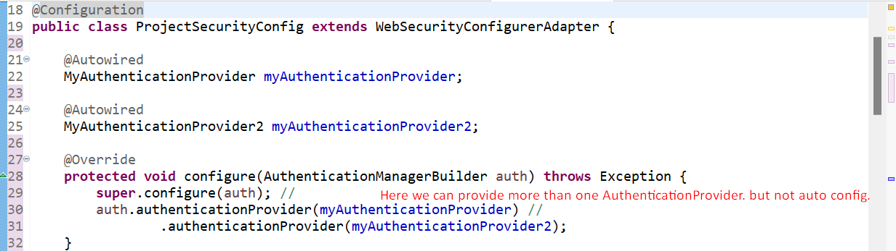
   1. If more than one custom UserDetailsService/UserDetailsManager, configuration will be ignored.
   2. If more than one custom AuthenticationProvider, configuration will be configured.
8. 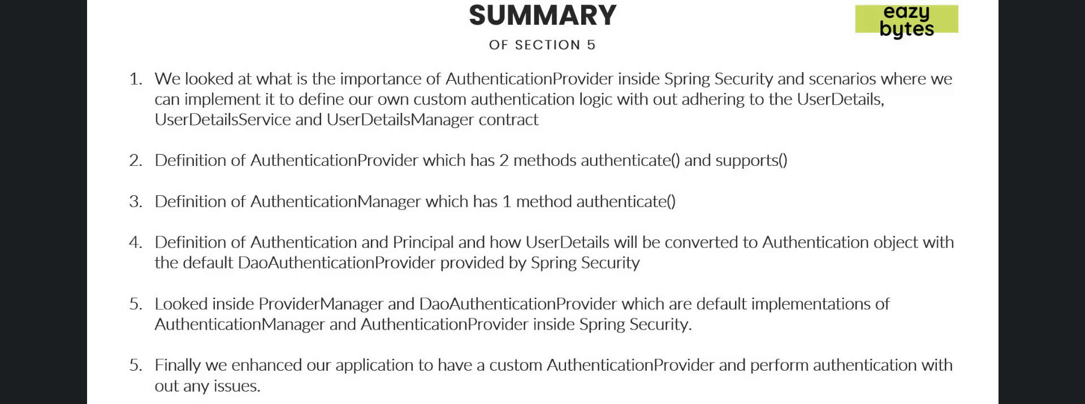
9. 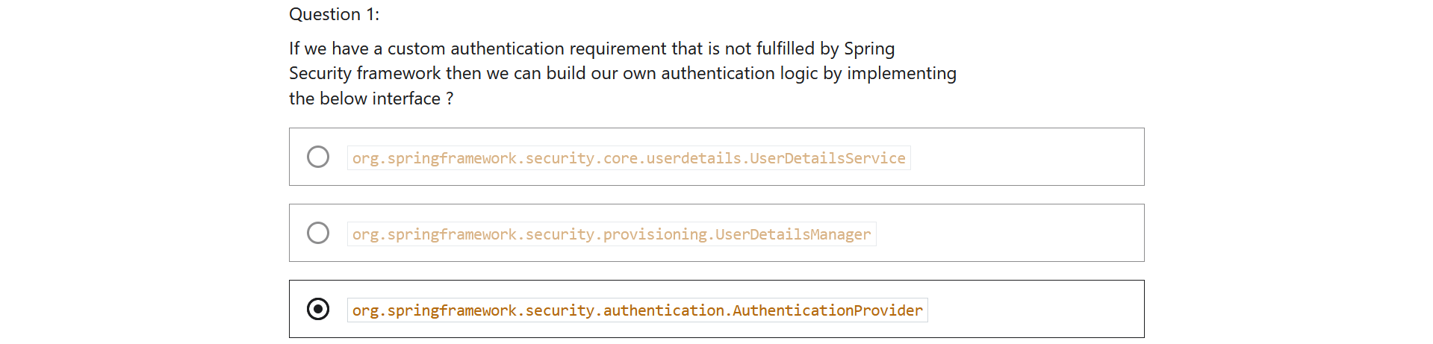
10. 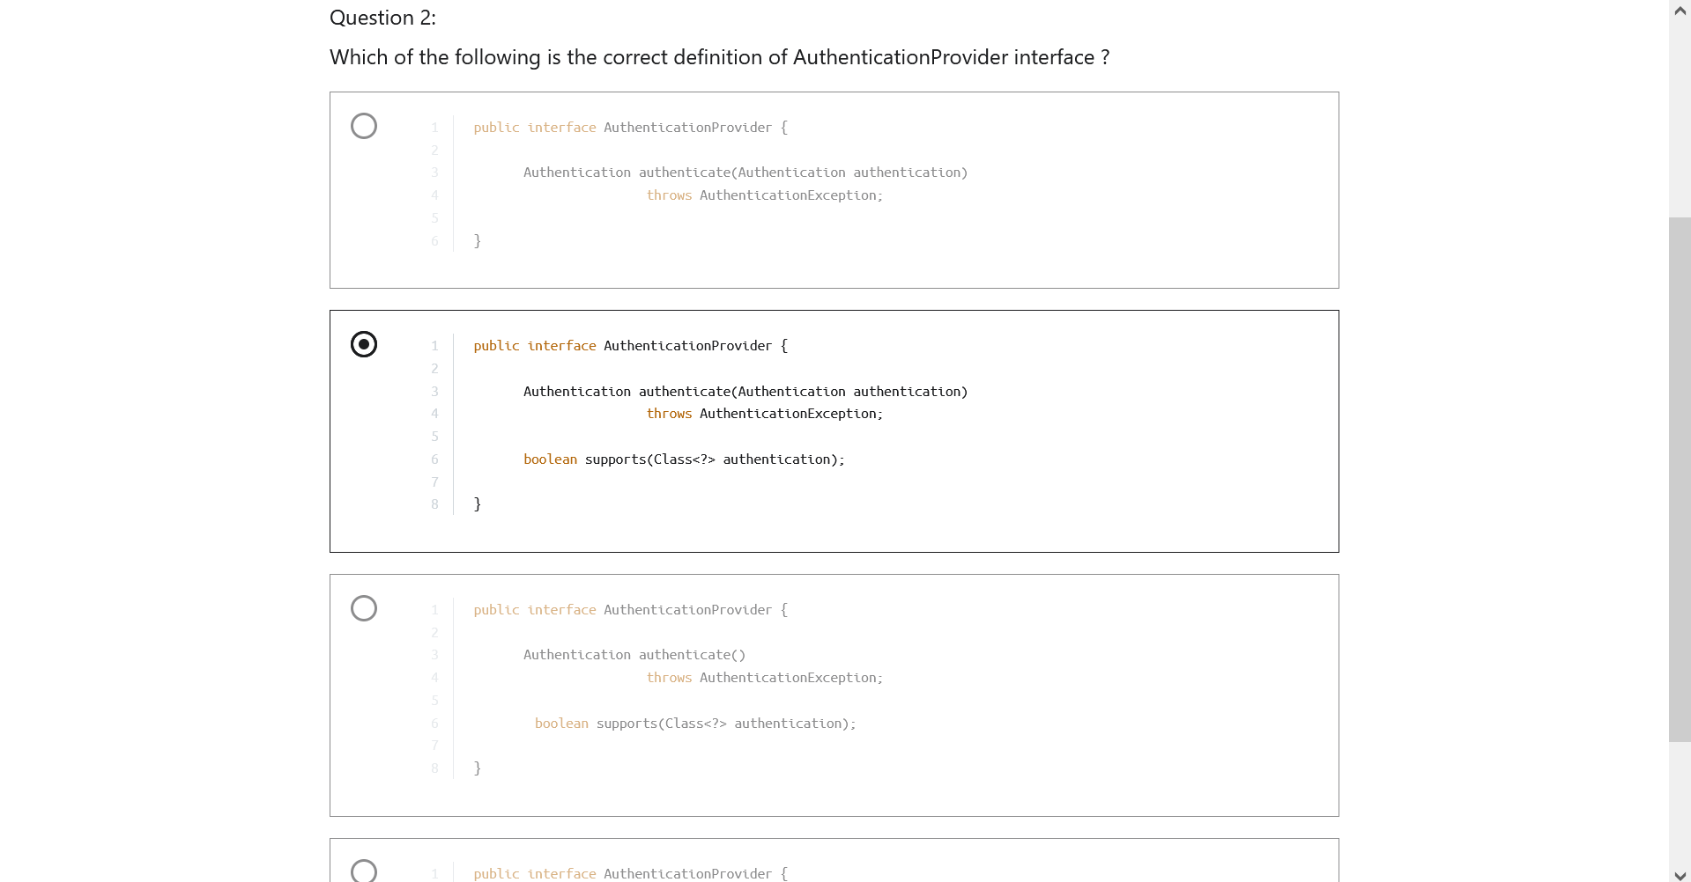
11. 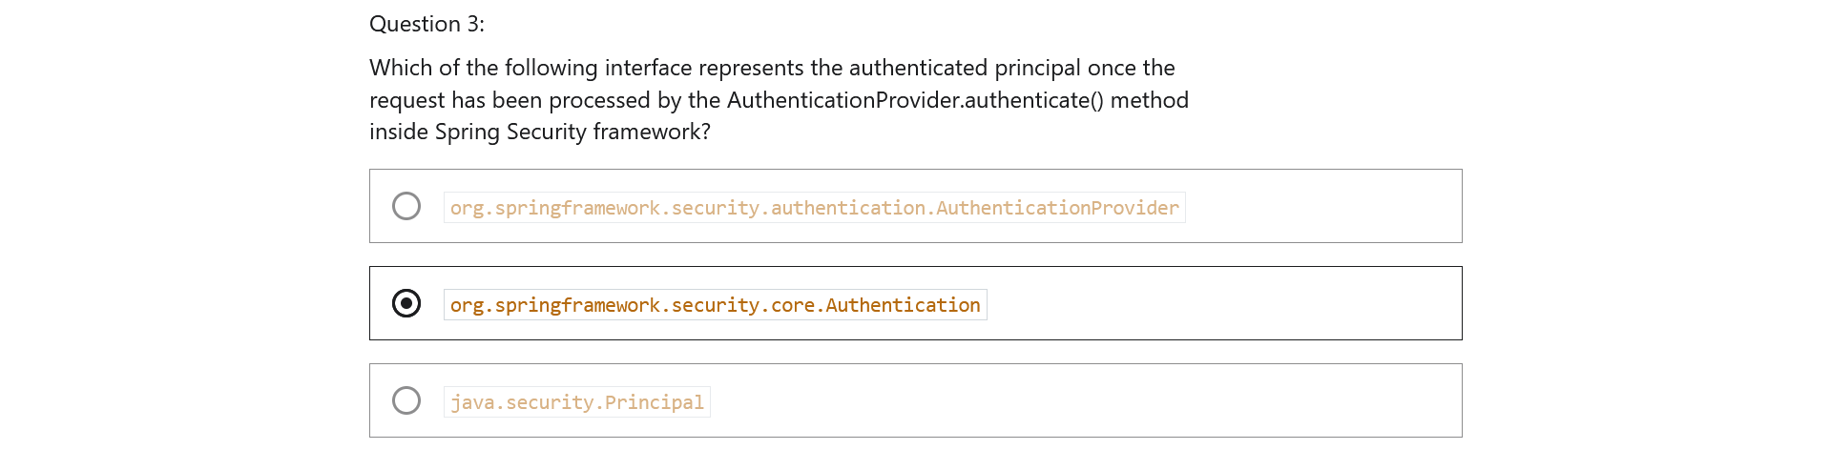
12. 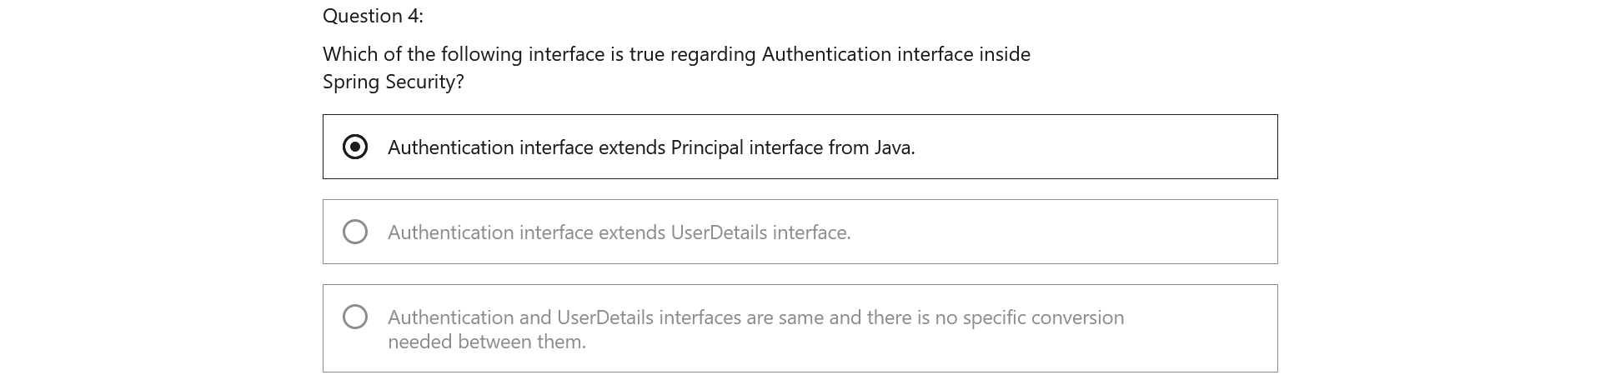

Section 6: Understanding CORs & CSRF

1. 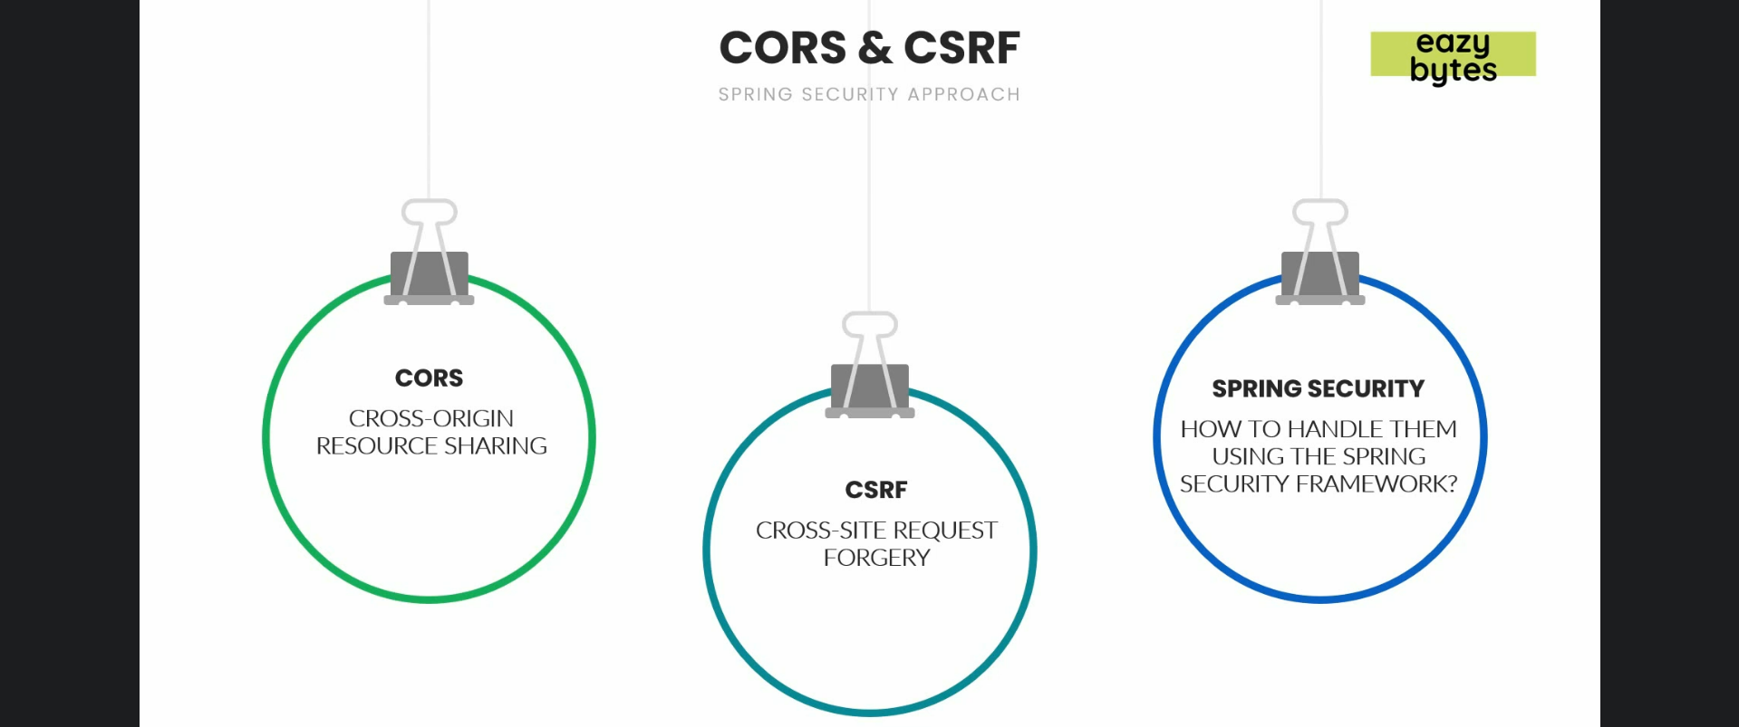
2. 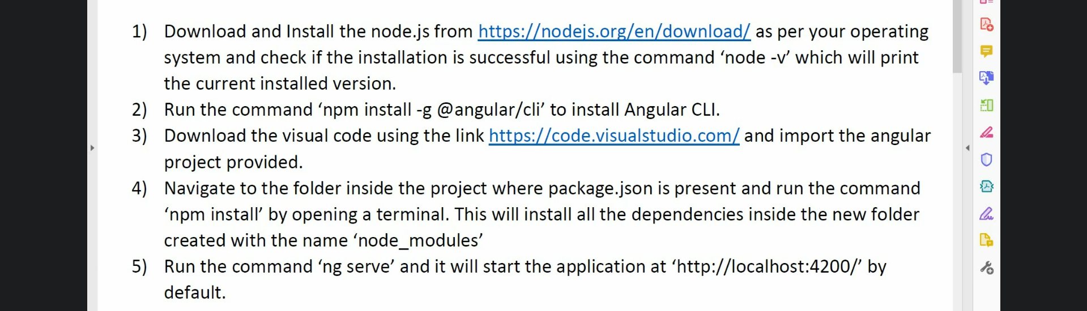
3. 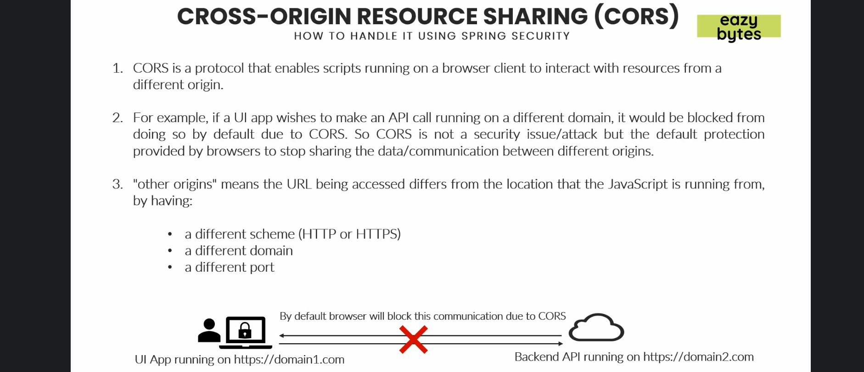
4. 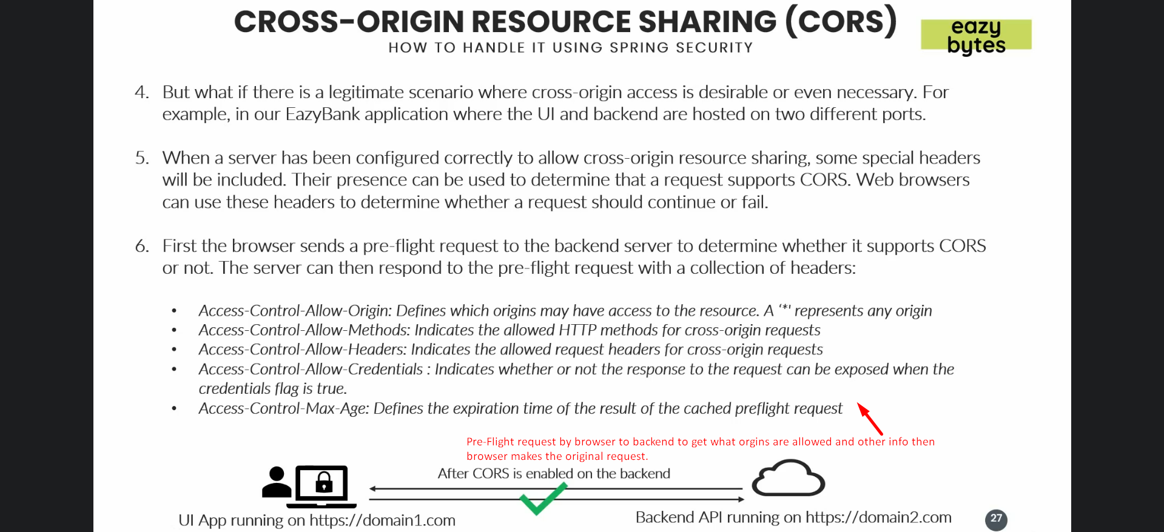
5. 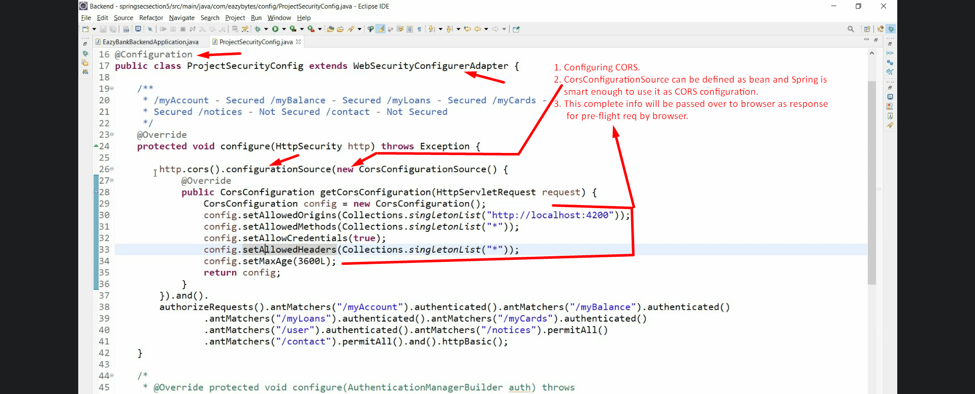
6. 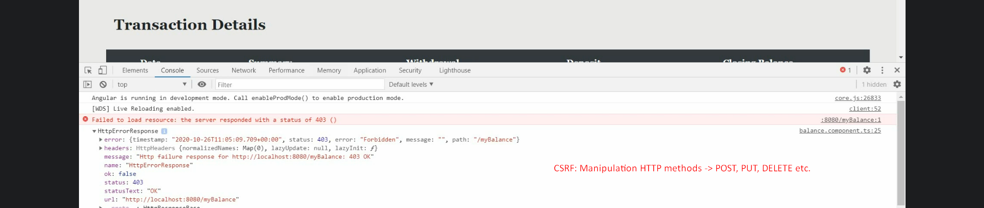
7. 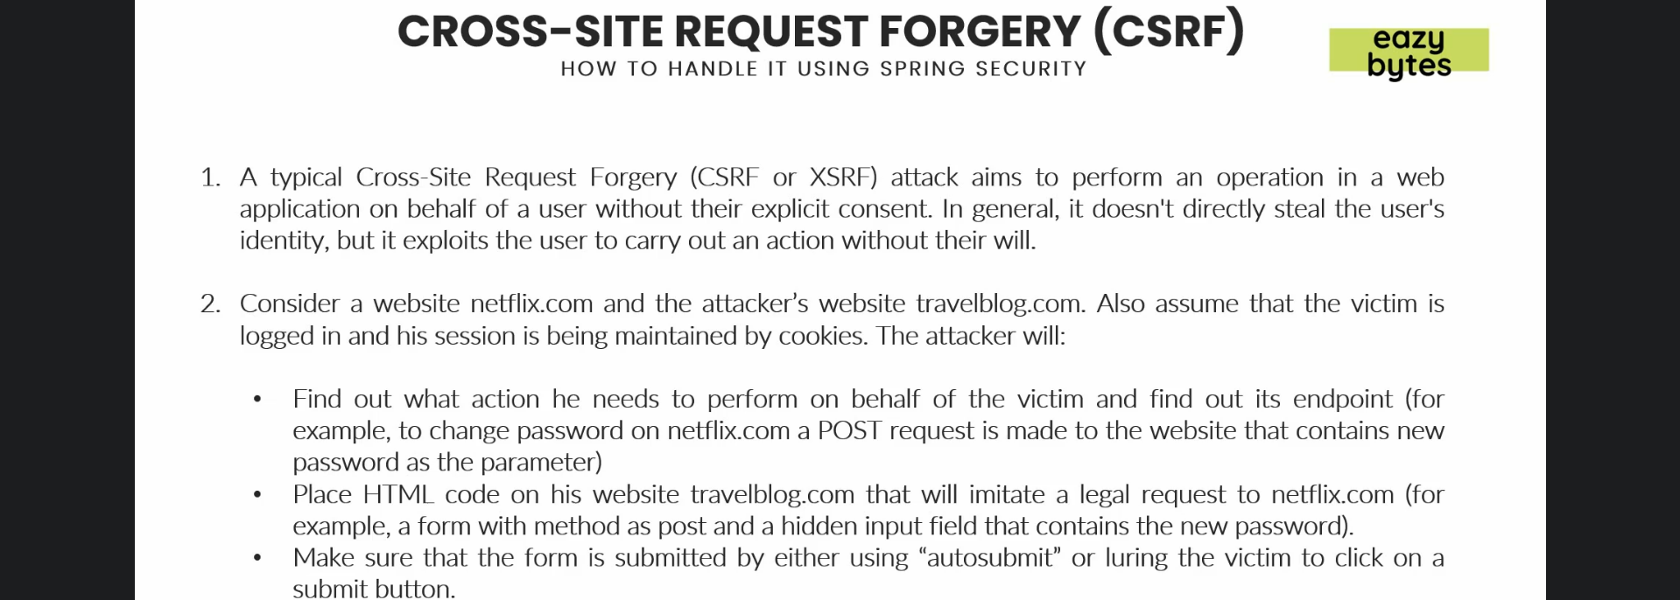
8. 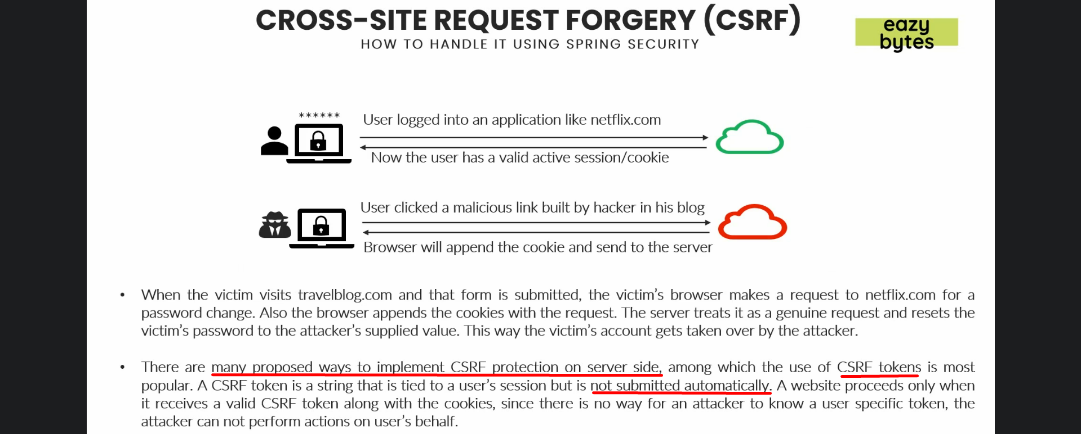
9. 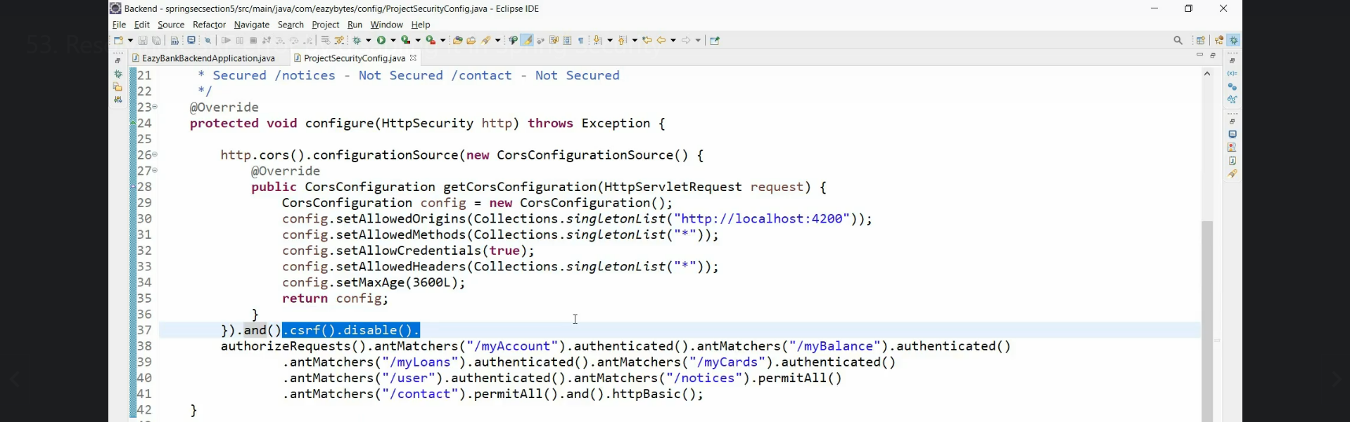
10. 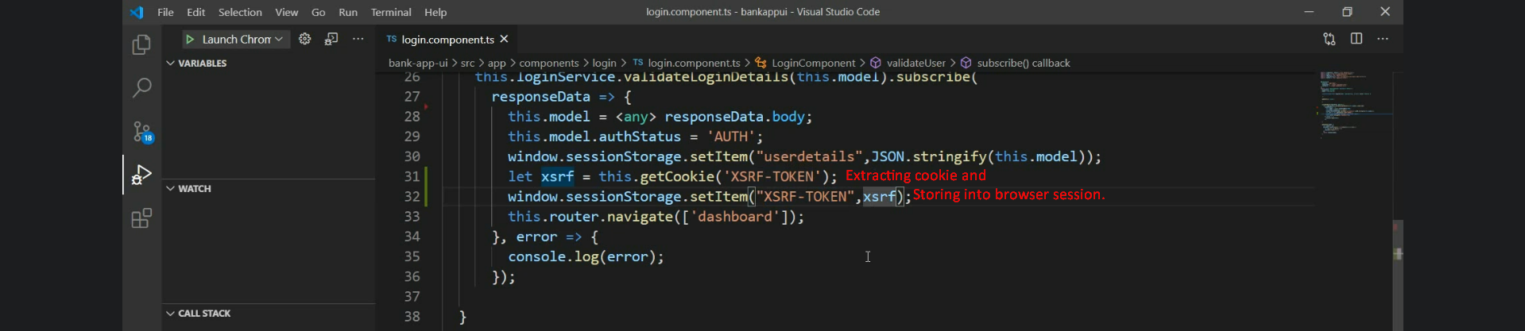
11. 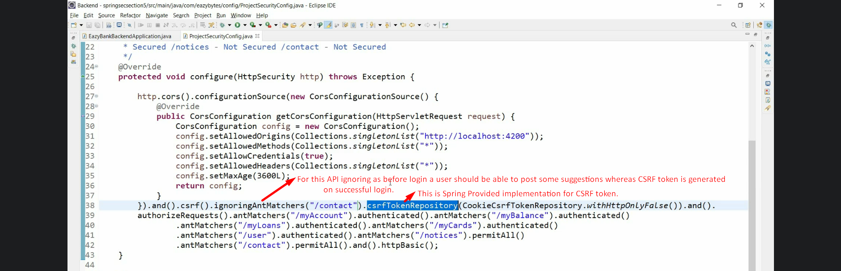 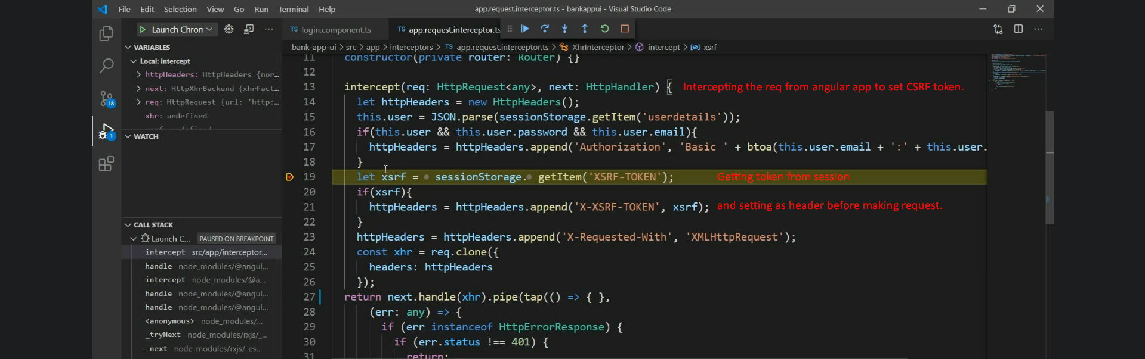
12. 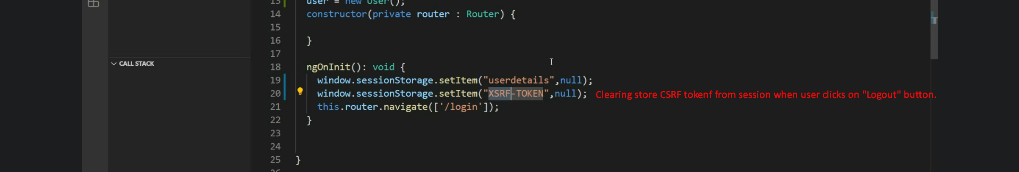
13. 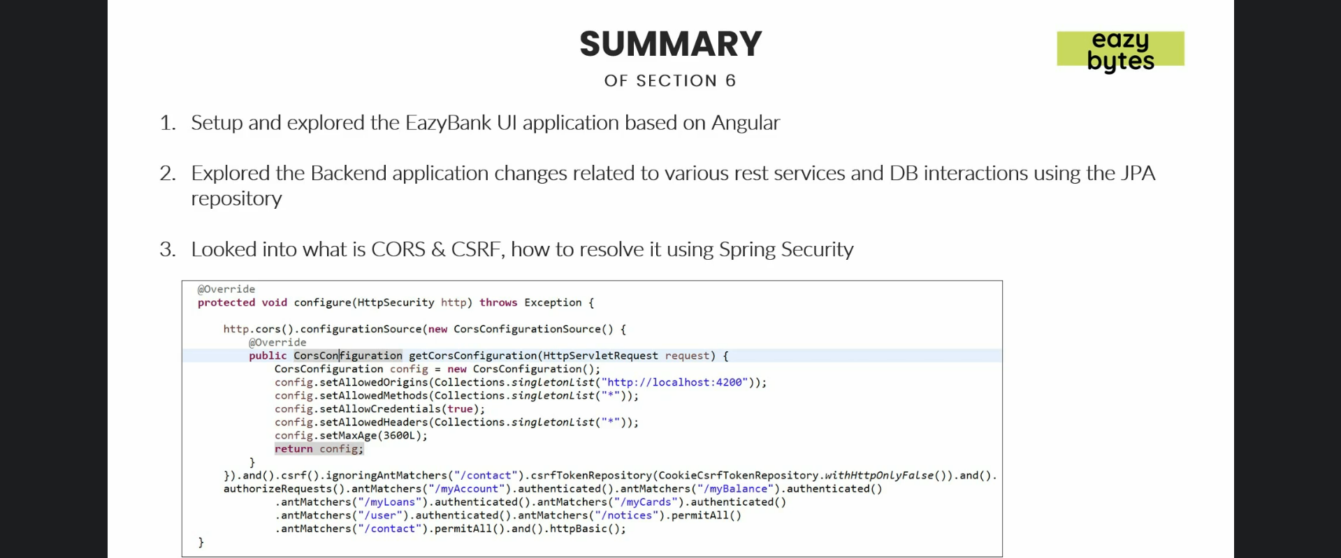
14. 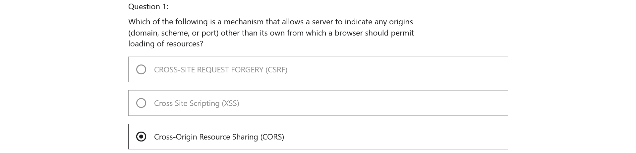
15. 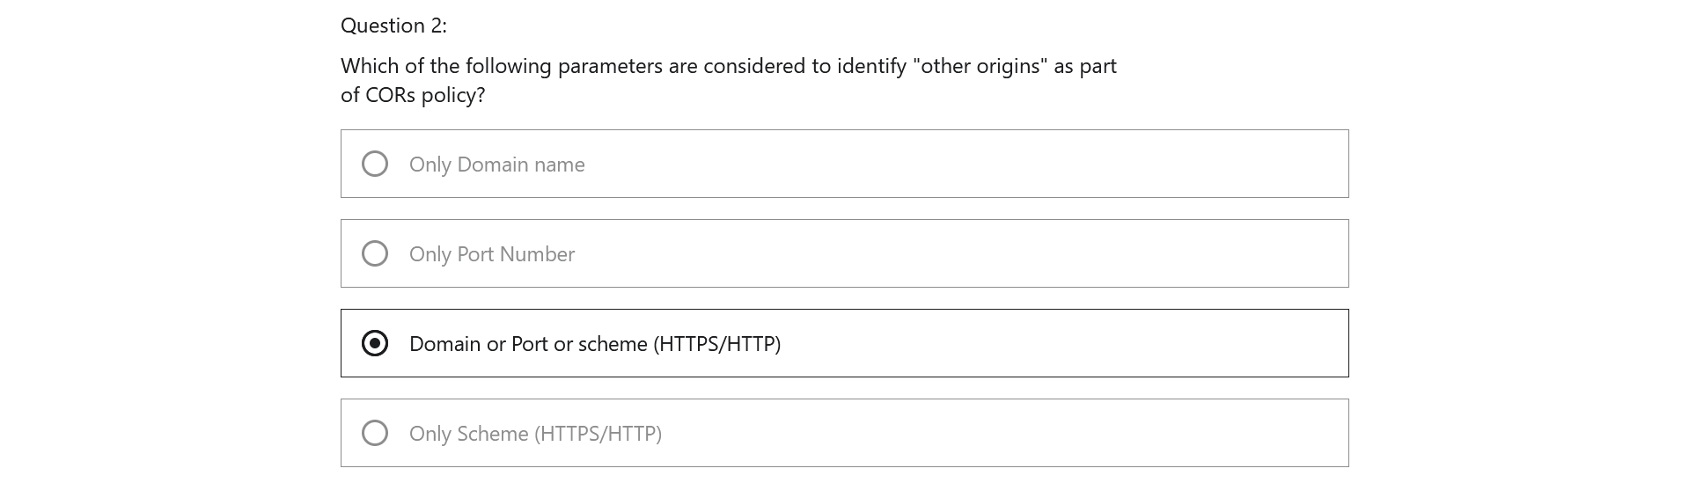
16. 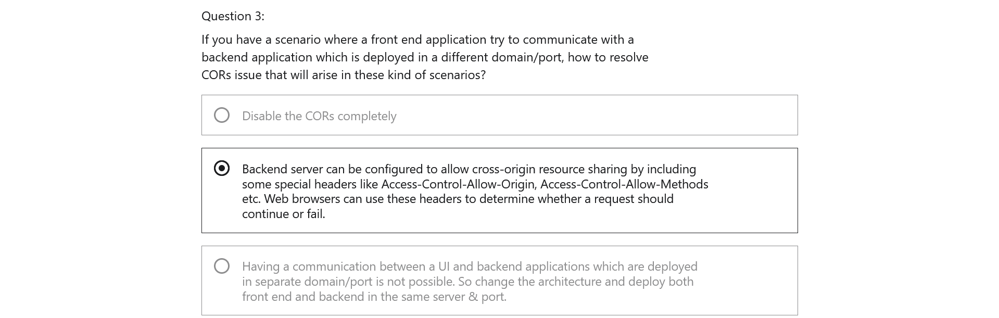
17. 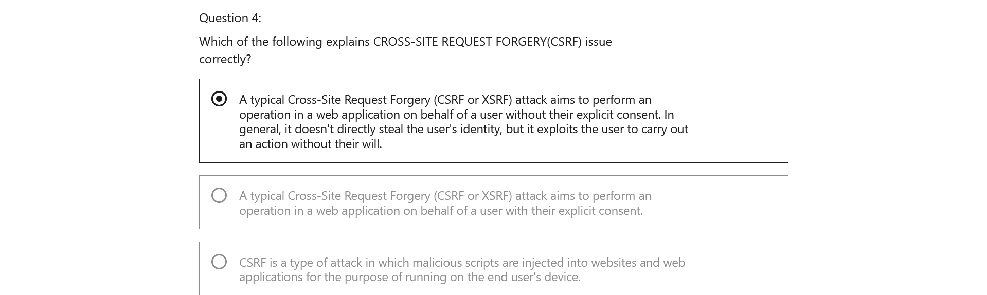
18. 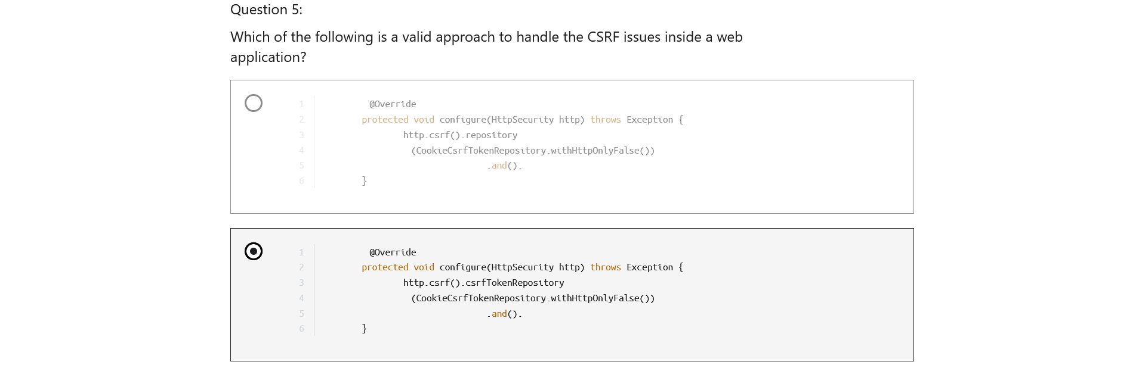
19. 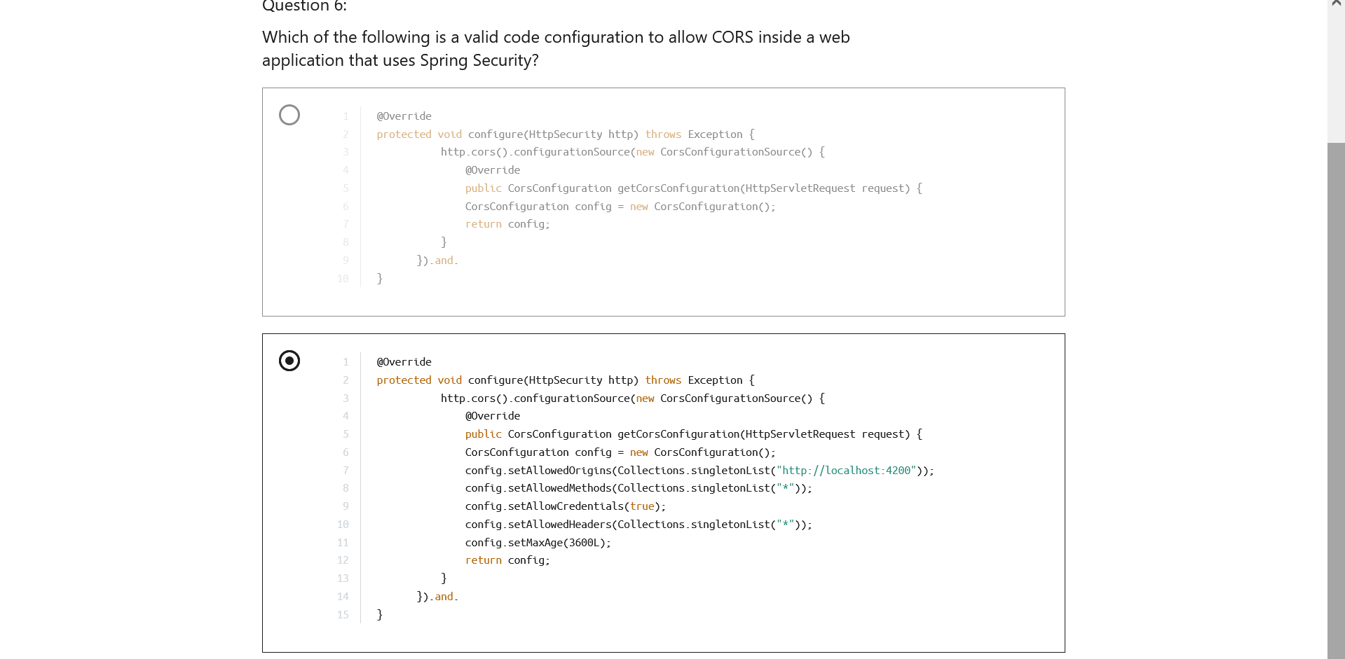

Section 7: Understanding & Implementing Authorization

1. NOTE: Later on, we will study authorization based on authority or role.  
   Role is simply a set of authorities.
2. 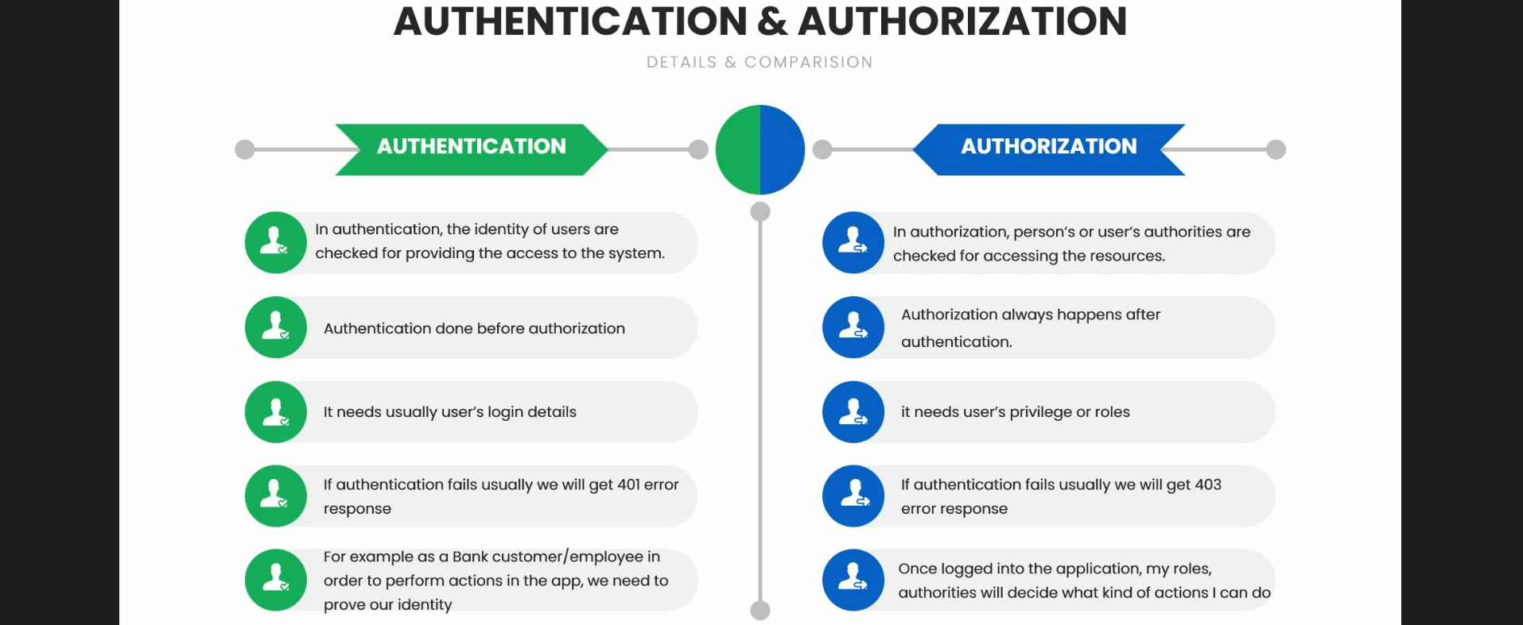
3. 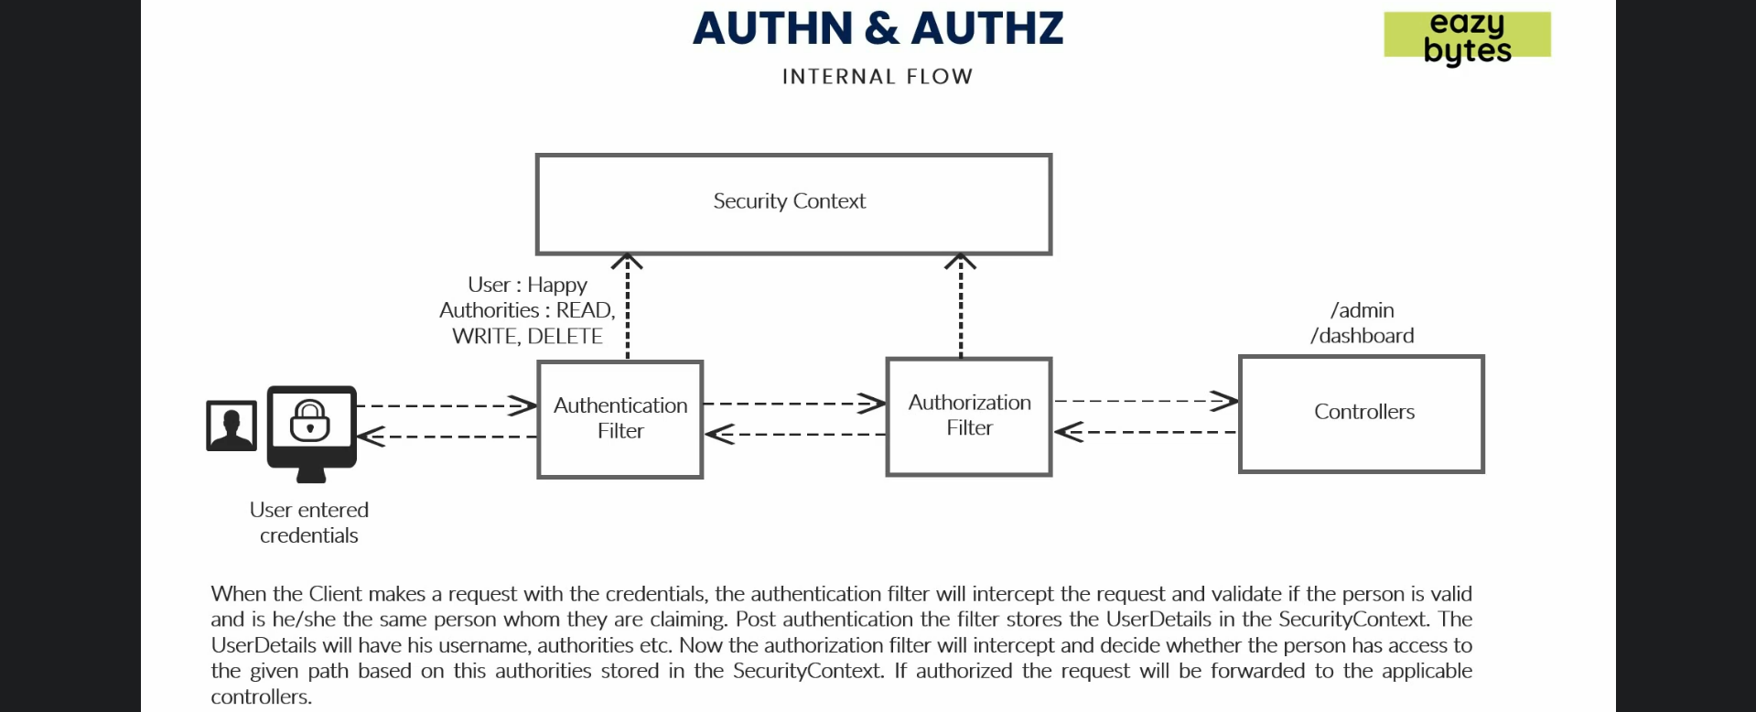
4. Authorities=Privileges=roles
5. 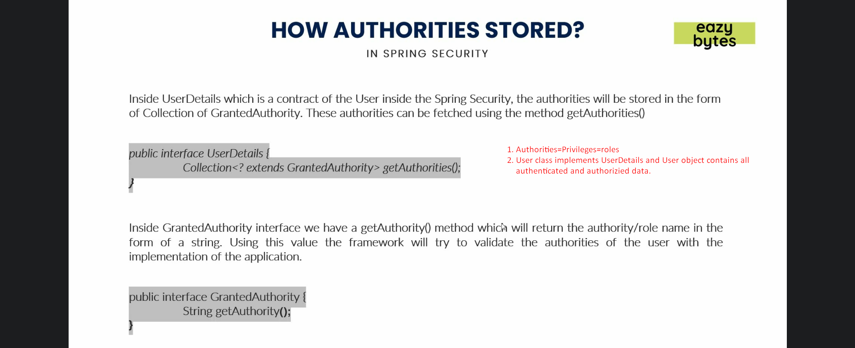
6. 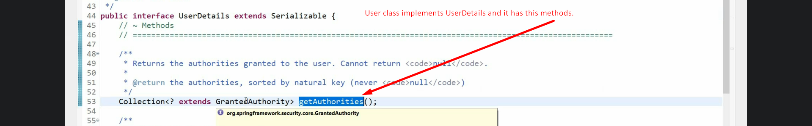  
   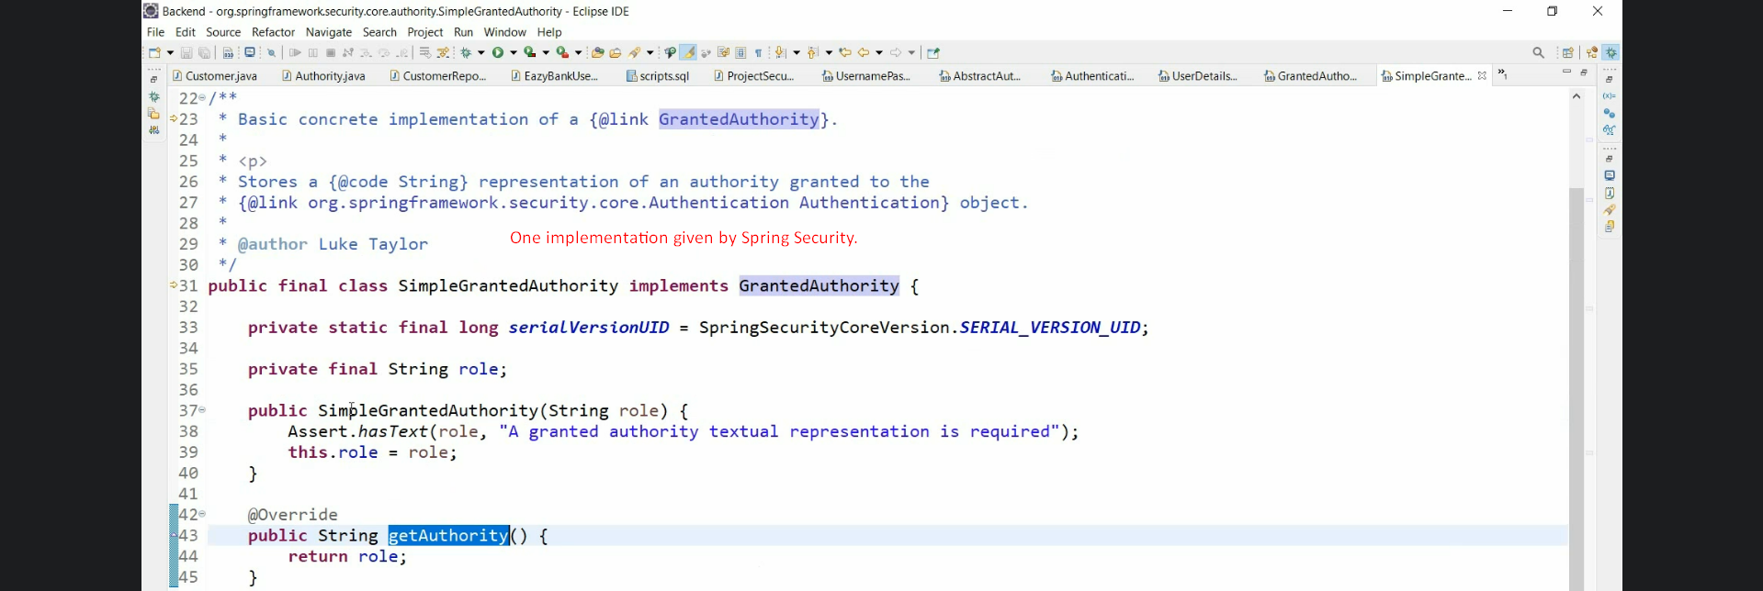
7. UserDetails and Authentication both are user schema for user representation.  
   UserDetails is used by AuthenticationProvider whereas Authentication by SecurityFilter.
8. 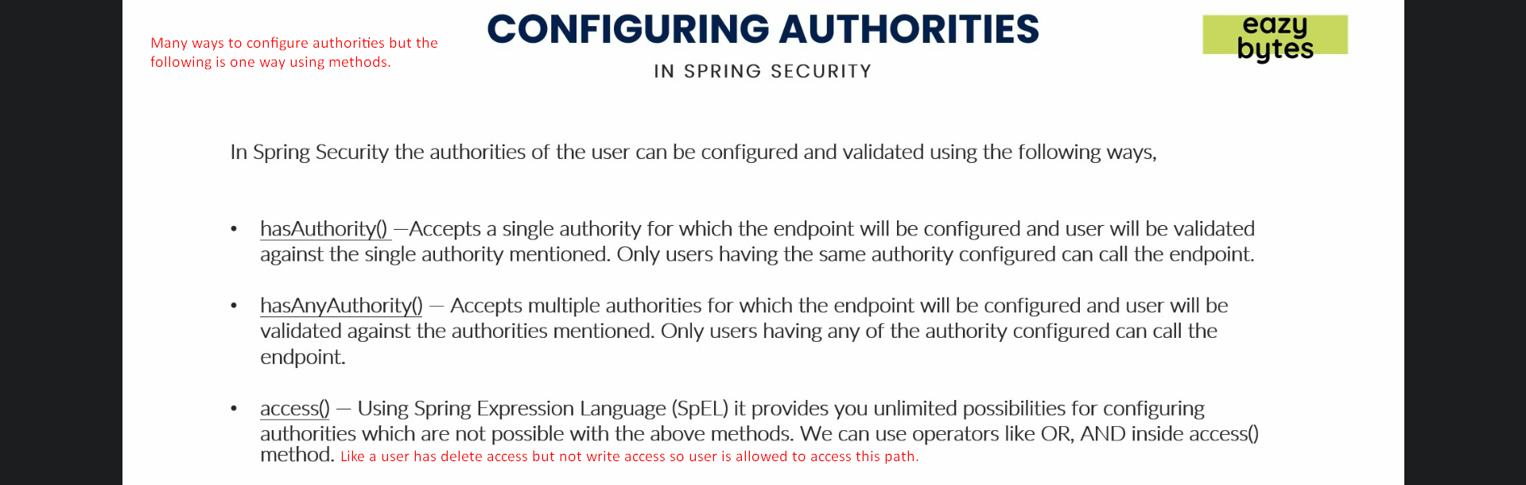
9. 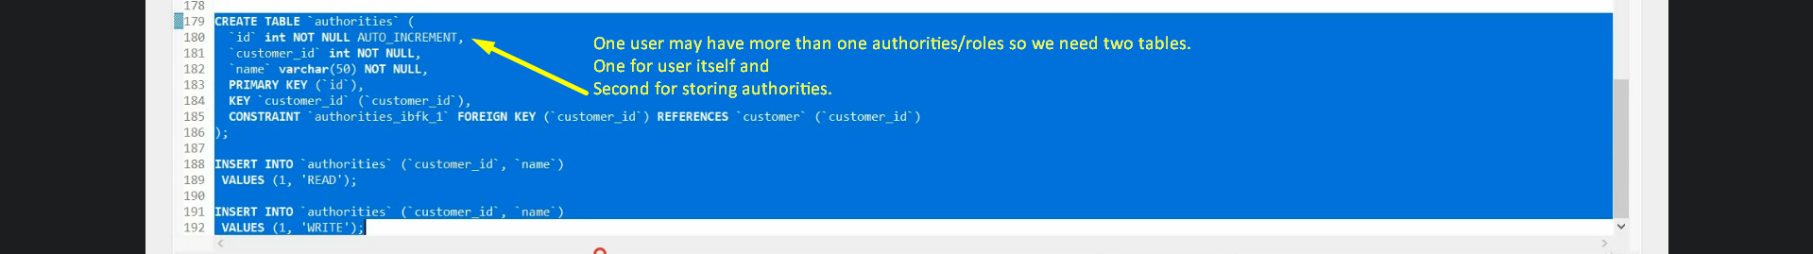
10. 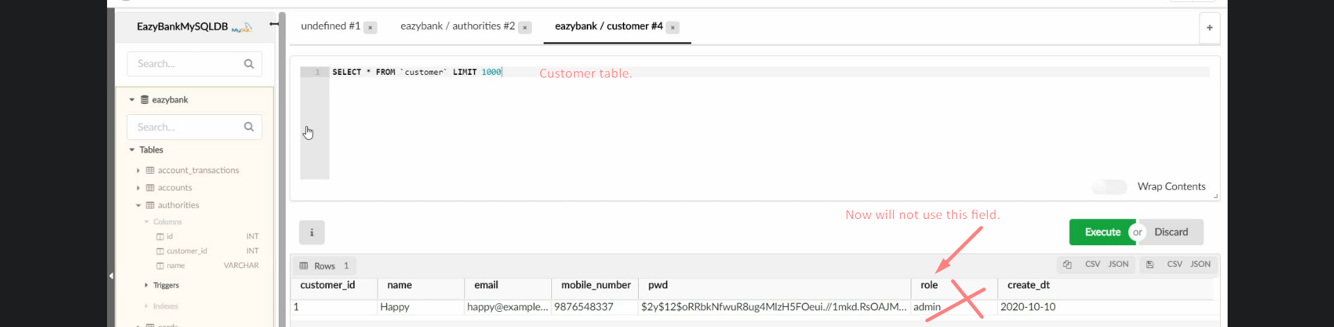 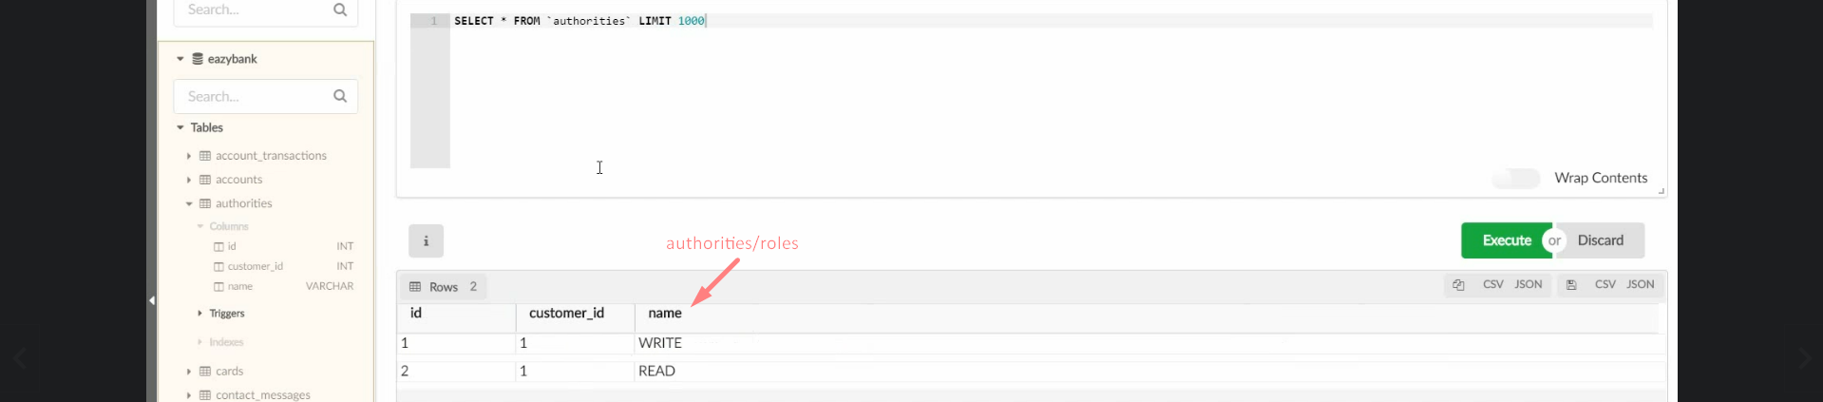
11. 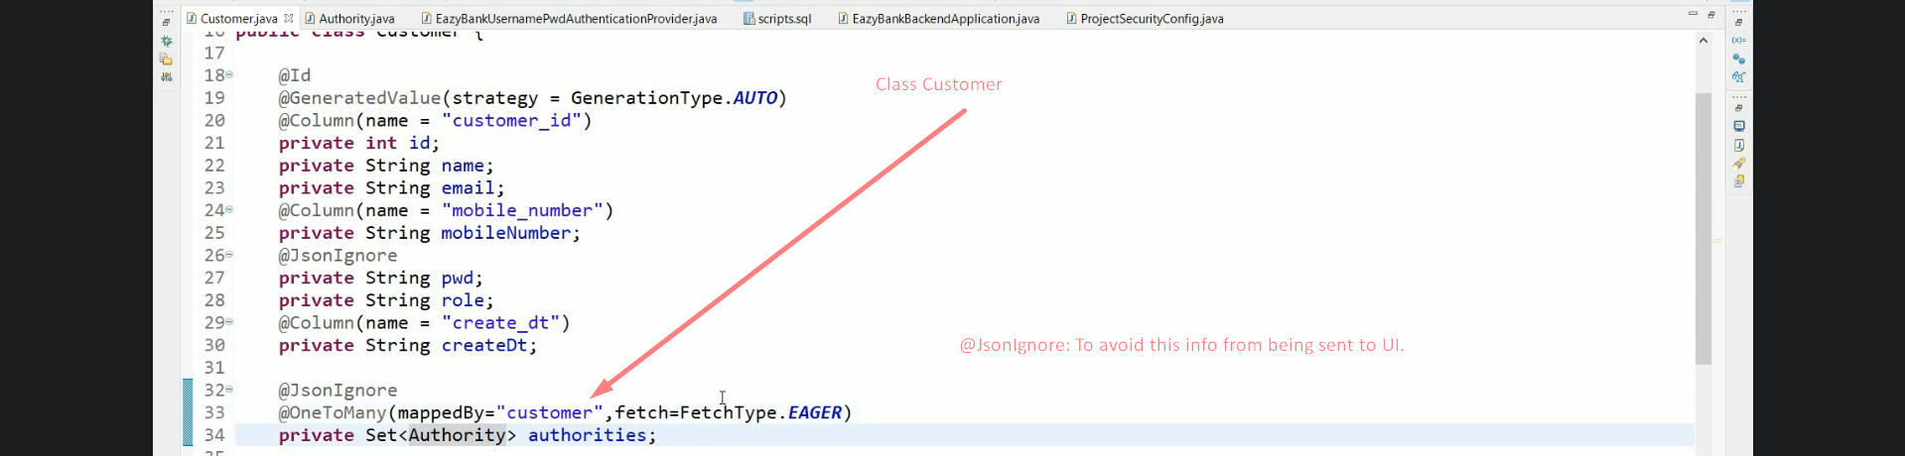
12. 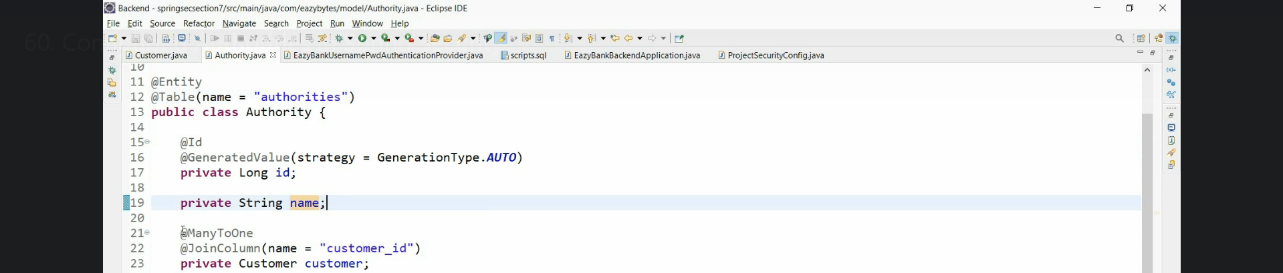
13. 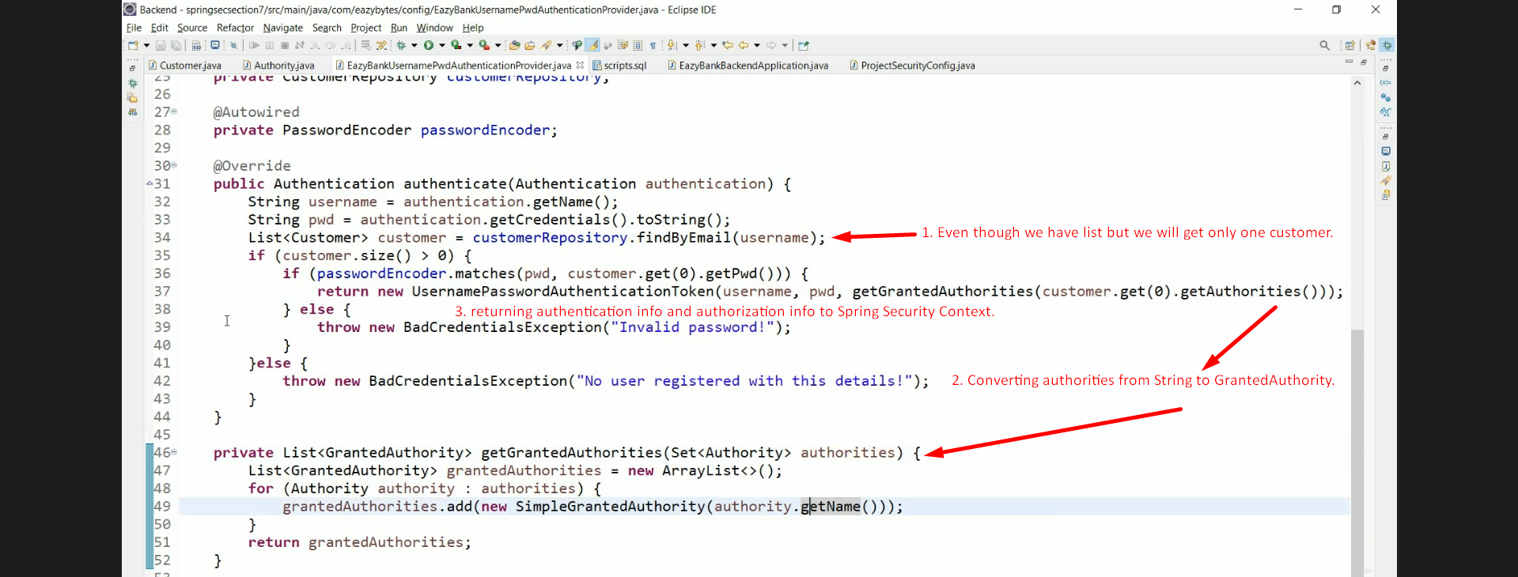
14. 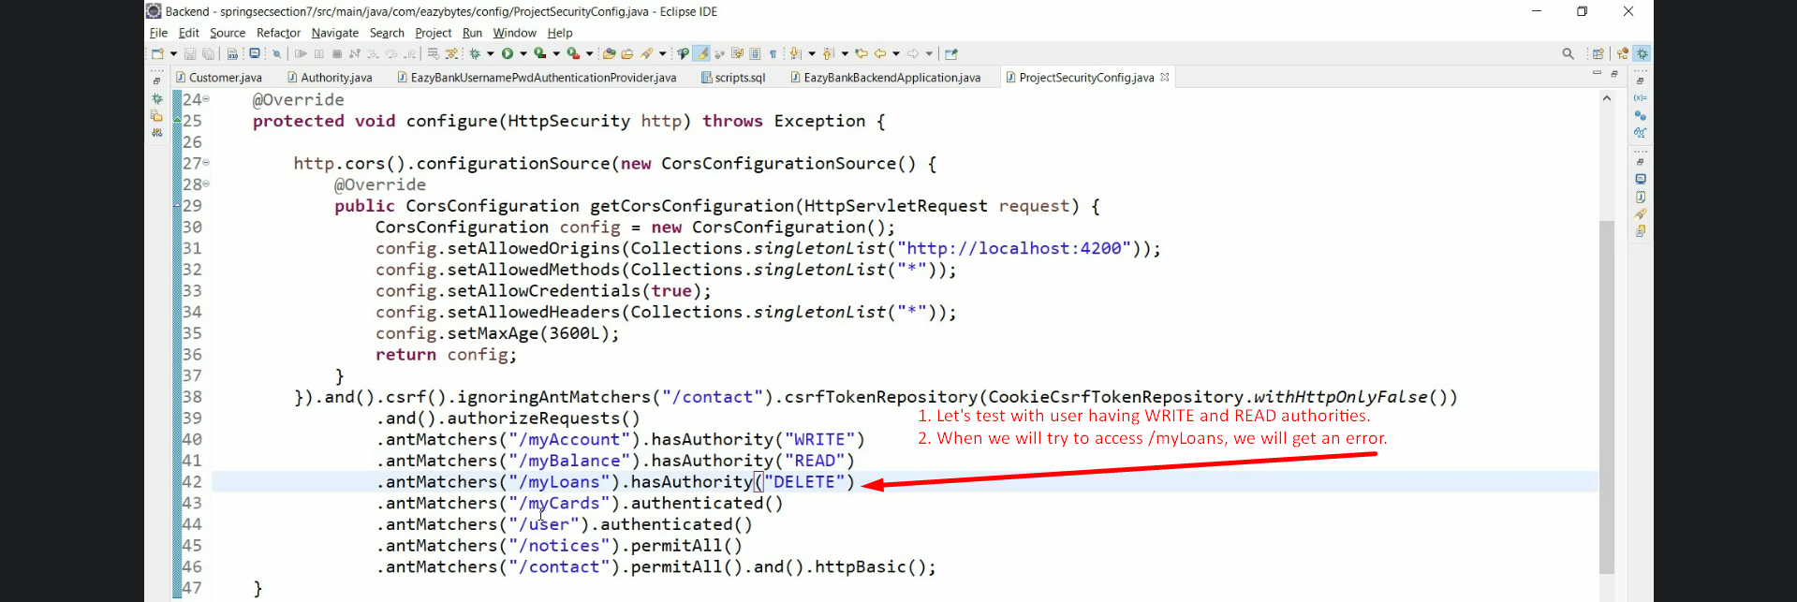
15. 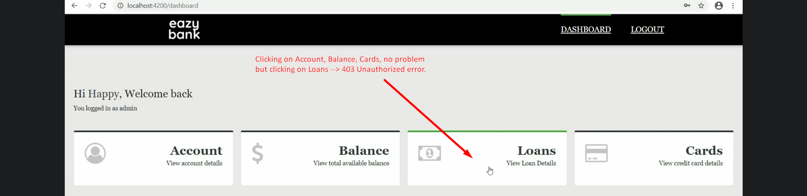 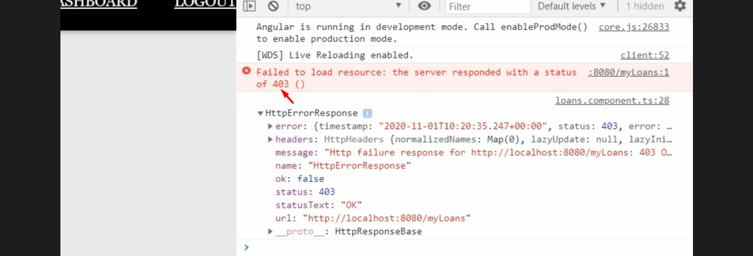 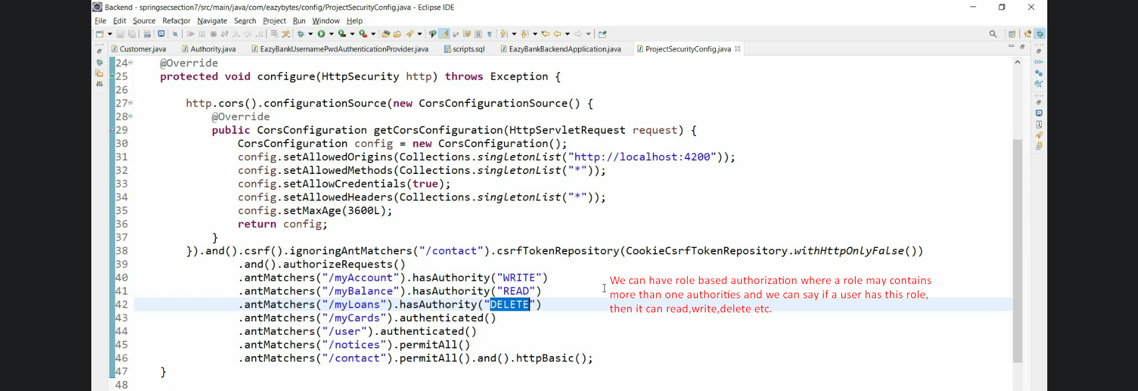
16. 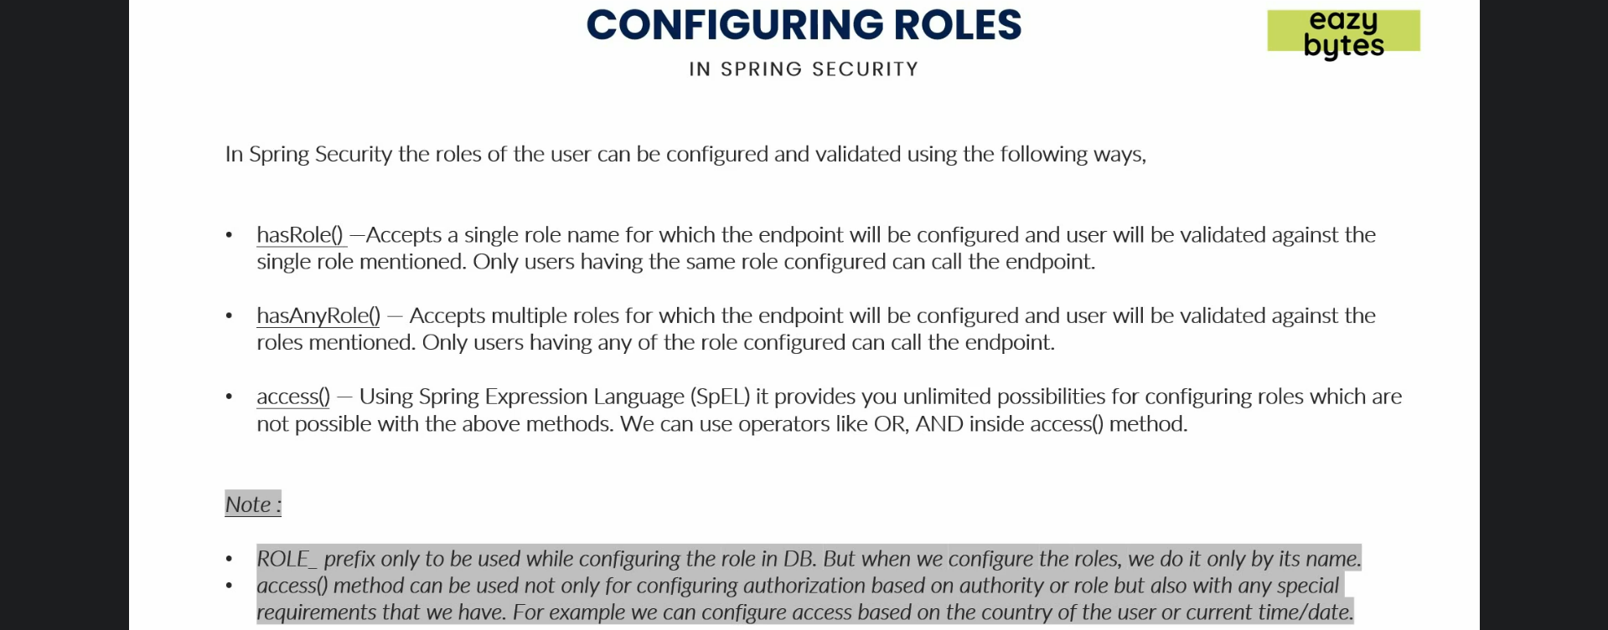
17. 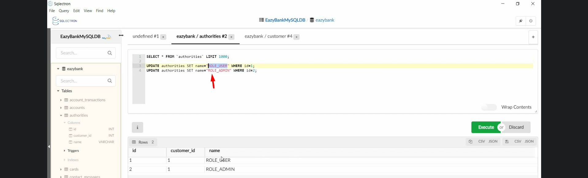
18. 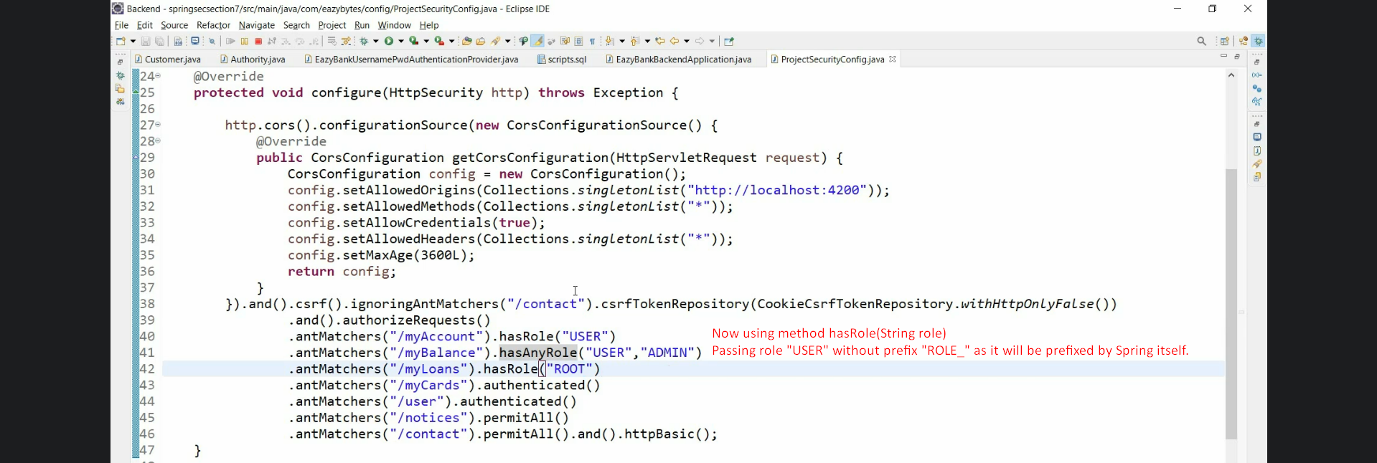
19. 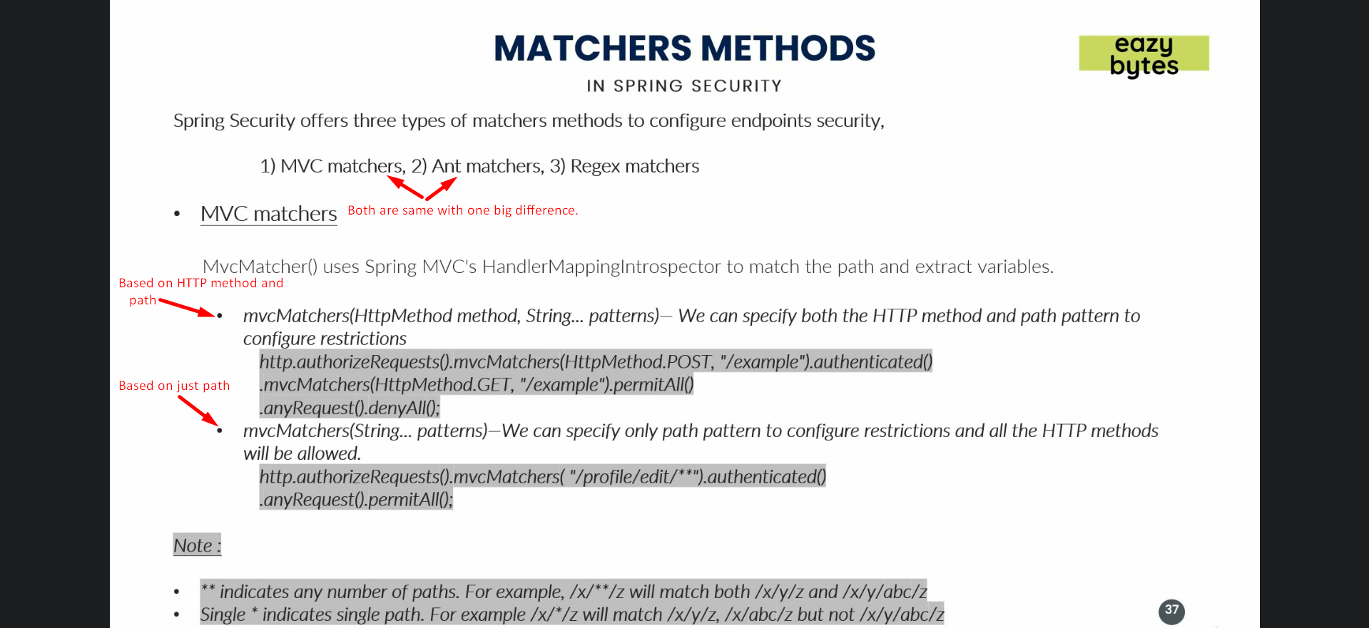
20. 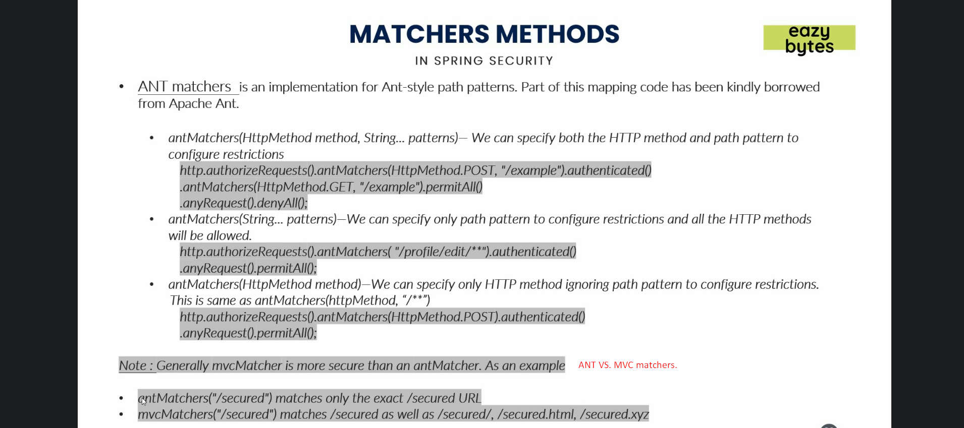
21. 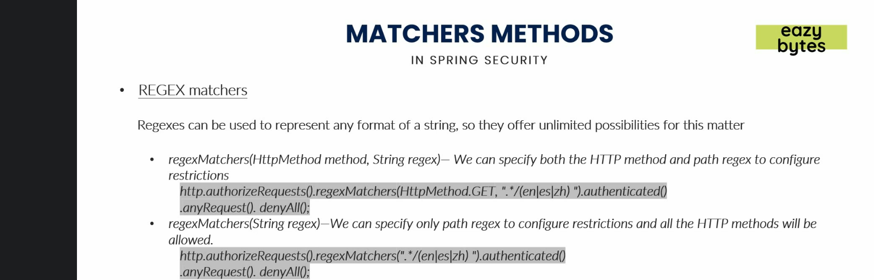
22. 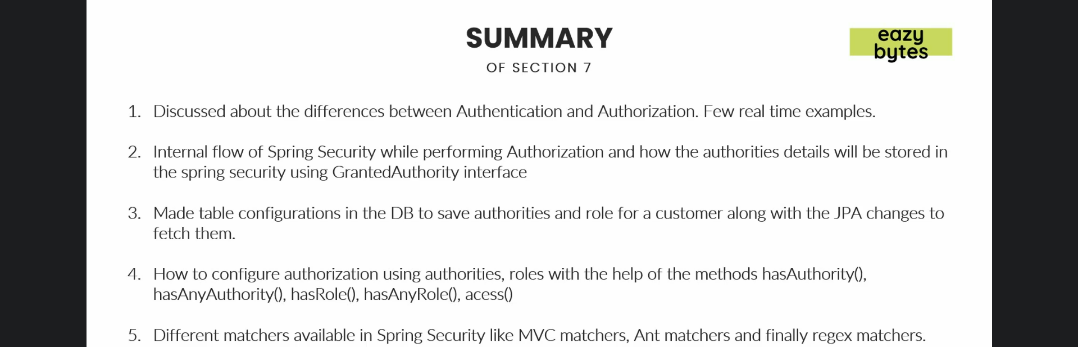
23. 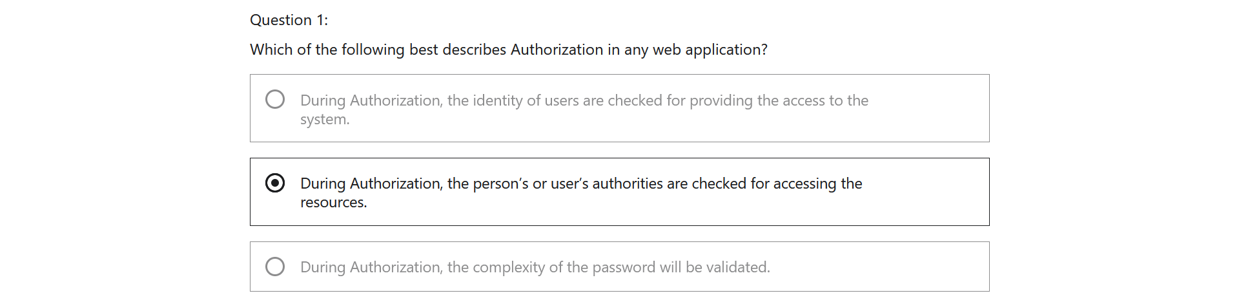
24. 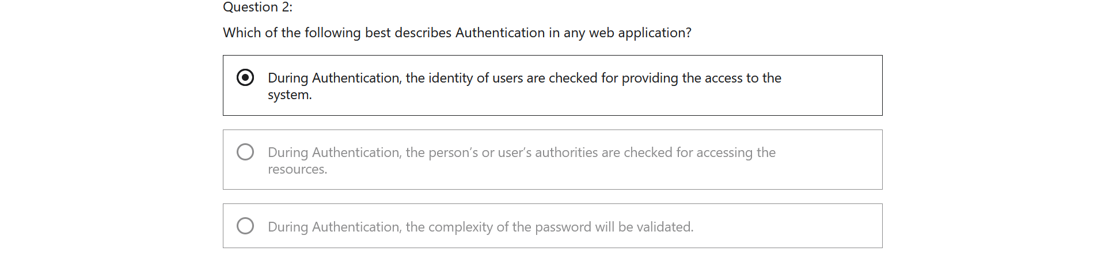
25. 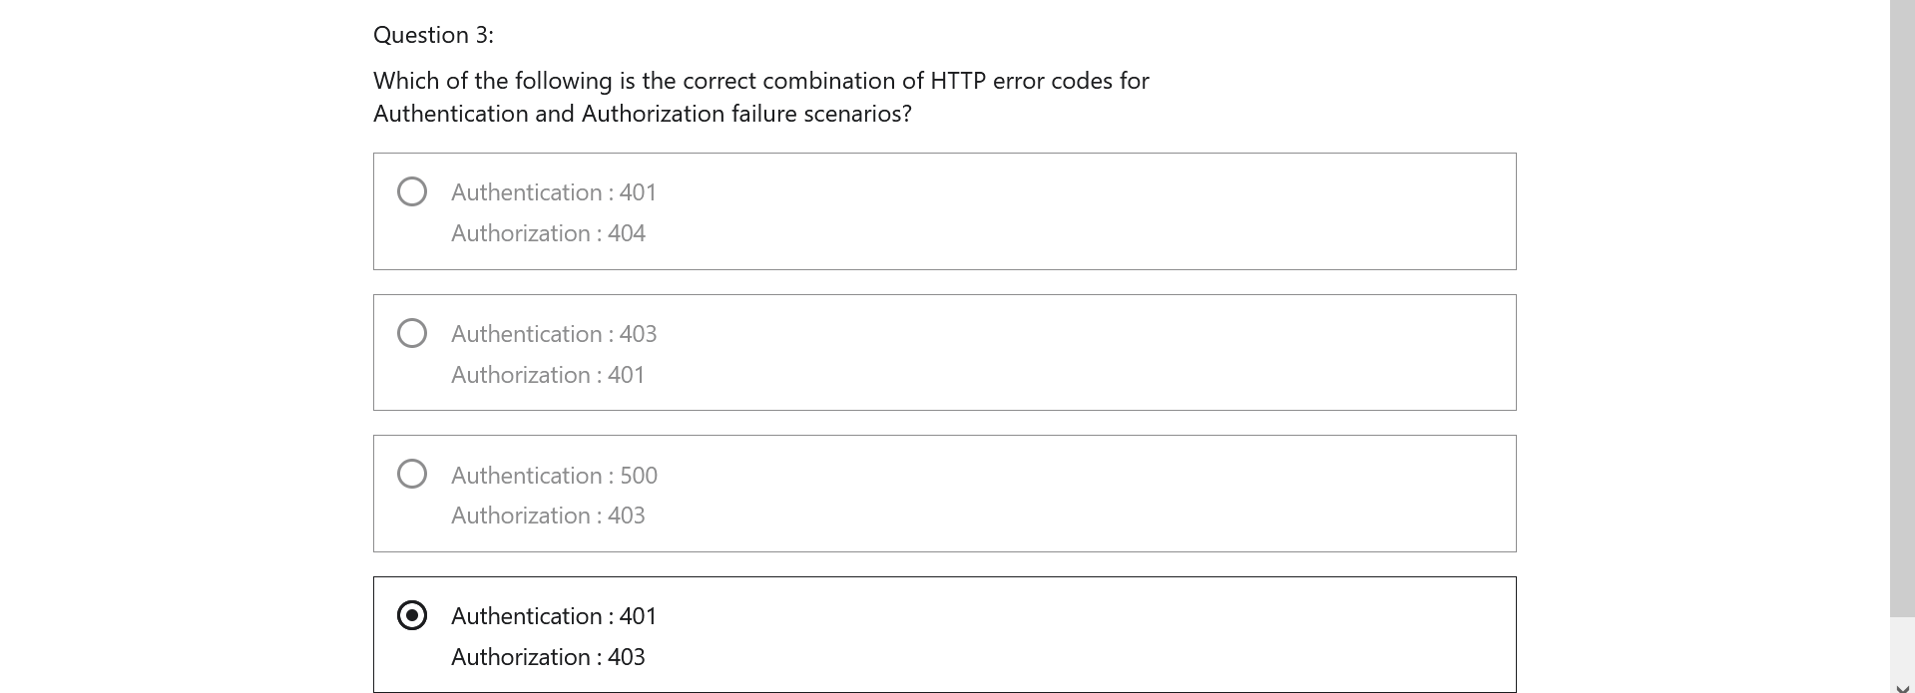 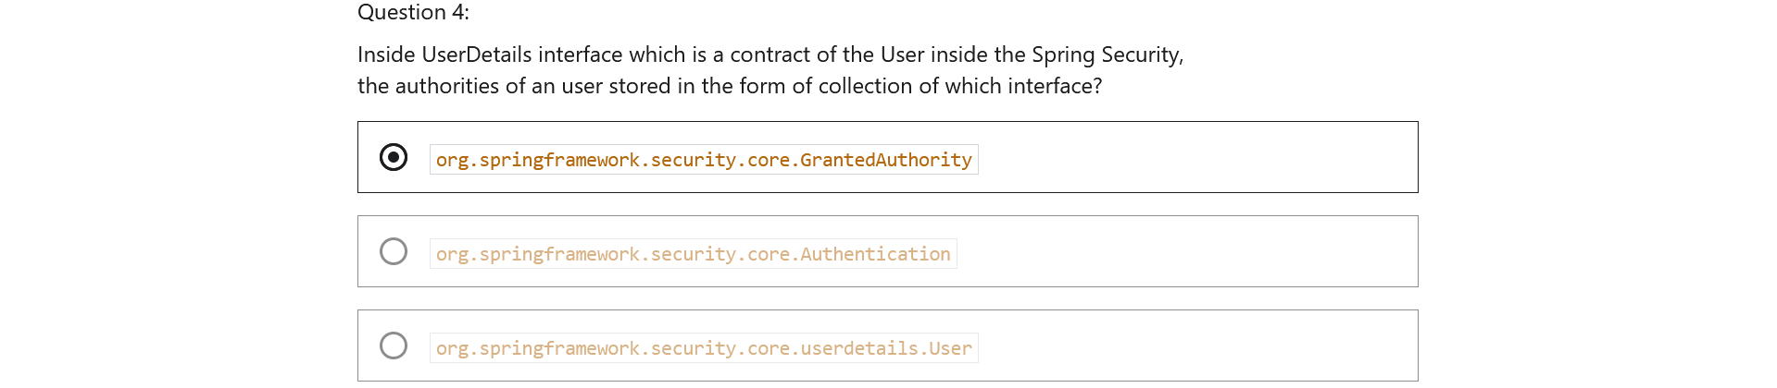
26. 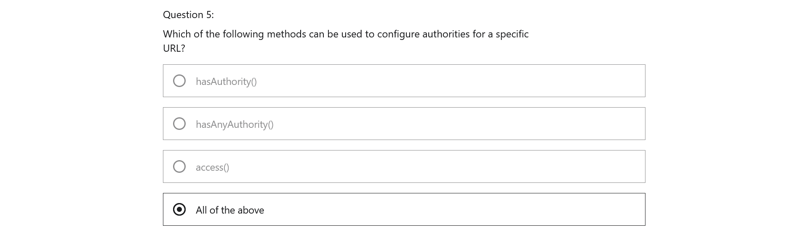
27. 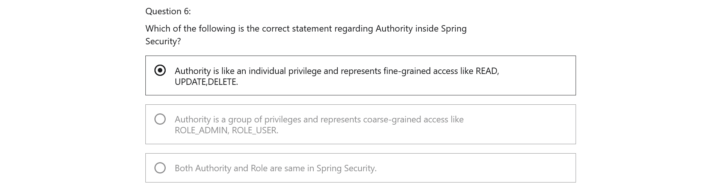
28. 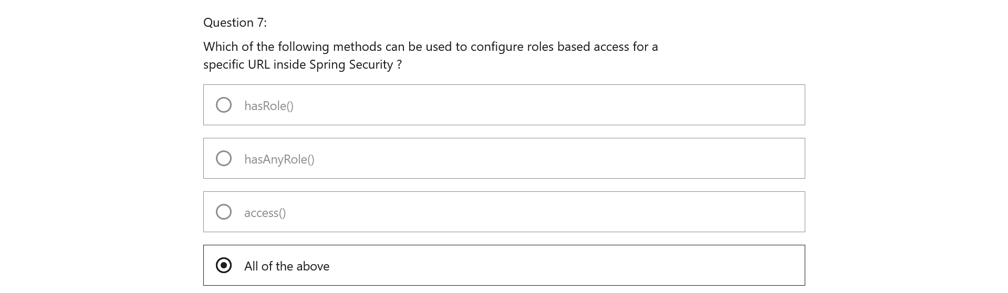

Section 8: Filters in Spring Security

1. 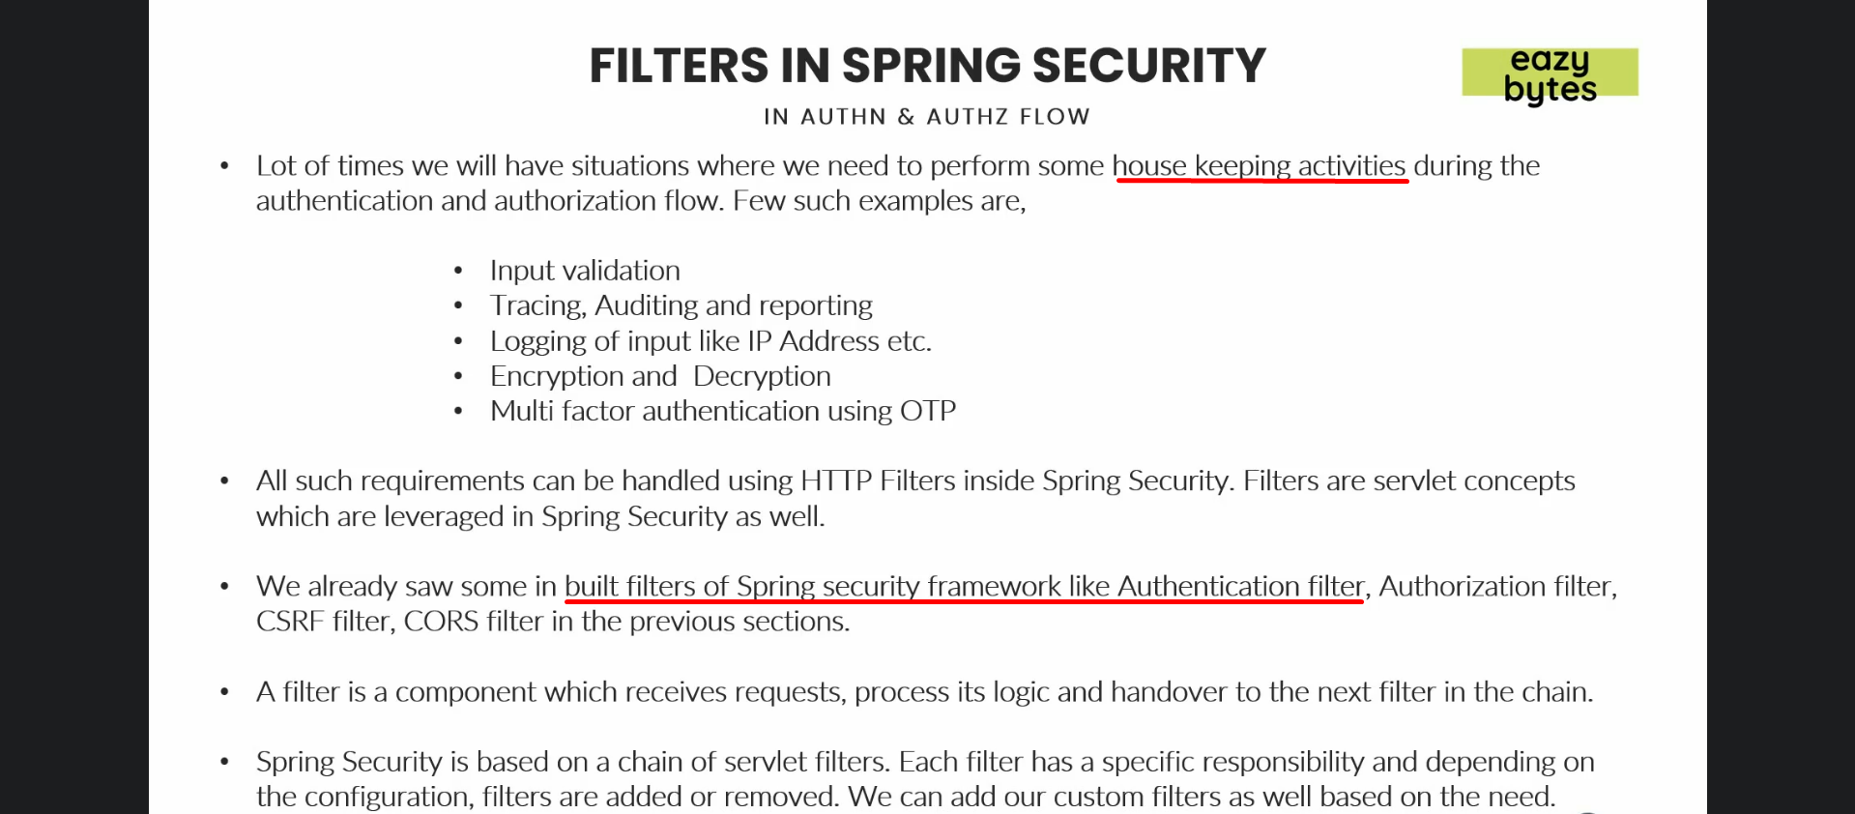
2. 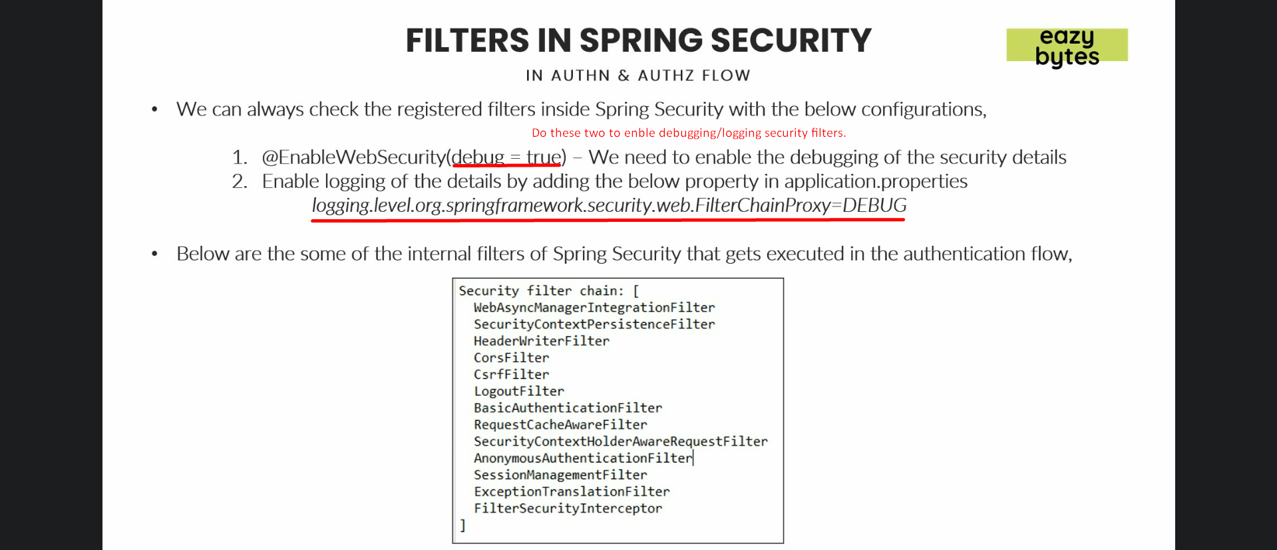
3. 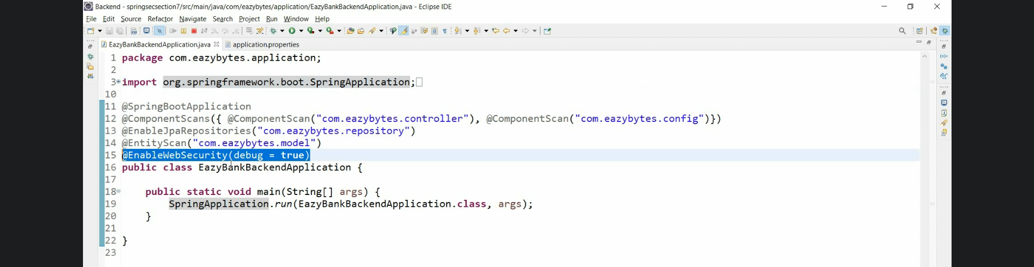
4. 
5. 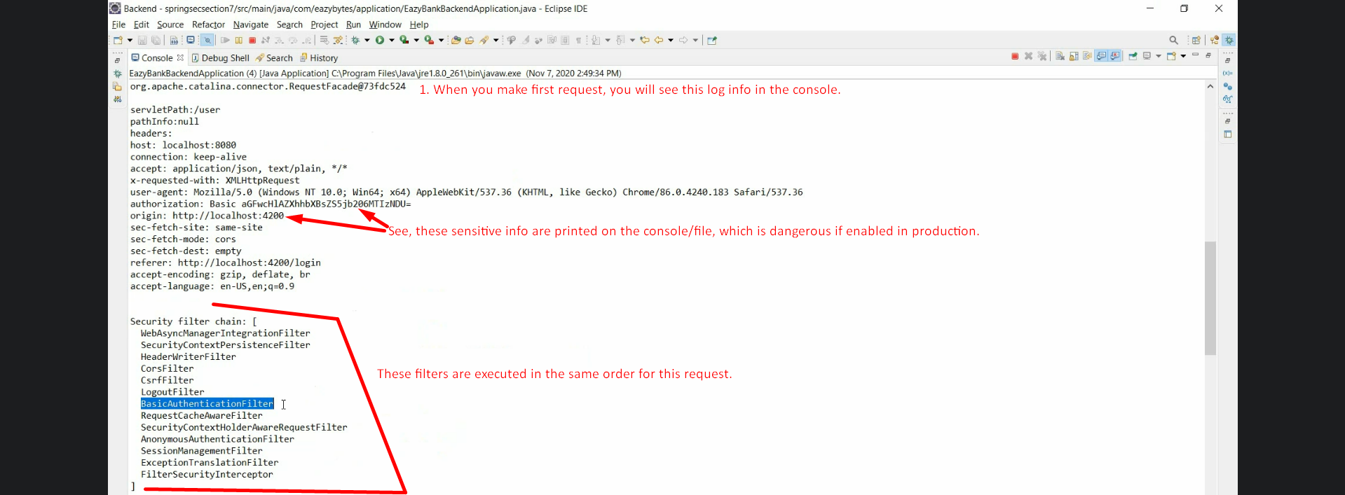
6. 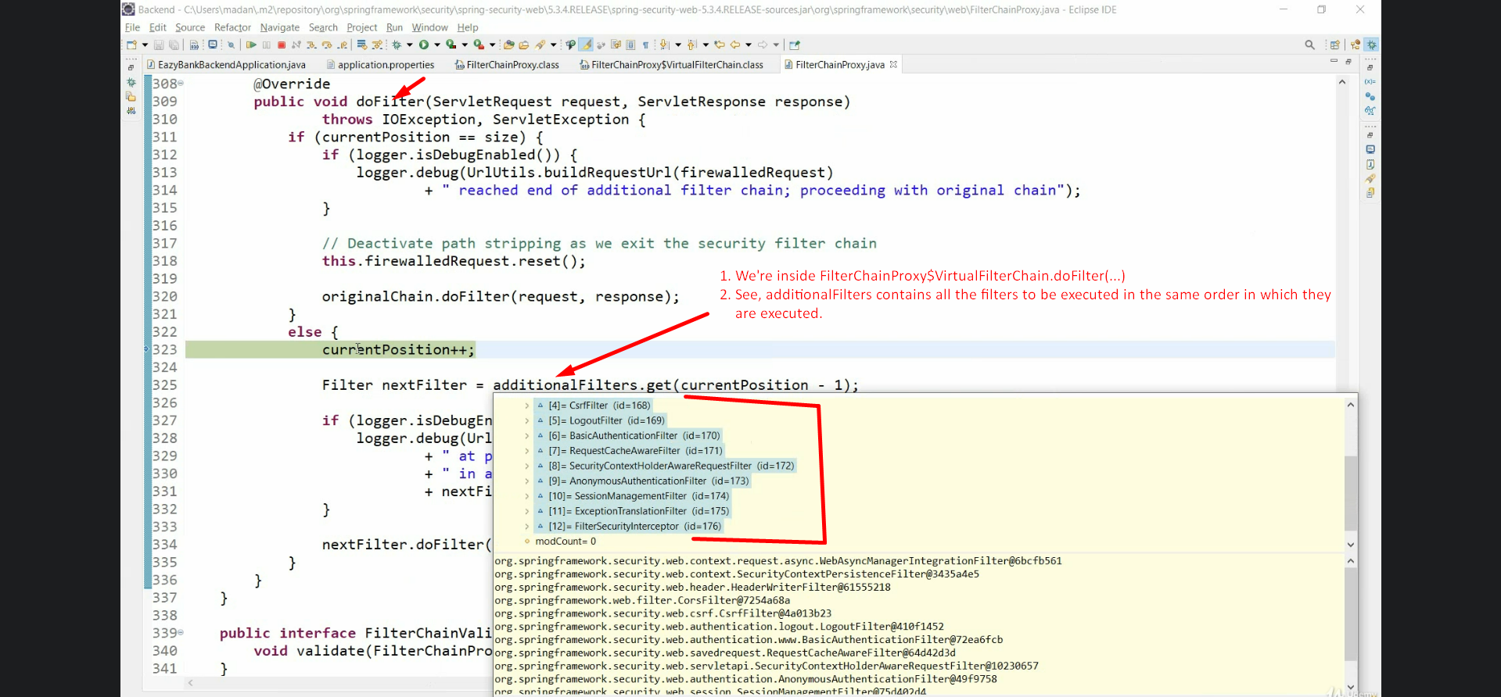
7. 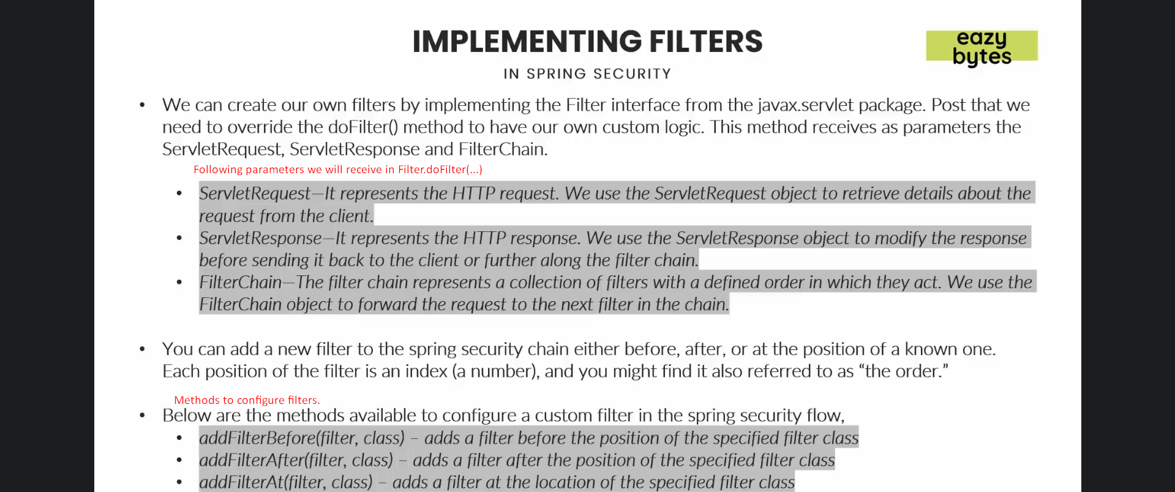
8. 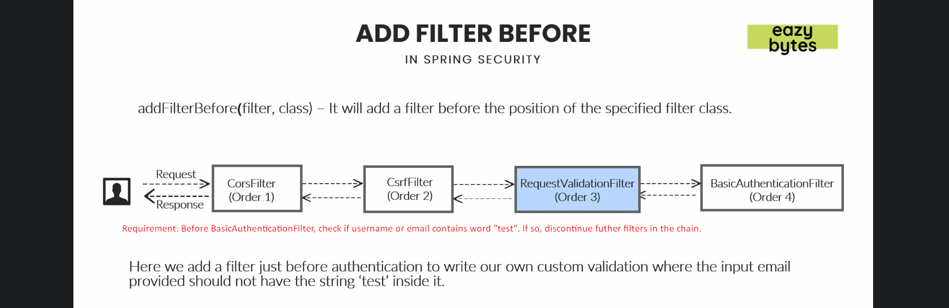
9. 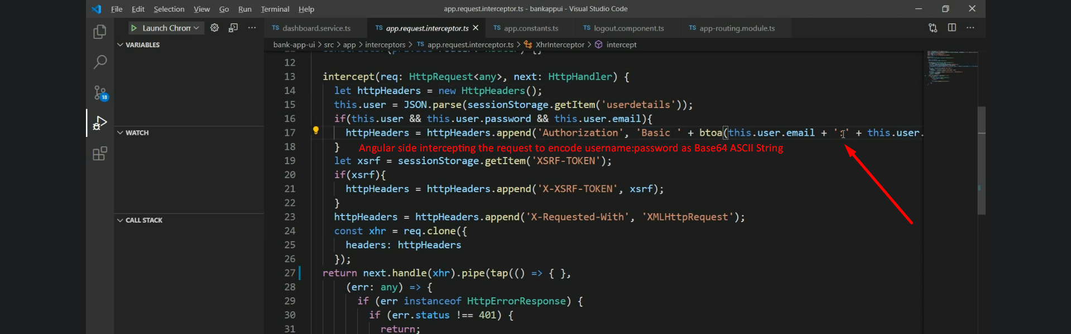
10. 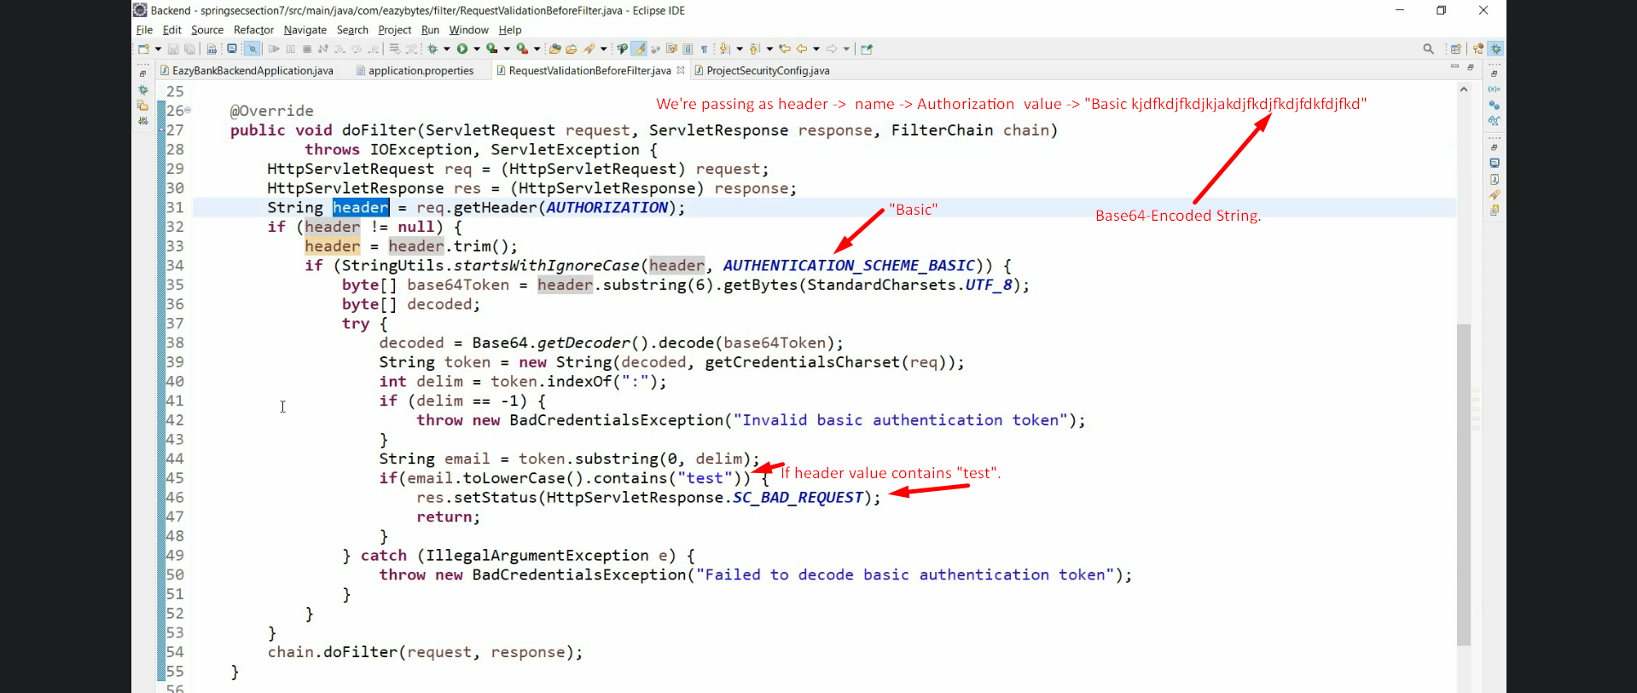 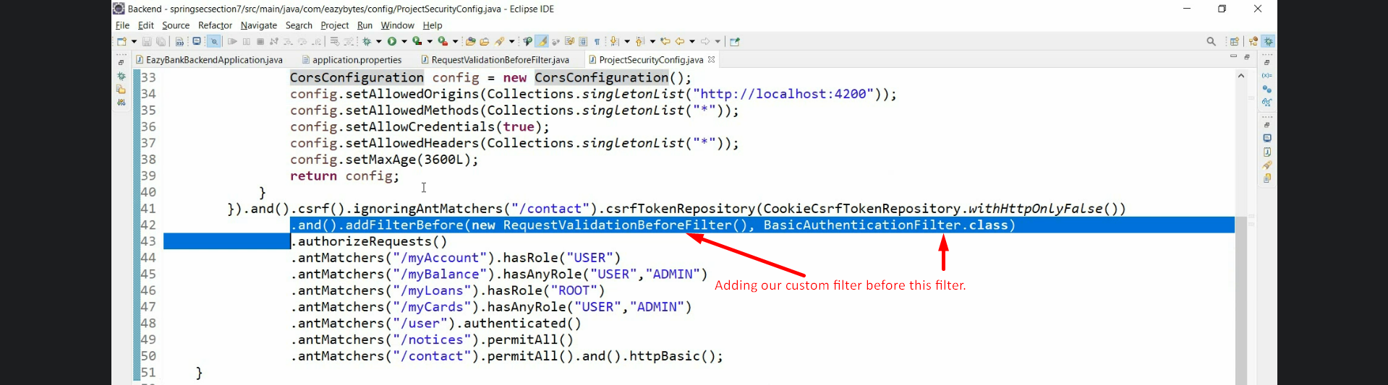
11. 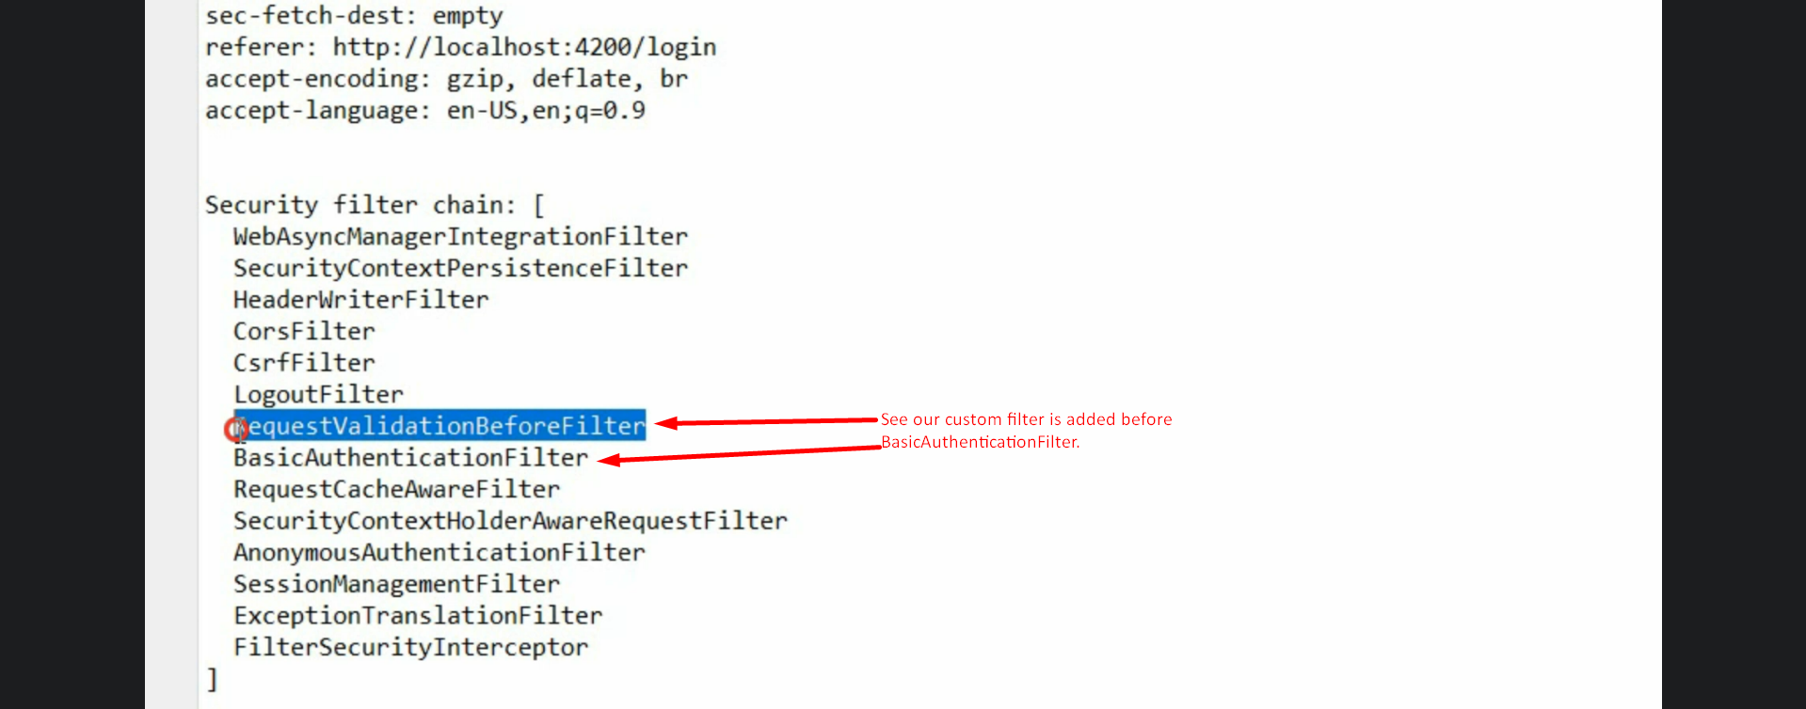 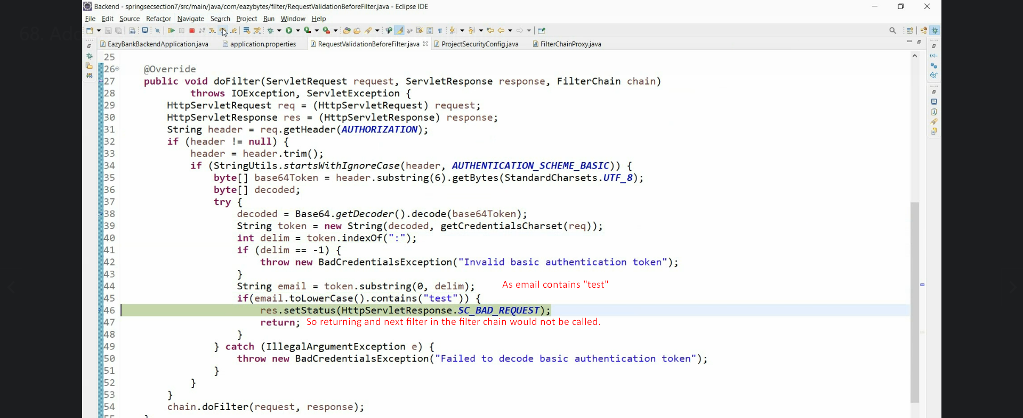
12. 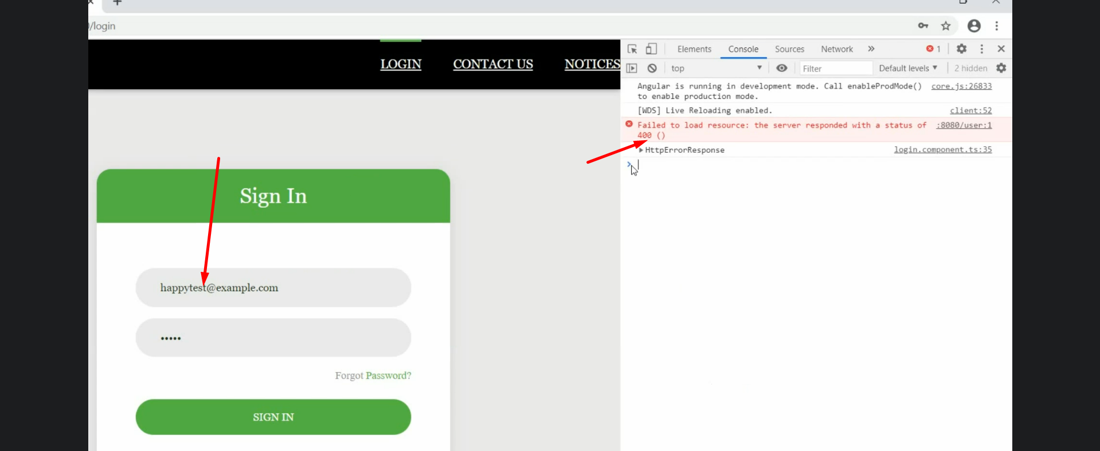
13. 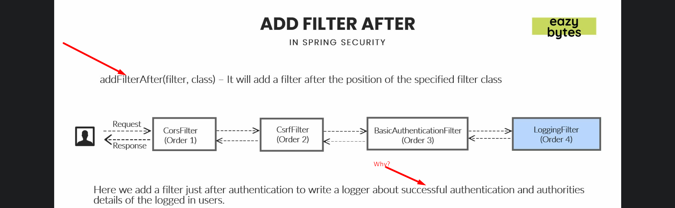
14. 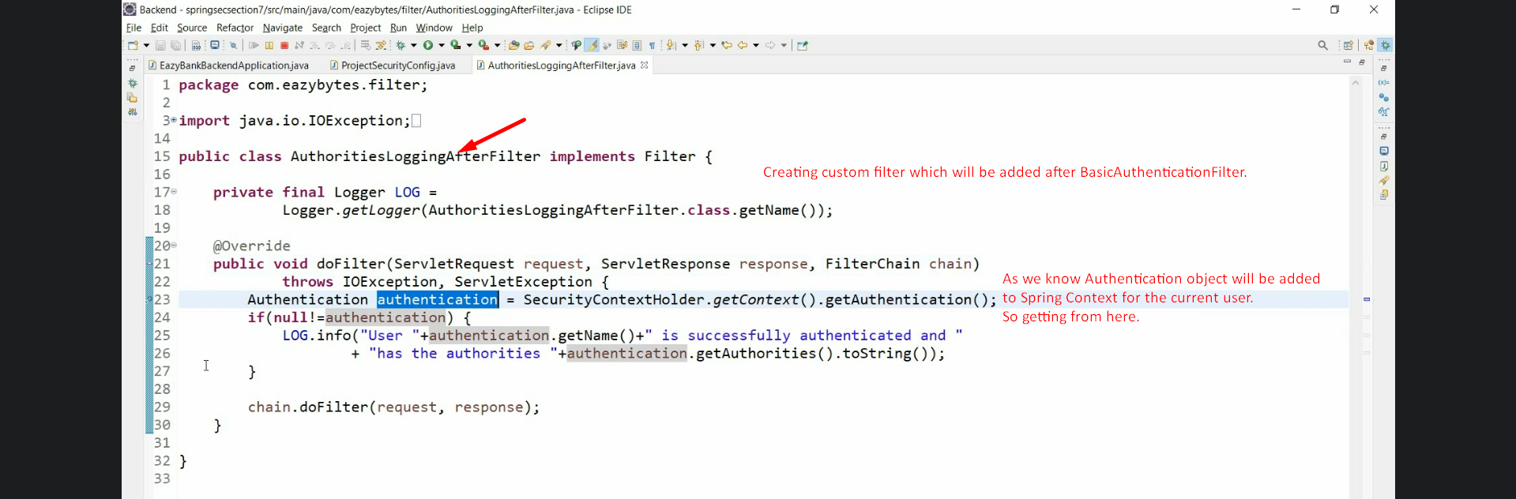
15. 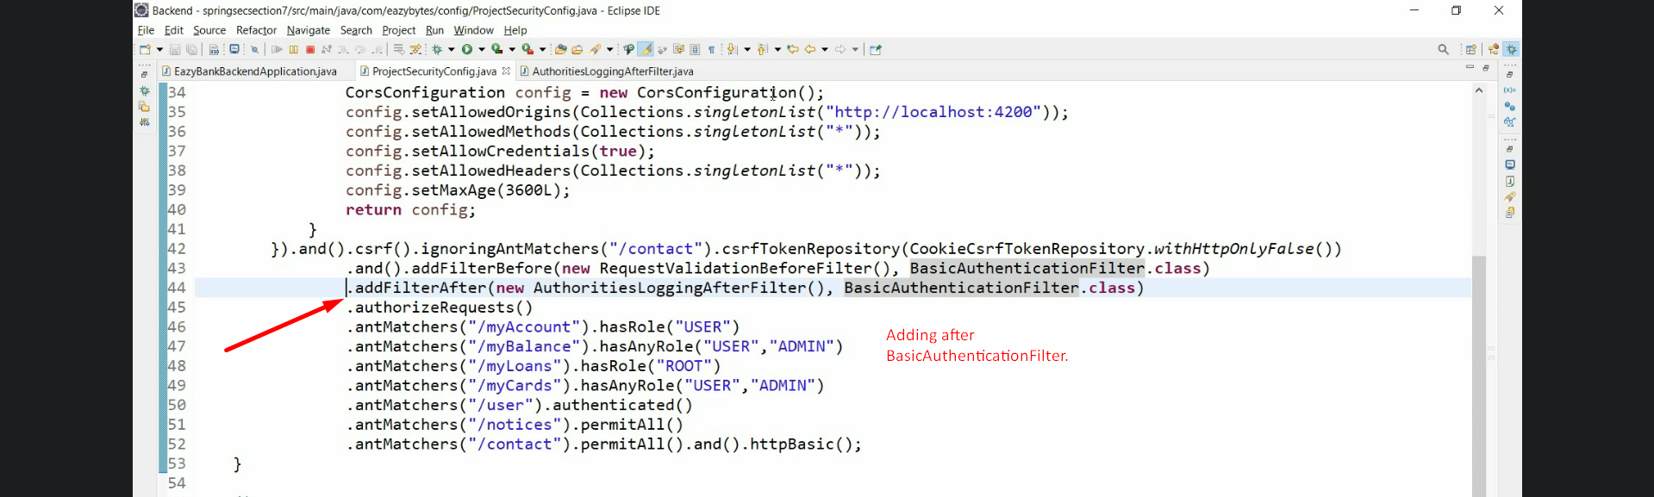
16. 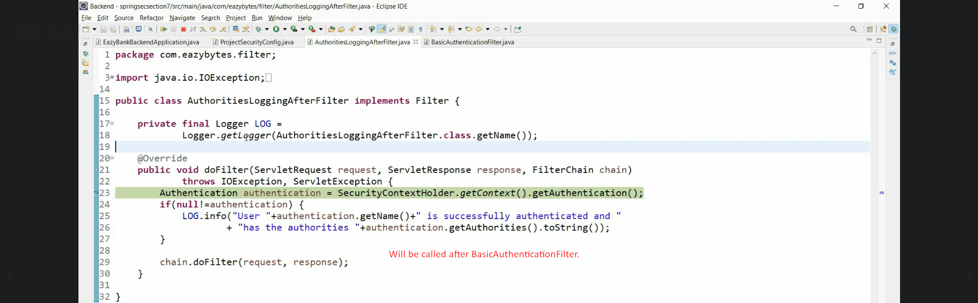
17. 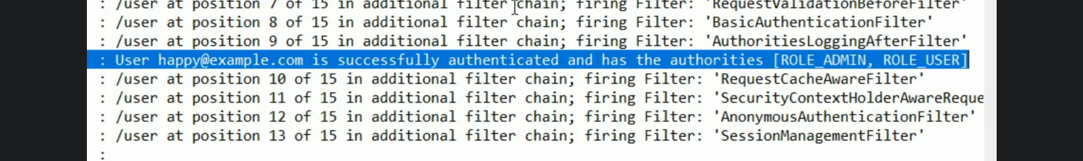 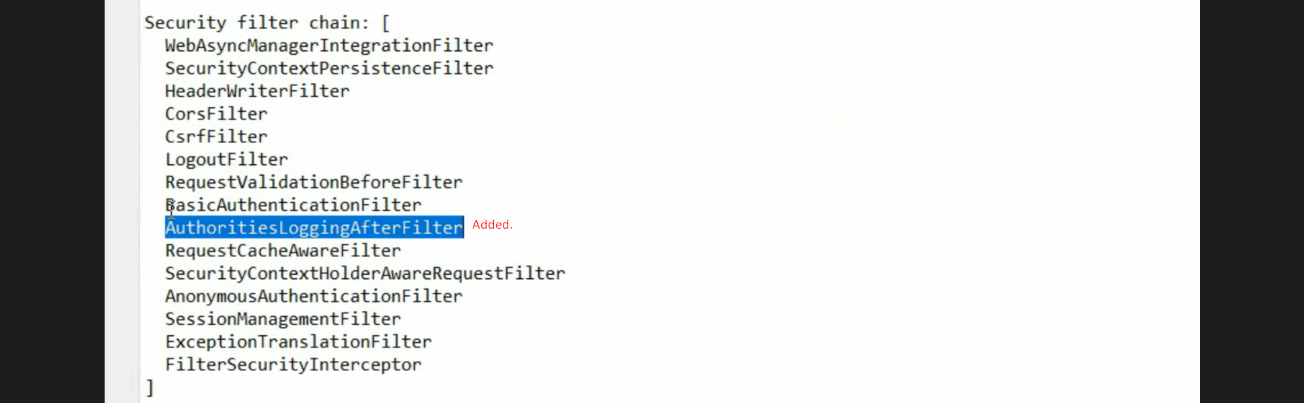
18. 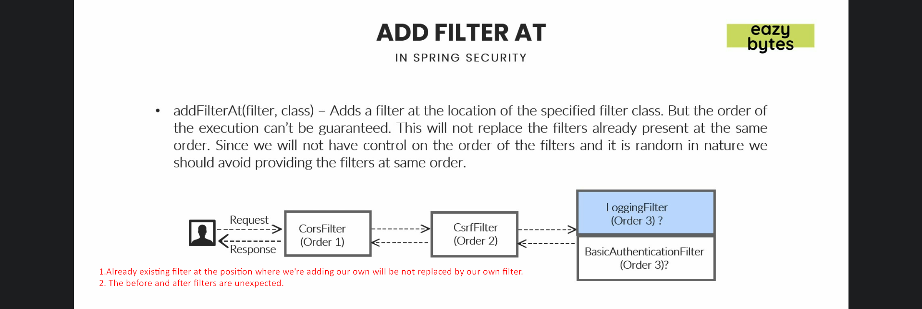
19. 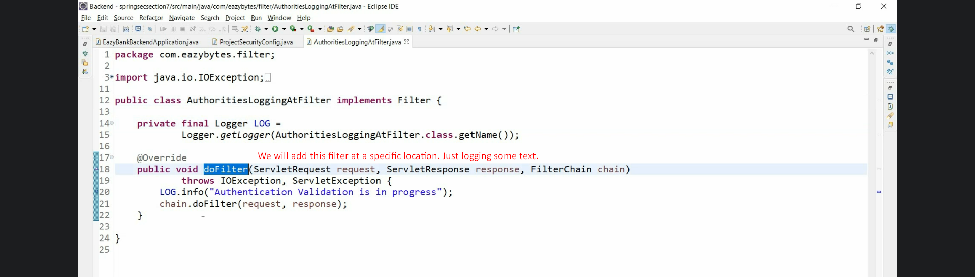
20. 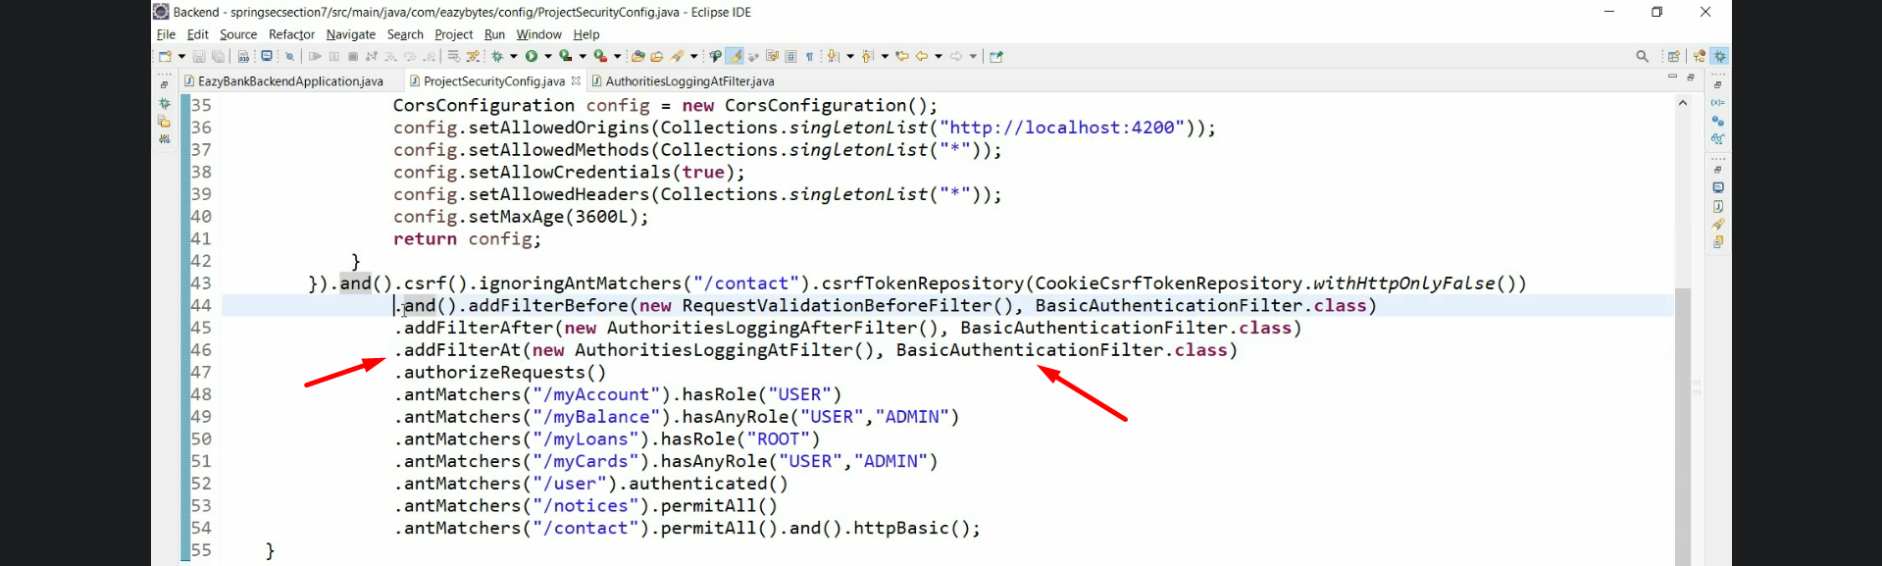
21. 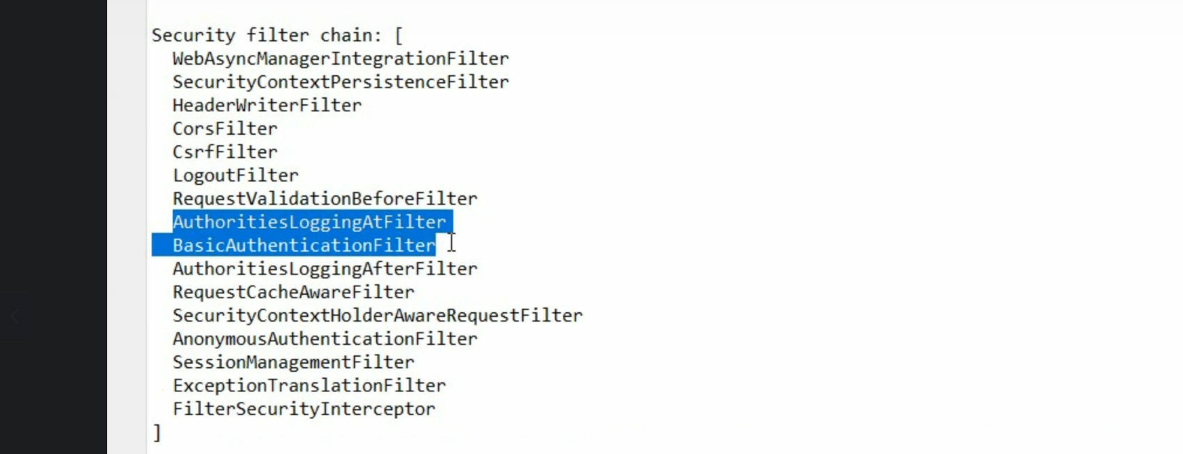
22. 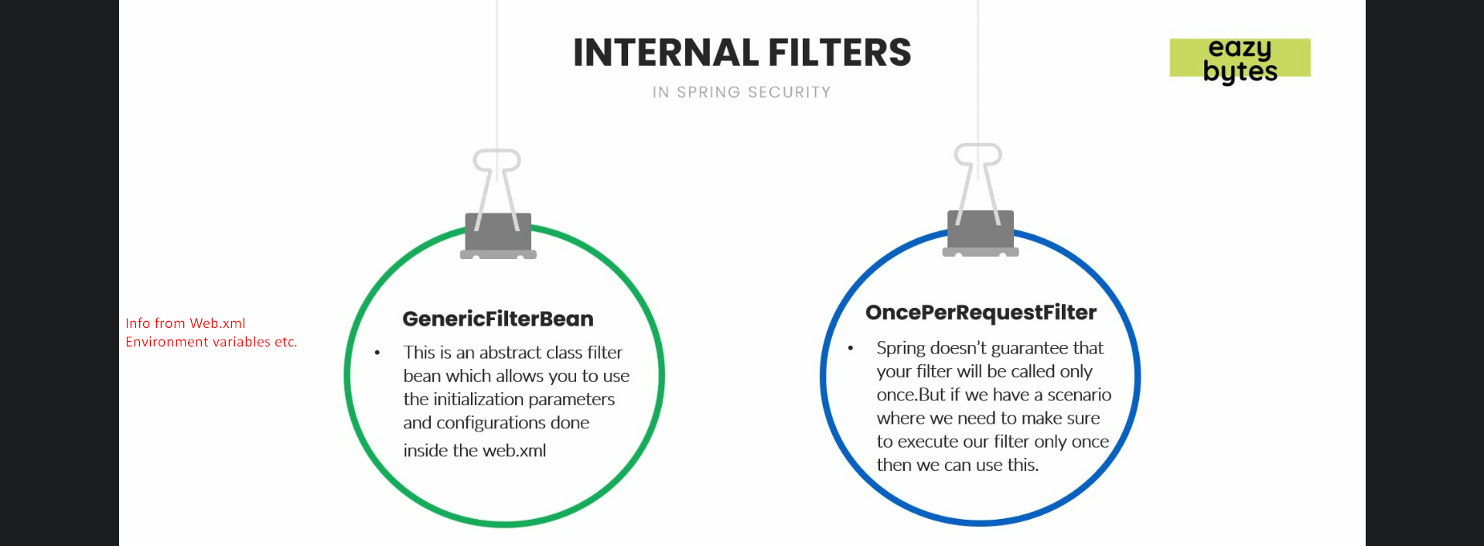
23. 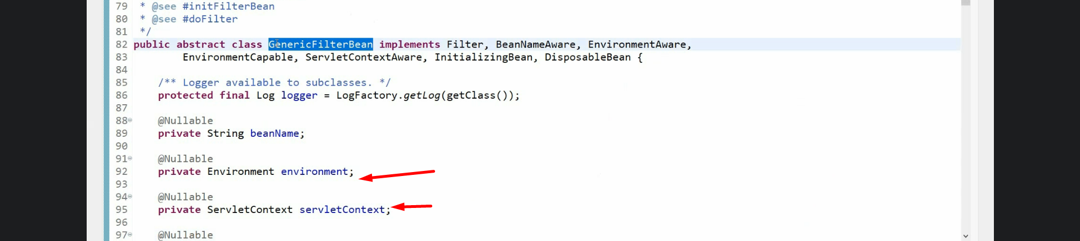 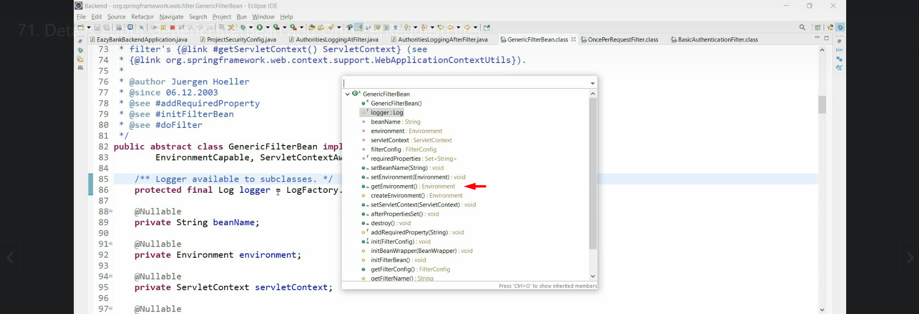
24. 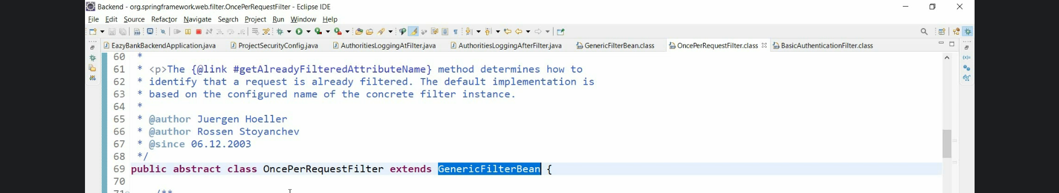
25. 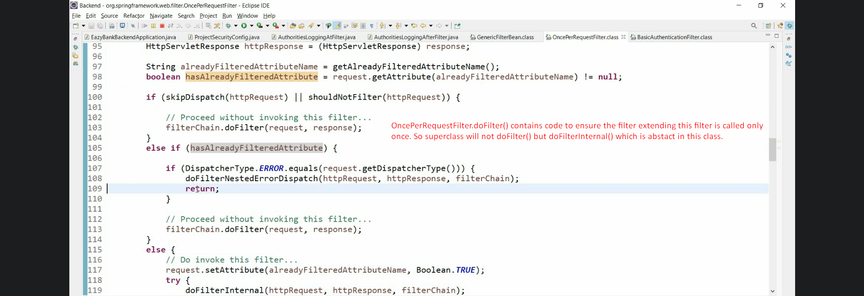
26. 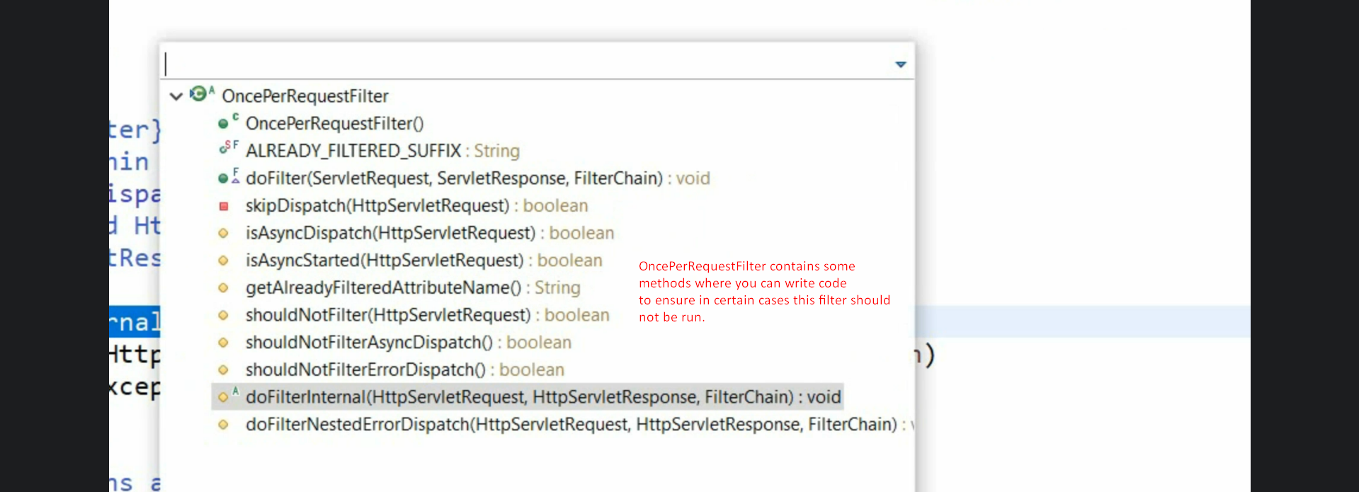
27. 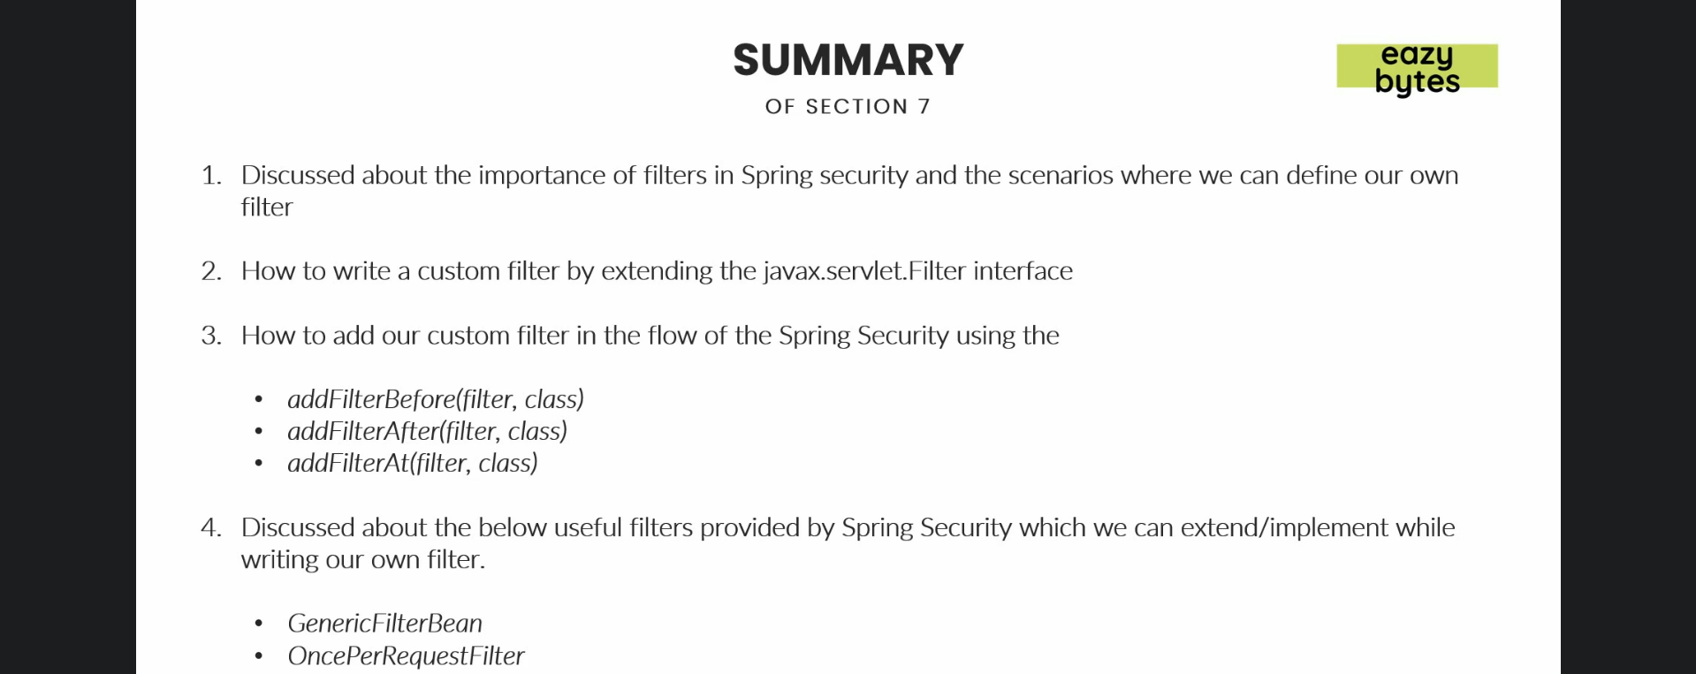
28. 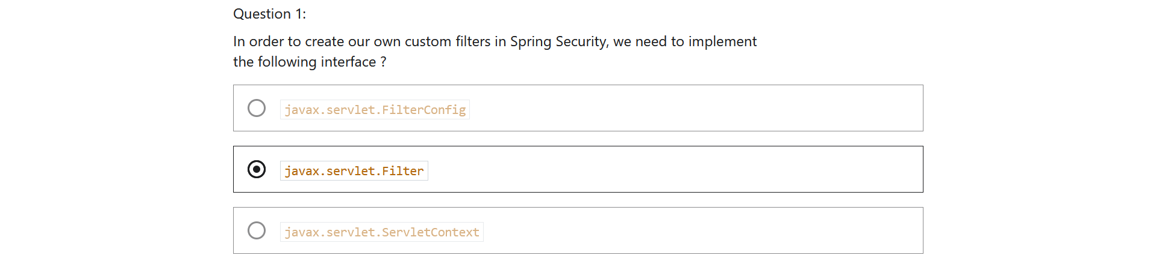
29. 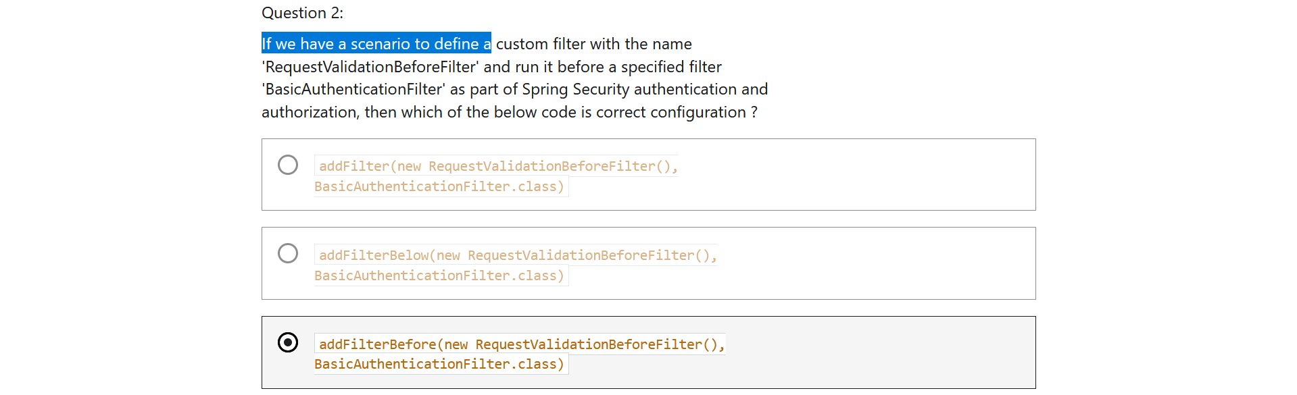
30. 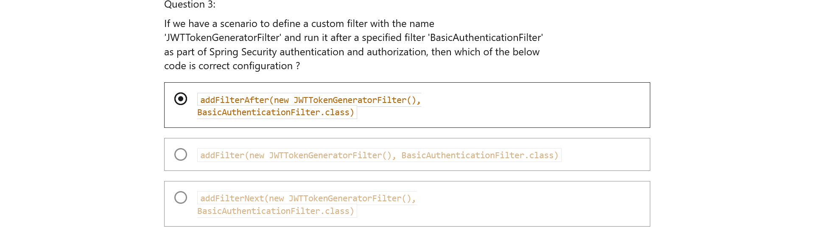
31. 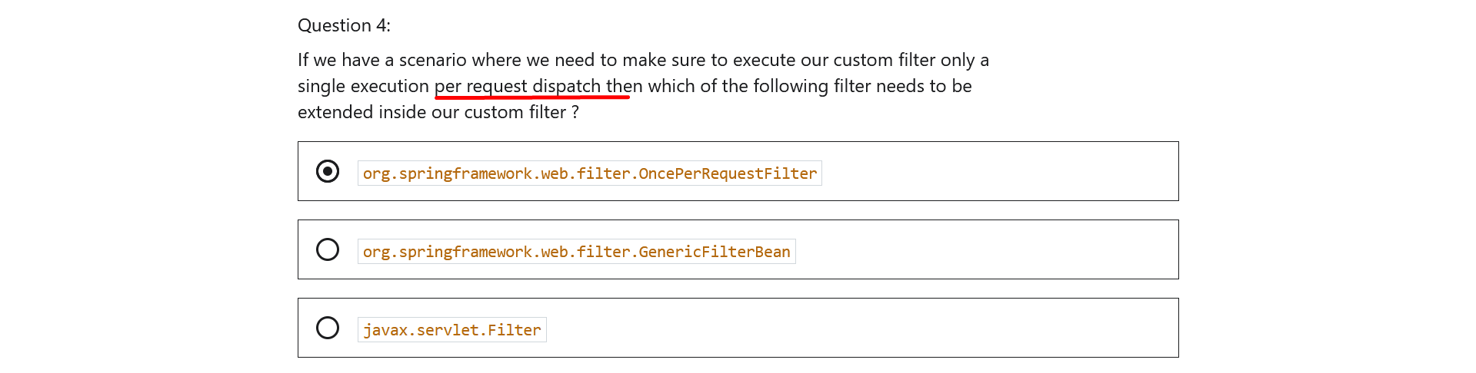

Section 9: Token based Authentication using JSON Web Token (JWT)

1. 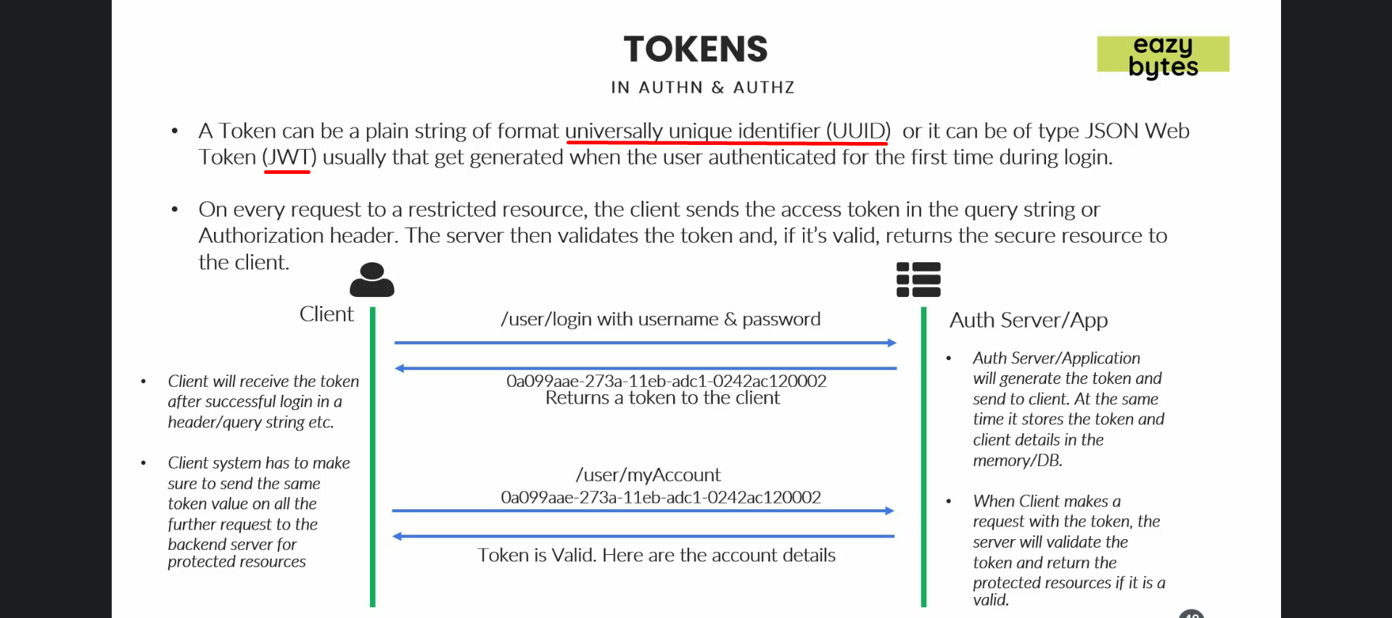
2. 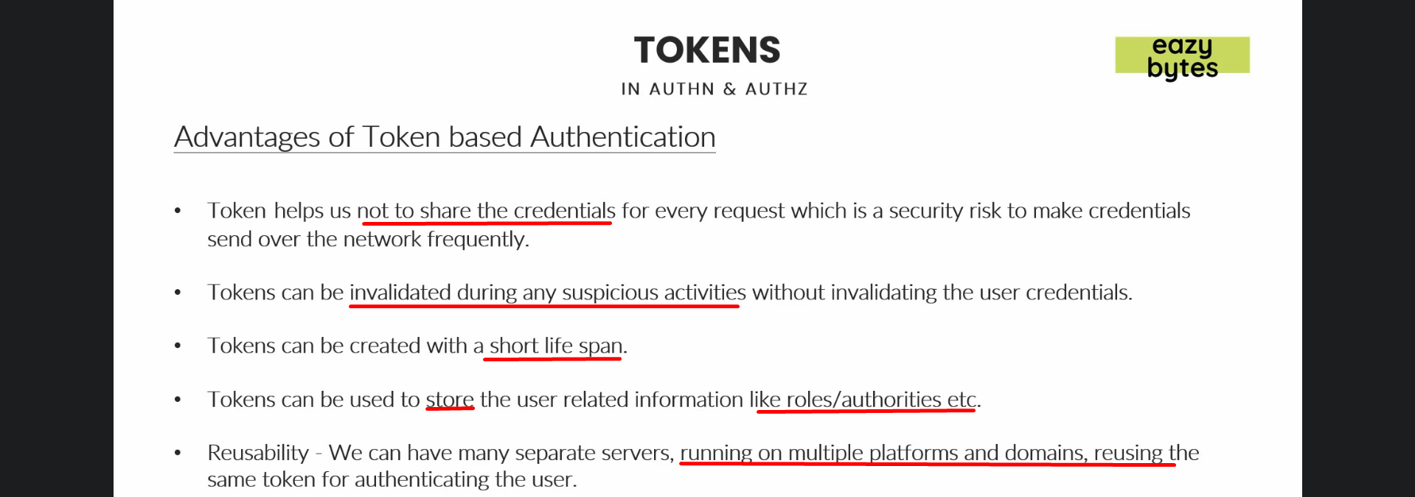
3. 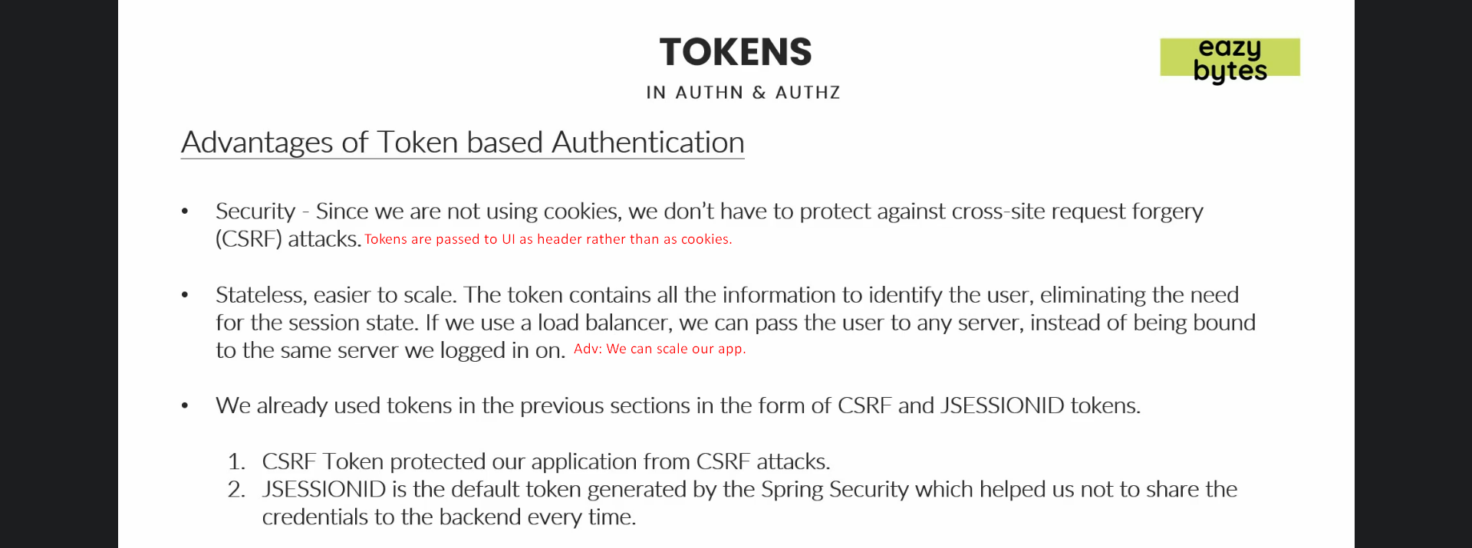
4. 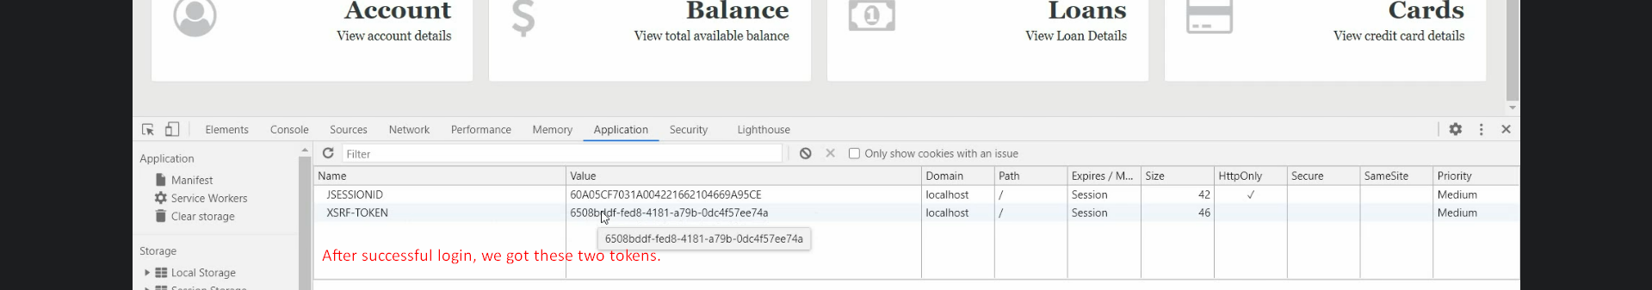
5. 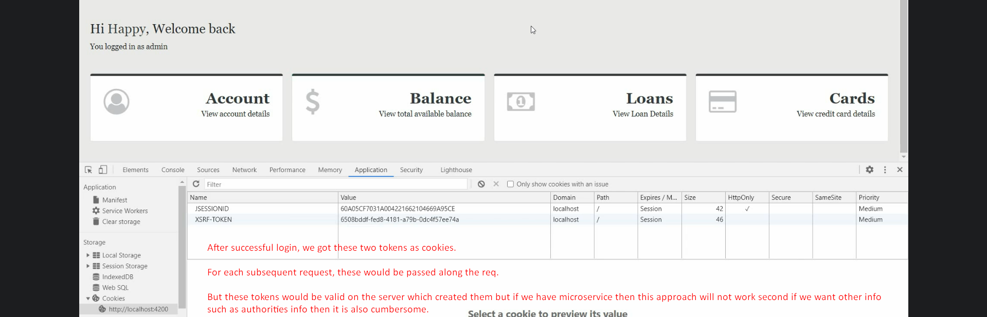**NOTE**: we don’t get CSRF token as cookie but is set in each page.
6. 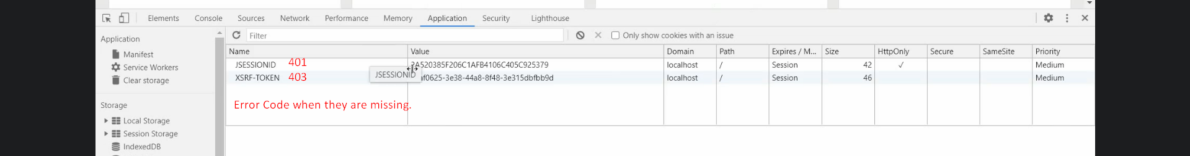
7. 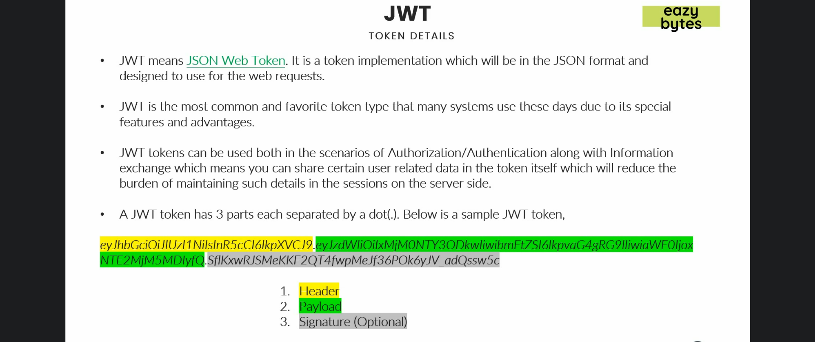
8. 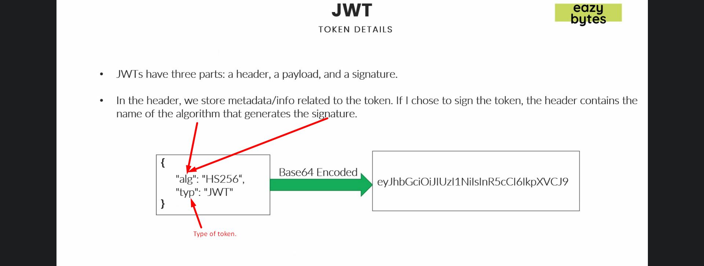 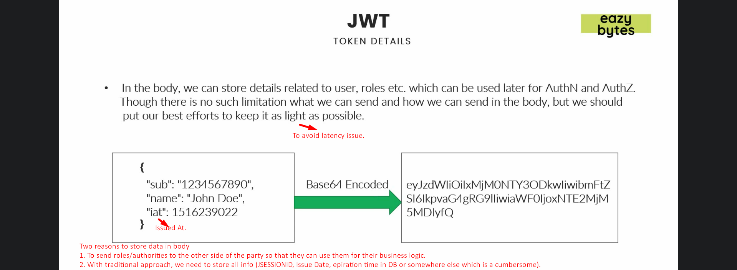
9. 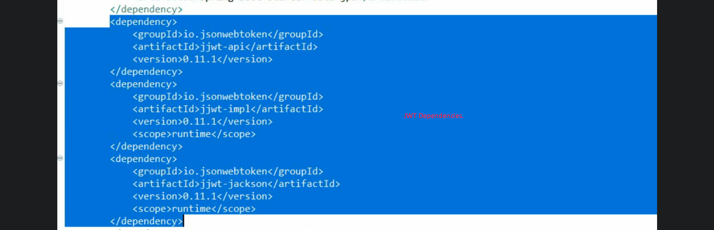
10. 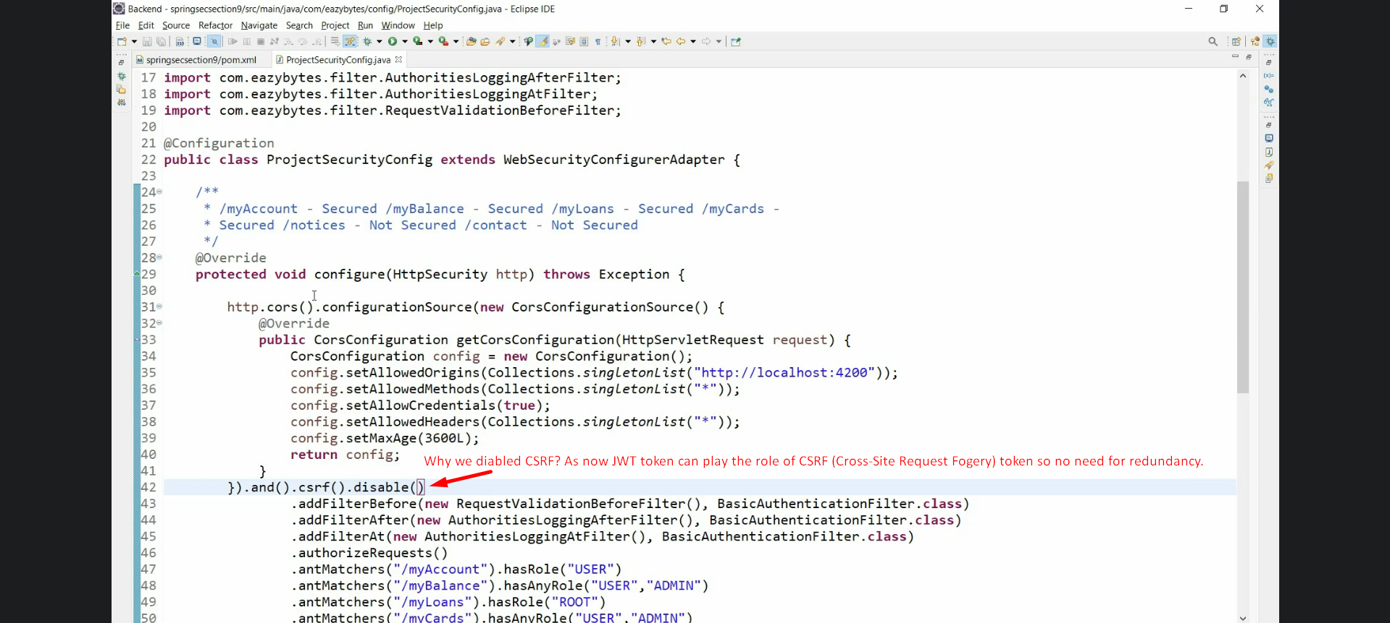
11. 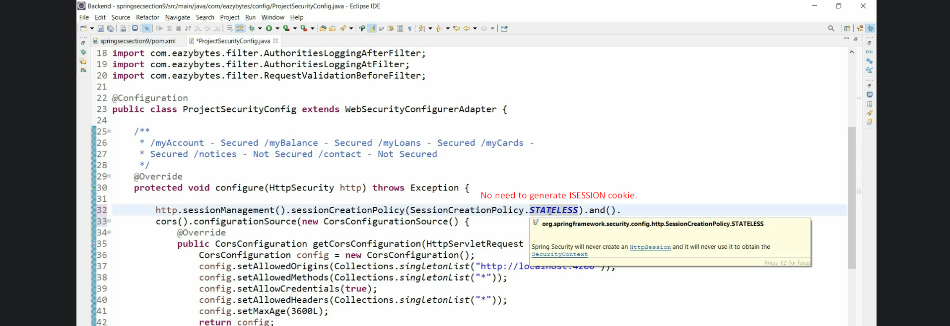
12. 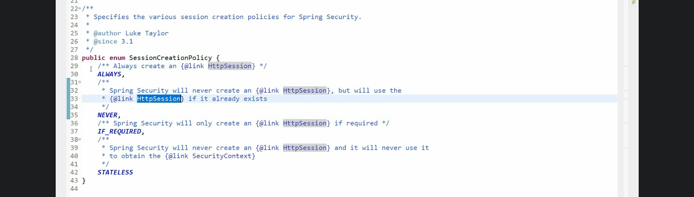
13. 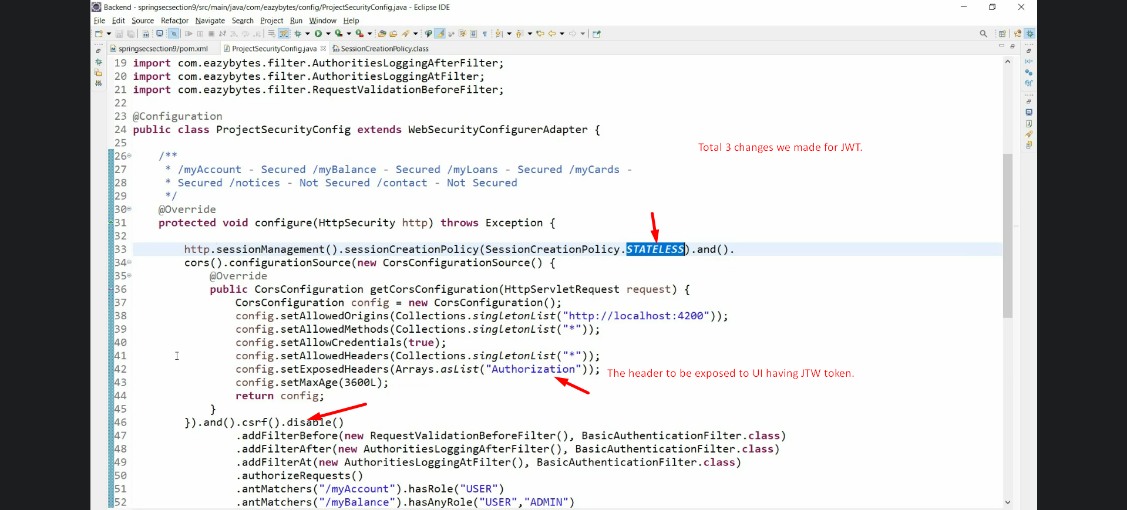
14. Steps:
    1. Add dependencies.
    2. Set 🡺 SessionCreationPolicy.STATELESS
    3. Set 🡺 Disable csrf
    4. Expose header “Authentication” in CORS.
    5. Before and after filters extending OncePerRequestFilter
       1. Before: To validate JWT Token
       2. After: To Generate JWT Token:
          1. Sorry in the below slide, Condition02: We will create JWT token when authentication is successful so not null.